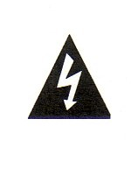
Safety:
Unplug the controller before opening the controller enclosure.
A 120VAC Electrical shock hazard exists on the lower controller circuit board when the controller is plugged in and the enclosure door is open.

This Controller:
Powers and controls chemical feed pumps for inhibitor, oxidant and sulfuric acid.
Powers and controls the cooling tower bleed solenoid.
Measures tower conductivity, temperature, ORP and pH using sensors supplied with the controller.
Measures make-up and bleed water meters.
Uses a flowswitch or jumper to stop bleed and chemical feed when tower flow stops.
Power and control for four biocide pumps.
Measures dual boiler conductivity with sensors supplied with the controller.
Power and control for two boiler blowdown valves.
Two 4-20mA inputs.

Sensor | Connect to: | Connection Location
Tower  Conductivity-Temperature | RED to S+, BLACK to S-  WHITE to T+, GREEN to T- | Top circuit board,  Part CT driver, Location A-B
pH | Clear coaxial center to 1+  Tinned coaxial shield to 1-  Green solution ground to  | Top circuit board,  Part OP driver, Location C
ORP | Clear coaxial center to 2+  Tinned coaxial shield to 2- | Top circuit board,  Part OP driver, Location D
Dual 4-20mA Input | Please see CI insert in the help section of this manual. | Top circuit board, Location E-F  Part CI driver
B1 Conductivity | BLACK to S1, WHITE to S1 | Top circuit board, Location I  Part B driver
B2 Conductivity | BLACK to S2, WHITE to S1 | Top circuit board, Location J  Part B driver
Make-up Watermeter | RED to O, BLACK to | Top circuit board,  Bottom, center terminals
Bleed Watermeter | RED to P, BLACK to | Top circuit board,  Bottom, center terminals
Flowswitch | RED to T, RED to | Top circuit board,  Bottom, center terminals
B1 Operating  (Interlock) | BLACK to U, WHITE to | Top circuit board,  Bottom, center terminals
B2 Operating  (Interlock) | BLACK to V, WHITE to | Top circuit board,  Bottom, center terminals

Warning:
Do not route sensor, flowswitch and water meter cables in the same conduit as 120VAC power, pumps and solenoids.

Default Passwords

User ID | Default Password | Note
Admin | AAAA | Case sensitive
User No.1 | 1 | Default is Keypad passwords OFF
User No.2 | 2 | Browser passwords are always ON
User No.3 | 3
User No.4 | 4 | Passwords may be changed
User No.5 | 5 | using Keypad OR Browser
User No.6 | 6
User No.7 | 7
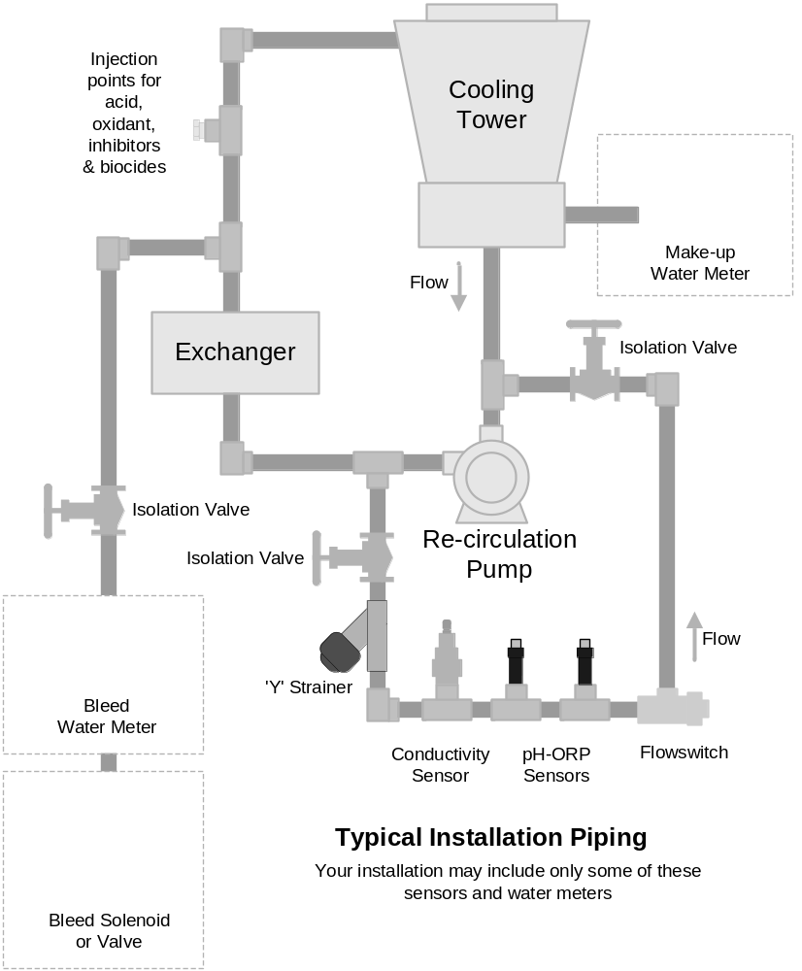
Typical Valve and Solenoid Wiring Color Coding

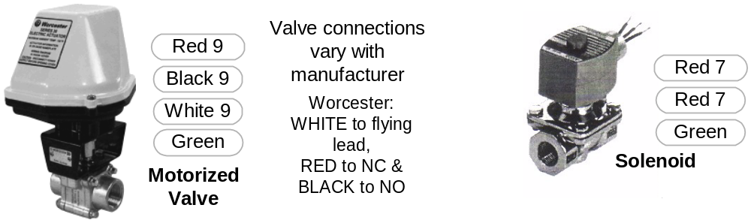

Terminate Green grounding cabling to bottom, center of aluminum backplate

Typical Valve and Sensor Locations
Captured Sample Blowdown Control

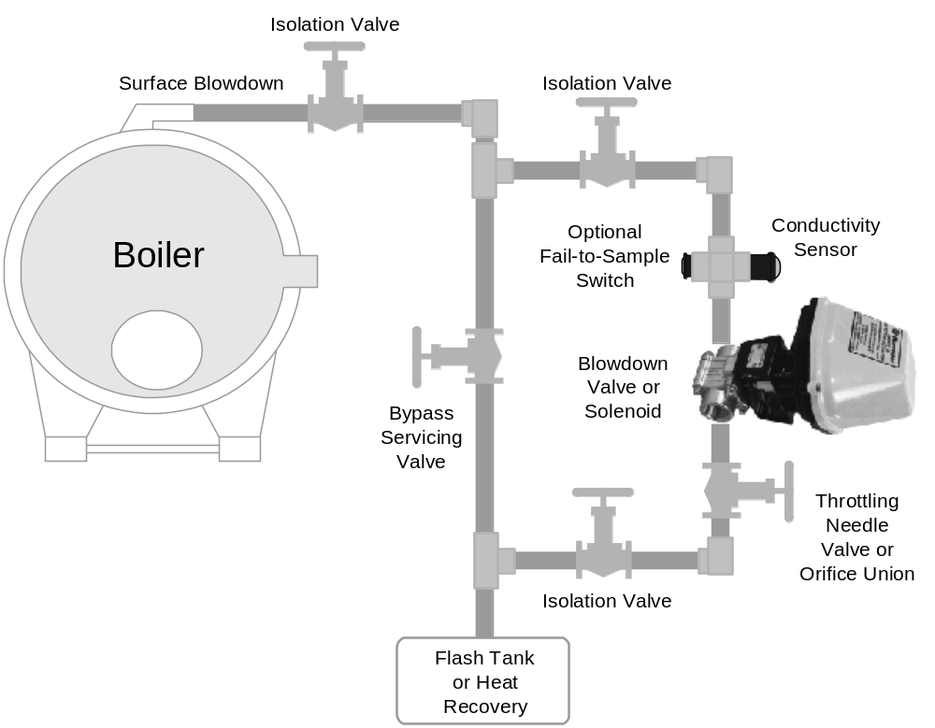

Automated blowdown control operates with Isolation Valves open,
Bypass Valve closed and Throttling Valve 15-25% open.

Optional Hardwiring
If you elect not to use the plug boxes or power plug provided with the controller.
Refer to the following table for hardwiring 120VAC.
Use multiple strand, AWG14 for 120VAC service, pumps and solenoid

Service | Cable: | Connect to  Lower circuit board | Notes:
Controller 120VAC 15Amp service | Line / Black  Neutral / White  Ground / Green | Center terminal block  L  N  Aluminum backplate grounding screw. | Maximum controller 13.6 Amps @ 120VAC  Existing flying lead grounds Controller to aluminum backplate.
Inhibitor Pump | Line / Black  Neutral / White | Relays 1-3 NO1  Neutral | Relay No.1
Bleed Solenoid | Line / Black  Neutral / White | Relays 1-3 NO2  Neutral | Relay No.2
Acid Pump | Line / Black  Neutral / White | Relays 1-3 NO3  Neutral | Relay No.3
Oxidant Pump | Line / Black  Neutral / White | Relays 4-5 NO4  Neutral | Relay No.4
Biocide Pump 1 | Line / Black  Neutral / White | Relays 4-5 NO5  Neutral | Relay No.5
Biocide Pump 2 | Line / Black  Neutral / White | Relays 6-8 NO6  Neutral | Relay No.6
Biocide Pump 3 | Line / Black  Neutral / White | Relays 6-8 NO7  Neutral | Relay No.7
Biocide Pump 4 | Line / Black  Neutral / White | Relays 6-8 NO8  Neutral | Relay No.8
B1 Blowdown Valve  OR | NO / Black  NC / Red  Neutral / White | Relays 9-10 NO9  Relays 9-10 NC9  Neutral | Blowdown 1 controlled by Relay No.9
B1 Blowdown Solenoid | Line / Red  Neutral / Red | Relays 9-10 NO9  Neutral | Blowdown 1 controlled by Relay No.9
B2 Blowdown Valve  OR | NO / Black  NC / Red  Neutral / White | Relays 9-10 NO10  Relays 9-10 NC10  Neutral | Blowdown 2 controlled by Relay No.10
B2 Blowdown Solenoid | Line / Red  Neutral / Red | Relays 9-10 NO10  Neutral | Blowdown 2 controlled by Relay No.10

