SMART ‘AS’ Automated Service
Water Management Controllers

Boiler Blowdown
INSTALLATION & MAINTENANCE
MANUAL
Sampling and Continuous

Version 4.09 Controller Software

8660 Red Oak • Rancho Cucamonga • California • 91730

contents 1 of 2

1. READ-ME!
1.1 Check controller box contents 1
1.2 Where’s the information for this controller? 1 1.3 Where can I get more information? 1

2. INSTALLATION
2.1 Enclosure Installation 2
2.2 Sampling Blowdown Installation 2
2.3 Sampling Blowdown Valve Installation 3
2.4 Continuous Blowdown Installation 5
2.5 Wiring Motorized Blowdown Valves 6
2.6 Cabling Sensors, Pumps, Valves, Solenoids, Meters 7
2.7 Terminal Block Locations 8
2.8 Connecting pH Sensors 9
2.9 Connecting Conductivity-Temperature Sensors 9
2.10 Connecting Watermeters 10
2.11 Connecting 4-20mA Sensors & Liquid Level Sensors 12
2.12 Connecting Flowswitches and Level Switches 13
2.13 Connecting AC Power, Solenoids & Pumps 14
2.14 Connecting Alarms and Motorized Valves 15
2.15 Connecting Serial Cables, Telephone Modem or 16
Controller Network

3. COMMISSIONING
3.1 Set-up Controller 17
3.2 Quik Operate 19
3.2.1 View what happening now 19
3.2.2 Adjust a Setpoint 20
3.2.3 View what’s causing an alarm 21

contents 2 f 2

4. CONFIGURING
4.1 Controller Display 23
4.2 ‘TV’ Remote Keys & Programming 24
4.3 MAIN MENU OPTIONS 26
4.4 ADJUST SETPOINTS 28
4.5 ADJUST BIOTIMING 29
4.6 VIEW ACTIVE ALARMS 31
4.7 CLEAR ALARMS 31
4.8 ADJUST ALARMS 32
4.9 ADJUST DATE & TIME 33
4.10 CALIBRATE SENSORS 33
4.11 VIEW WATERMETERS 37
4.12 ADJUST BOILER TIMING 37
4.13 PRIME PUMPS 39
4.14 BIOCIDE LOCKOUT 40
4.15 INHIBITOR CONTROL 41
4.16 ADJUST 4-20mA LOOPS 43
4.17 ADJ. ENABLED PARAMS 44
4.18 ADJ. SITE SETTINGS 45
4.19 VIEW BOILER STATUS 47

5. OPERATION & MAINTENANCE
5.1 ‘Out-of-the-Box’ Operation 48
5.2 Setpoint Guidelines 49
5.2.1 Conductivity 49
5.2.2 pH 49
5.2.3 Inhibitor Control 49
5.3 Calibration 50
5.4 Biocide Timed Events 50
5.5 Alarms 50
5.6 Fault-Cause Summary 52
5.6.1 NO POWER-NO DISPLAY 52
5.6.2 NO CONDUCTIVITY CONTROL 52
5.6.3 NO pH CONTROL 53
5.6.4 NO BIOCIDE FEED 53
5.6.5 NO TV REMOTE KEYPAD OPERATION 54

6. PRODUCT SUPPORT 54

APPENDIX ‘A’ CONTROLLER OPTIONS
& Sensor Part Numbers 55
APPENDIX ‘B’ TV Remote Keypad Menu Tree 56
APPENDIX ‘C’ Options Sub-Panel 59.

USER WARNING : CAUTION

Water Treatment Controllers operate steam and water valves and may pump hazardous, corrosive and toxic chemicals. Opening the controller enclosure exposes user to the risk of electrical shock at power line voltages.

Understand fully the implications of the control setpoints, interlocks and alarms that you select. Harm to personnel and damage to equipment may result from mis-application.

Unplug or turn OFF the AC power to the controller if you have any concerns regarding safety or incorrect controller operation and notify supervisory staff.

YOUR CONTROLLER
Aquatrac controllers are supplied in many different configurations.

The HELP section in the back of this manual contains the Field Wiring information for terminating the sensors supplied with your specific controller.

The HELP section in the back of this manual contains the installation plumbing header which shows the sensor set supplied with your specific controller.

1. READ ME!

1.1 Check controller box contents
‘AS’, Automated Service, series controllers are shipped configured for many applications.
The conductivity & optional condensate pH sensor set required for your controller is shipped with the controller.
Optional blowdown valves or blowdown valve assemblies and water meters may be included with the controller.

If your controller is configured for boilers and a cooling tower or a process stream, you will have a copy of the Cooling Tower Operating Manual included with this manual.

Verify that your controller includes the required sensors, this operating manual and a TV remote keypad.

1.2 Where’s the information for this controller?
This is a generic manual for all of Smart ‘AS’ sampling and continuous Boiler Blowdown controllers.
Cooling Towers and Process Streams are supported in a separate manual.

The Technical Manual for this controller is available at www.aquatrac.com
Detail for your controller and its sensor set is in the HELP section at the back of this manual

Identify the sensors and options purchased with your controller by the label located at the bottom, inside of the enclosure door below the controller circuit card.

You’ll see a part number that looks like this SAB B2 TB3 L1 R2 AD.
The first three letters identify a controller family and the following letters identify options.
Flip to Appendix ‘A’ & you’ll see what sensors and functions are included with your controller.

These letter codes are used throughout the Manual so you’ll know if the instructions apply to your controller.

1.3 Where can I get more information?
See Section 4. for an explanation of what you’re seeing as the display scrolls & the TV remote Keypad commands. www.aquatrac.com has both operating and technical manuals.

The HELP section at the back of this manual has information specific to your specific controller Part# set-up and sensor set.

The Technical manual for ‘AS’ series controllers, available at www.aquatrac.com as
Flx-AS_TechMan.doc, contains advanced troubleshooting sequences and detail on communication and sensor specifications.

2. INSTALLATION

HELP: Wiring details and options unique to your controller are detailed in the HELP section at the back of this manual

2.1 Enclosure Installation
Wall mount controller enclosures so that the front panel display is at chest level, placing the top of the enclosure at nominally 5 ft. above the floor. Select a location:
1. To minimize sample piping distance.
2. Close to chemical drums.
3. Beside an electrical outlet.
4. With 12” of clear wall below and on both sides of the enclosure.
5. Which allows 180 degree door opening for left hand side hinged door.

Controller  Type | Mounting  Hole Centers | Mounting Hole Size
SAB…. | 10.75” V x 6” H | 4 x 5/16”D corner mount
SAB….RM | 12.75” V x 8” H | 4 x 5/16”D corner mount
Option  LE16-14 | 16.75” V x 12” H | 4 x 5/16”D corner mount

PUMP PLUG ENCLOSURES
The chemical pump plug enclosures are labeled with the chemical pump designations to match each controller’s options.

The pump plug enclosures may be disconnected from the controller and extended with EMT or rigid conduit.
Note the color coding before disconnecting the 120VAC power cabling and extend the cabling in AWG14 to AWG18 gauge cable, preserving the color original coding

2.2 Sampling Blowdown Installation
Most boiler blowdown automation at sites operating at pressures of 7 to 250psi steam, use Sampling Boiler Blowdown, a technique which eliminates the errors due to flashing and thermal lag on temperature compensation.
Sampling boiler blowdown is a four step operation:
- Sampling Time, typically 30 seconds, it’s the time the controller opens the valve to obtain a boiler sample.
2. Wait-to-Measure, typically 60 seconds, it’s the time between valve closure and measurement of
conductivity. Re-calibration is required any time you change this time.
- Blowdown Time, typically 60-240 seconds, it’s the time the valve is open on high conductivity before the controller re-checks the boiler conductivity.
4. Re-Sample Time, anywhere from 5 minutes to 600 minutes, typically 15-45 minutes, it’s the time between samples. Small, lightly loaded boilers may be hours between samples. Large loaded boilers may Re-Sample every 15 minutes.

CAUTION: Condensate pH Sensor Installation
pH sensors should be installed vertically, with the measuring tip pointed down.
Horizontal sensors are more likely to fail due to air bubbles in the sensor tip.

pH sensors at condensate temperature last a maximum of 6-9 months. Use of sample coolers for condensate pH measurement is strongly recommended.

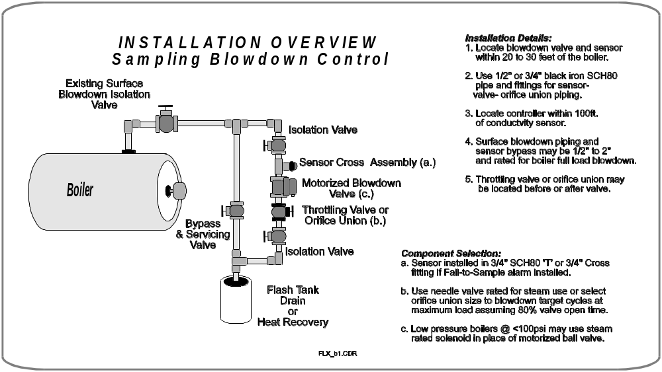

2.3 Sampling Blowdown Valve Installation
The preferred installation is as shown in the following graphic with the blowdown valve vertically so that piping heat is not convected to the valve.

The conductivity sensor, blowdown valve and throttling valve may be oriented vertically or horizontally. Lower pressure boilers, <100psi may use steam rated solenoids.

Very low pressure boilers, 10psi, are more sensitive to air blocking the sensors. Ensure that the sensor is installed in a ¾” ‘T’ and not in a the top of a 1” ‘T’ with a 1” x ¾” reducer.

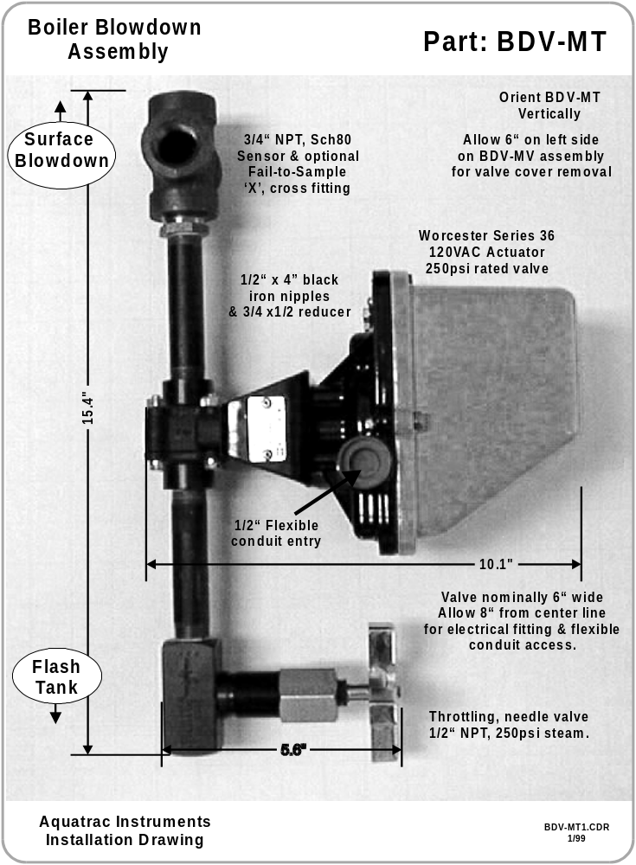

2.4 Continuous Blowdown Installation
Continuous boiler blowdown is used to blowdown boilers operating at pressure over 250 psi steam or at sites where a continuous blowdown is required for heat recovery. The conductivity sensors are usually installed downstream of a sample cooler with a continuous flow through the cooler.
The sensor is not sensitive to flow rate. Low rate streams may be used to limit boiler water usage.

Continuous boiler blowdown controllers, read the conductivity continuously, opening and closing the blowdown valve as the conductivity rises above & falls below the controller setpoints.

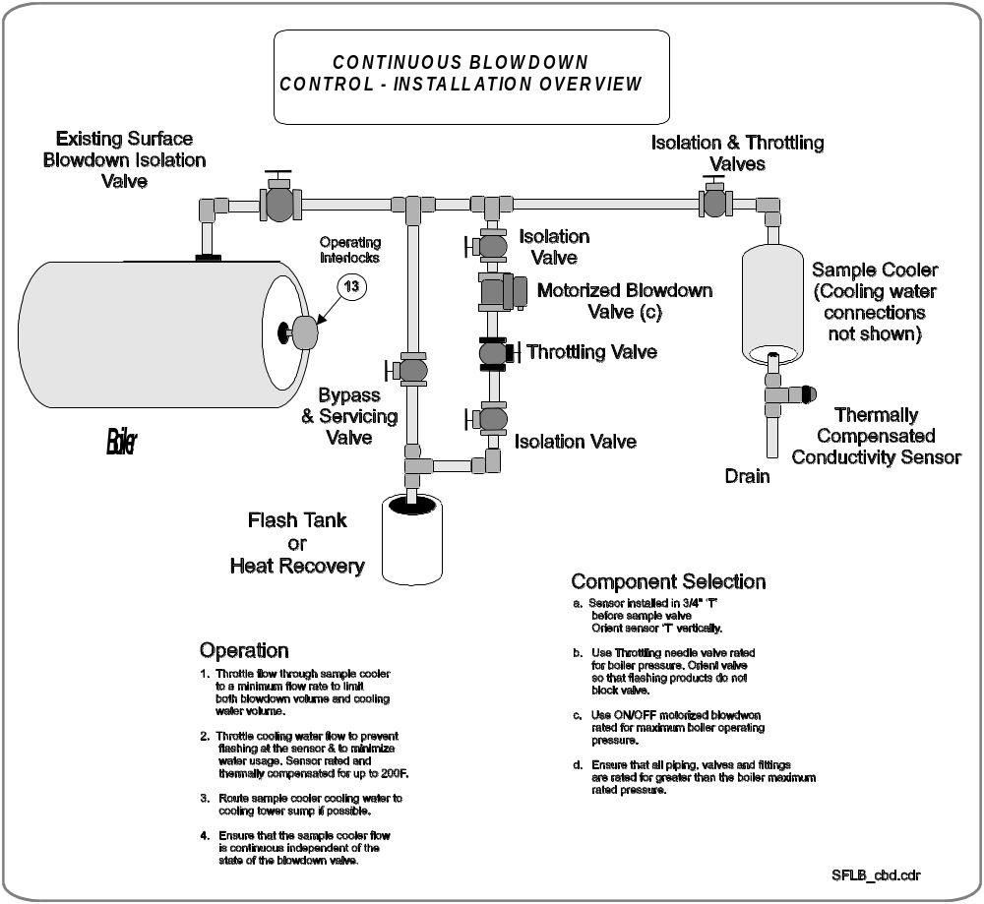

2.5 Wiring Motorized Blowdown Valves

Motorized blowdown valves require three 120VAC wires, Power OPEN, Power CLOSED and Neutral.
The following graphic shows field wiring for the Worcester Series 36 Actuator; the valve with the yellow cover that Aquatrac supplies with its’ blowdown assemblies. Wiring detail will vary with other valve vendors.

Steam rated solenoids require only Power OPEN and Neutral.

Fail safe sites may use spring return blowdown ball valves which are wired like solenoids.

Sites using continuous blowdown may use proportional valves controlled by a 4-20mA level

CAUTION: Do not wire Valve or Solenoid 120VAC power in the same conduit as conductivity sensors.

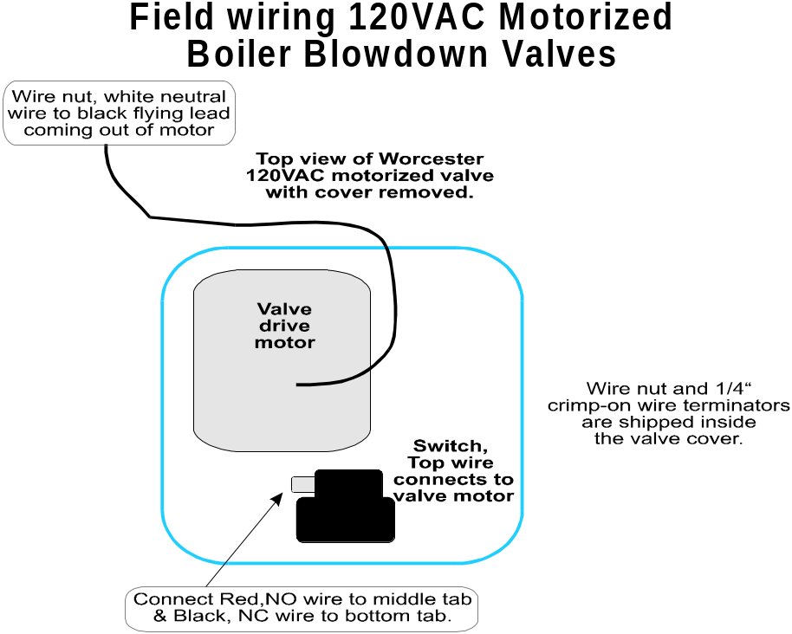
2.6 Cabling Sensors, Pumps, Valves, Solenoids, Meters ...

CAUTION ELECTRICAL SHOCK HAZARD
Unplug the controller before opening the controller enclosure
and installing or changing any wiring or cabling

CABLING RULES
Sensor and AC power cables must be installed in separate conduits.
Mixing sensor, valve and pump cables in one conduit will cause intermittent controller operating problems, false and unstable conductivity and pH measurements and overstated water meter readings.
Extending Sensor, Flowswitch and Water Meter Cables
All sensor, watermeter and interlock extension cables are twisted pair AWG16 to AWG24, shielded cable with the shields terminated to the enclosure grounding screws at the bottom, left of the enclosure. Shields are not grounded or terminated at the sensor end.
Extending Conductivity Sensor Cables
Conductivity sensor cables measuring conductivities greater than 5000uS may be extended up to 200 ft using AWG22 gauge twisted pair, shielded cable. Conductivities above 5000uS and below 10,000uS require AWG18 gauge cable at 200 ft. Cable gauge is selected to minimize the error due to the fixed DC resistance of the cable.
Extending pH Electrode Cables
pH electrode cables over 25ft/10m long are susceptible to noise pickup from lights and motors which appears as an unstable pH reading.

120VAC CABLING
Do not connect AWG14 & heavier seven stranded cable directly to the controller door terminal blocks.
Controllers are fused for AWG18 allowing you to butt splice AWG12-14 field wiring to AWG 18-16 before connecting to the door terminal blocks.

CONNECTING 7 STRAND CABLE TO DOOR TERMINAL BLOCKS WILL BREAK THE TERMINAL BLOCK OFF THE CIRCUIT BOARD

FRACTIONAL HORSEPOWER PUMPS
External motor starter rated relays are required for fractional horsepower, Milton Roy or Neptune chemical feed pumps. Connecting fractional horsepower pumps directly to the controller will fail the controller fuse and may fuse the power relay contacts closed.
The 120VAC coils of the starter relays, located in an external enclosure, are powered by the Flex and AS series controller relays.

DO NOT power fractional horsepower pumps from the same AC circuit breaker that feeds the controller.

ROUTING USER INSTALLED CABLING
User installed sensor cabling must be routed away from 120VAC cabling. The central set of
cabling clips on the Flex backplate are provided for sensor, flow switch and water meter cables.
Ensure that when the enclosure door opens and closes the sensor cable falls to the right hand side of the enclosure.
Use the left hand set of cable clips for AC power cables.

2.7 Terminal Block Locations
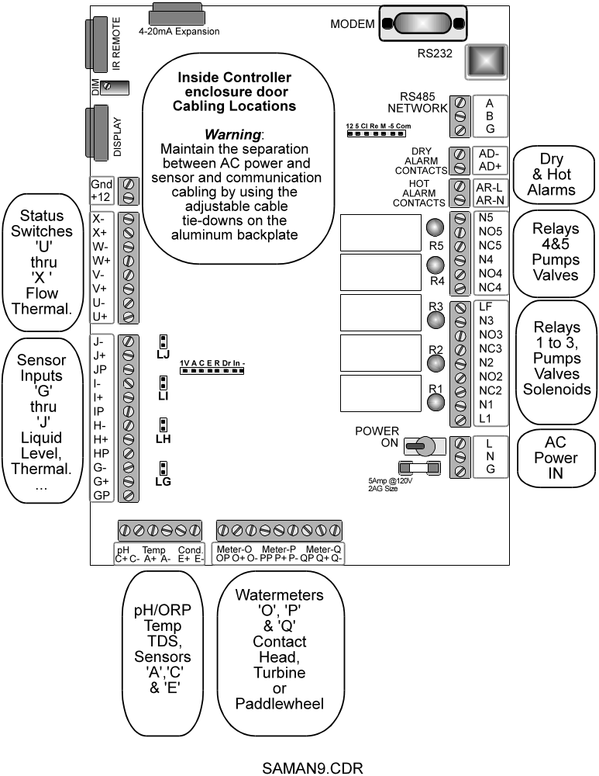

2.8 Connecting pH Sensors
Route the electrode cabling across the bottom of the terminal blocks, away from 120VAC pump, valve and solenoid cables. Coil extra sensor cable at the sensor, not in the controller enclosure.
Controllers with more than one pH sensor; connect the extra sensors to modules in the
back of the controller enclosure – See Appendix D.

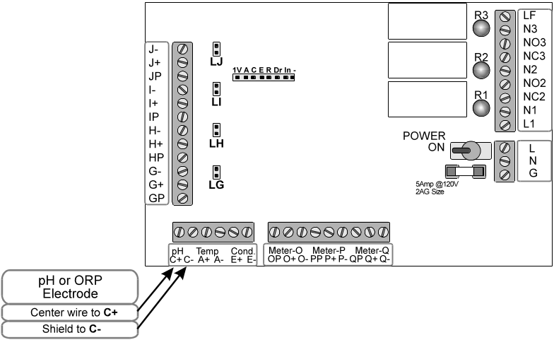

2.9 Connecting Conductivity-Temperature Sensors
Controllers with more than one conductivity sensor; connect the extra sensors to modules in the back of the controller enclosure – See Appendix D.

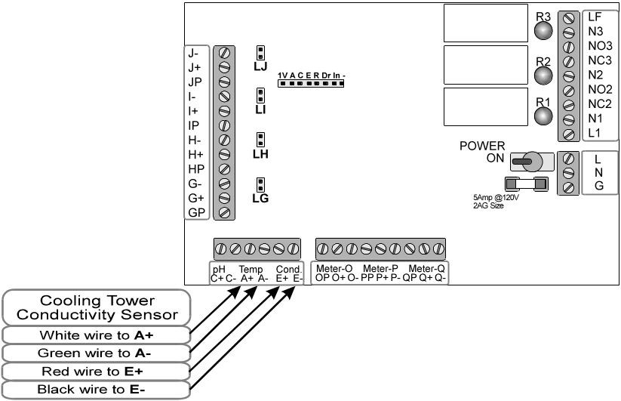

‘AS’ series controllers allow direct connection of one conductivity sensor to the controller.
Additional conductivity sensors require a sensor driver board either located on a sub-panel within the
enclosure or in an external enclosure.

NOTE: Continuous blowdown Boiler sensors installed on sample coolers which directly connect to the controller use electronic temperature sensors for compensation Part# A261016.
Added conductivity sensors using thermistor compensation are Part# A261017.
Direct Connect and Additional conductivity sensors are therefore NOT interchangeable.
Sampling Boiler Conductivity Sensors are interchangeable and are Part A261000 for boilers rated 250 psi & below.

2.10 Connecting Watermeters
Water meters require software configuration the set the gallons per contact or the ‘K’ factor for turbines and paddlewheels.

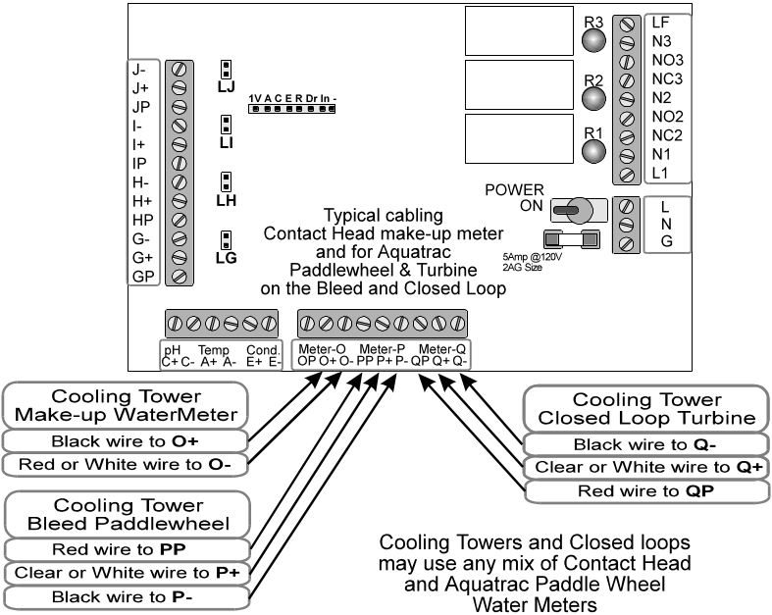

CONTACT HEAD WATER METERS WIRING
Cable the two conductor meter cables to any two of the terminals labeled
O+ & O-, P+ & P- and Q+ & Q-.

TURBINE & PADDLEWHEEL METER WIRING
Cable the three wire sensors to the any of the three connections labeled
P(12VDC Power), + (Signal) & - (Common or Ground)
Color coding varies with manufacturer.
Aquatrac paddlewheel water meters connect Red to P, White to + and Black to -.
The scaling factor printed on the side of the meter is Pulses per Gallon
Osmonics turbine meters connect Red to P, Black to + and White to -.

WATER METER SOFTWARE CONFIGURATION.
TRACKSTER or the TV Remote keypad can be used to convert water meter signals into Gallons, liters, cubic feet .....
The TV Remote uses the CALIBRATION menu where SCALE and ‘K’ Factor are used.

Meter | TV Remote Keypad | Trackster | ‘PA’ Command
Contact Head  100 Gallons/Contact  Connected to ‘O’ | Parameter ‘O’  Scale = 0  ‘K’ Factor = 100 | Parameter ‘O’  GAIN = 100  SCALE = 0 | PAO, Tower1 Make-up,  100,0
2” Osmonics Turbine  No scaling on sensor  Connected to ‘P’ | Parameter ‘P’  Scale = 75  ‘K’ Factor = 5 | Parameter ‘P’  GAIN = 5  SCALE = 75 | PAP, Tower1 Bleed,  5,75
1” OsmonicsTurbine  No scaling on sensor  Connected to ‘S’ | Parameter ‘Q’  Scale = 120  ‘K’ Factor = 2 | Parameter ‘Q’  GAIN = 2  SCALE = 120 | PAQ, Boiler Make-up  2,120
Aquatrac Paddlewheel connected to ‘Q’  In a 4” Line,  Sensor Label = 18 | Parameter ‘Q’  Scale = 90  ‘K’ factor = 5 | Parameter ‘Q’  GAIN = 5  SCALE = 90 | PAQ, Process Flow,  5,90
Aquatrac Paddlewheel connected to ‘O’  In a 1” Line,  Sensor Label = 30.8 | Parameter ‘O’  Scale = 154  ‘K’ factor = 5 | Parameter ‘O’  GAIN = 5  SCALE = 154 | PAO, Process Flow,  5,154

Note: GAIN = Gallons per Contact or Gallons pre SCALE pulses
SCALE = Sensor factor, Pulses/Gallon for turbines and paddlewheels
Must be less than 255. If Sensor Factor > 255, correct by increasing gain.
Example: Sensor Factor = 1000, therefore SCALE = 200 & GAIN = 0.2
2.11 Connecting 4-20mA Sensors and Liquid Level Sensors

Loop powered Liquid Level sensors and other loop powered 4-20mA sensors connected to inputs ‘G’ through ‘J’ require that configuration headers ‘LG’ thru ‘LJ’ be jumpered.
These jumpers terminate the current loops with 50 ohms, converting the current loop to a
measurable voltage.

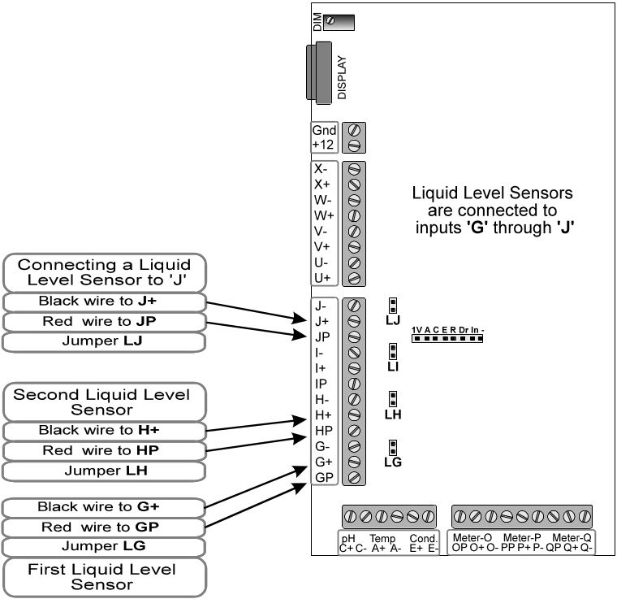

AQUATRAC extra sensor modules mounted on the controller backplate may be connected to inputs ‘G’ through ‘J’. An LG thru LJ jumper must be removed only on the analog input which connects to the backplate module. Jumpers on module inputs are removed by Aquatrac if an extra sensor module is supplied with the controller.

2.12 Connecting Operating Interlocks and Fail-to-Sample Switches

Boiler blowdown interlocks are shipped jumpered. Boiler No.1 Interlock is usually input ‘U’,
No.2 on ‘V’ …
Power up your controller and scroll through the installed parameters. If you are using the FV, Fail-to Sample Option, you’ll view the controller inputs ‘U’ to ‘X’, which are used Fail-to-Sample wiring.
Inputs ‘U’ to ‘Z’ are dry contact inputs which display ON when the contacts are closed.

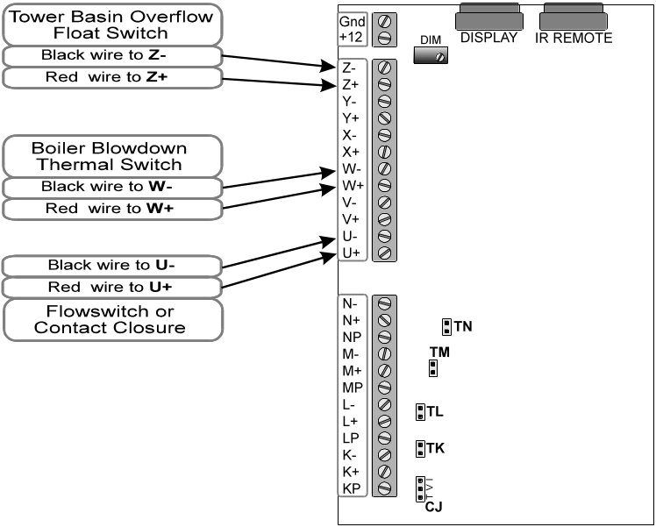

Any switch or dry contacts which close to indicate an operating state may be connected to Status inputs ‘U’ thru ‘Z’.

WARNING-DRY CONTACTS
Only ‘Dry’ contacts may be connected into Status Inputs. ‘Dry’ contacts do not have any DC or AC voltage connected through them by whatever supplies the contacts, a motor starter, a PLC etc.
Contacts with 120VAC or 24-48VDC on them will fail the controller catastrophically.
If you’re not sure check the contacts in both the open and closed state with a digital voltmeter on both AC and DC volts ranges.

2.13 Connecting AC Power, Solenoids and Pumps

CAUTION ELECTRICAL SHOCK HAZARD
Unplug the controller before opening the controller enclosure
and installing or changing any wiring or cabling

Relays 1 thru 5 switch the 120VAC power fused by the 5 Amp controller fuse. When the Relay NO (Normally Open) contact is powered, the R1 to R5 neon indicator is ON.

Typical LMI and PulsaFeeder chemical feed pumps plug into the controller plug box enclosures
or connect directly to the Relay terminal blocks.

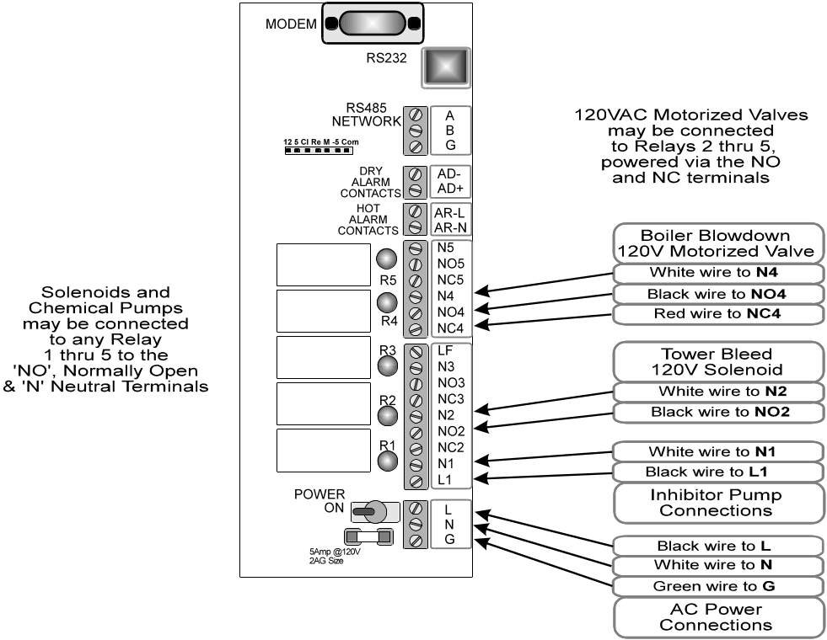

Do not operate the controller ungrounded. An AC power safety ground is required both to meet electrical codes and for measurement accuracy. An ungrounded controller will fail FlexNET communications.

CABLING CAUTION: Do not connect seven strand AWG14 cable directly to the controller terminal blocks. Bridged strands and loose connections will result. Use either a butt splice to stranded AWG 18 or use multiple stranded AWG14. Controller fusing is code compliant using AWG 18 cable.

2.14 Connecting Alarms and Motorized Valves

CAUTION ELECTRICAL SHOCK HAZARD
Unplug the controller before opening the controller enclosure
and installing or changing any wiring or cabling

120VAC Motorized valves require three wires, Power Open ( Labeled NO ), Power Close
( Labeled NC ), and Neutral ( Labeled N ).

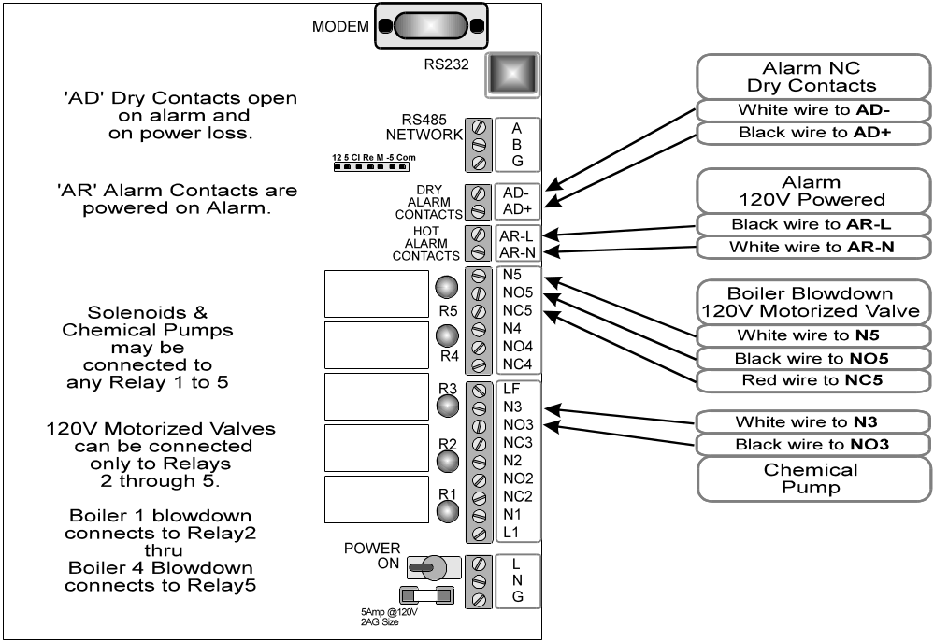

ALARMING PUMPS & VALVES
Sensors, watermeters and interloks can cause dial-outs and alarm relay trips but they will NOT turn OFF relays. Only one-time actuation or daily time-outs can turn OFF relays controlling pumps & valves.

2.15 Connecting a Serial Cables, Telephone Modem or Controller Network

RS232 Serial Connections
Controllers with the R2 option can be connected to a notebook PC for a monthly or weekly system check and report download. Controllers can also be continuously connected to an on-site PC using the RS232 port on the right side of the controller enclosure.

Continuous connection to an on-site PC does not prevent controller Modem access

The controller communicates at 9600 Baud, which limits serial cable length from 100 to 250ft. depending on cable type. Longer distances require RS232 to RS422 converters at both ends of the serial cable. RS232-422 converters are available from AQUATRAC INSTRUMENTS.

Connect a DB9 male cable to the DB9 female connector on the right, top side of the controller enclosure.
The RS232 cable may be extended up to 250ft. to a remote PC by connecting Pins 2 to2, 3 to 3 and 5 to 5 and each end of the DB9, male-female cable

Telephone Modem
Controllers with the RM option can be connected to a telephone line and remotely monitored and controlled.
A telephone service similar to one required for a FAX or an extension on the existing telephone system which allows direct modem connection is all that’s required.
Have the telephone service terminated in a modular jack beside the controller enclosure and route a telephone cable with male jacks on both ends between the modular jack and the LINE modem jack.

Do not plug a telephone service into the telephone jack on the door mounted circuit board.
Controller failure will occur. This connector is not use for telephone-modem communications.

Controller-to-Controller FlexNET Cabling
Controllers with the NT option can be linked together in master-slave networks. If your controller has the NT, networking option, the FlexNET manual will be included with this operating manual within the same binder.
Daisy chain a single pair, shielded AWG22 cable between all of the controllers in the network.

Controller-to-LAN Ethernet Cabling
Controllers with the LN option can be directly connected to a 10BaseT, TCP-IP Ethernet LAN. If your controller has the LN option, a serial port-to-LAN converter will be installed in the back of the controller.

Before cabling into your LAN, connect serially to the LAN converter using Trackster LN and set the IP address to the one provided by the site network administrator.
Do not connect to the site LAN without setting the IP address.
An address conflict may fault the LAN, making you very unpopular.
3. COMMISSIONING

3.1 Set-up the controller
After you’ve connected the blowdown valve, water meters and sensors to the controller, plug in the controller but don’t connect chemical pumps until you’ve set-up the controller.

See Appendix ‘B’ for the TV Remote keypad navigation and key functions.

1. GET YOUR TV REMOTE PASSWORD
Open the controller enclosure.
The controller passwords are on a removable sticker on the enclosure, hinge side sidewall
The three digit Level 3 password is 123 and allows viewing of operating levels only.
The six digit Level 2 password is 123456 and is required for setpoint adjustment.

2. SIGN ON USING THE REMOTE KEYPAD
Press Power followed by the six digit password & Enter,
You’ll see Password Verified. Level 2 access
Press Enter & use channel up & down to scroll through all the sensors, water meters, valves and solenoids.

3. CALIBRATE SENSORS AND WATER METERS
Press Enter again & you’ll be at the top of the main menu, ADJUST SETPOINTS?
Press Channel DOWN until Calibrate Sensors? is displayed, then press Enter
Calibrate your Conductivity, pH, temperature and level sensors and water meters by using Channel UP & Channel DOWN to scroll through all of the installed sensors.

WARNING: Calibrating Sampling boiler blowdown sensors opens the blowdown valve to obtain a sample of boiler water

Key Enter to select the desired sensor or water meter.
Press Enter at the Key Current Value? to single point calibrate; recommended for most sensors and required for sampling boiler sensors.

See Section 4.10 for calibration details on each sensor type.
Refer to Section 4.10, Calibrate Sensors for details on water meter set-up.
Press Enter to accept your Calibration then Power to end Calibration.

4. ADJUST YOUR SETPOINTS
Adjust Setpoints ? is the top of the menu. When it’s displayed, press Enter
Set your Conductivity, pH, inhibitor pump setpoints by using Channel UP & Channel DOWN to scroll through all of the controller outputs.
See Section 2.2 for Setpoint adjustment details.
Press Power to end Adjust Setpoints.

5. SET UP BOILER BLOWDOWN / Sampling Boiler Blowdown Only
Press Channel UP until Adj. Boiler Timing? is displayed, then press Enter
Select each boiler blowdown relay by using Channel UP & Channel DOWN then press Enter
You’ll be asked to key in four times:
Sampling Time, typically 30 seconds.
Wait-to-Measure, typically 60 seconds. Re-calibration is required any time you change this time.
Blowdown Time, typically 30-240 seconds.
Re-Sample Time, anywhere from 5 minutes to 600 minutes, typically 15-45 minutes
Press Power to escape Boiler Timing.

6. SELECT YOUR INHIBITOR CONTROL MODE
Press Channel UP until Adjust Inhibitor ? is displayed then press Enter
Use Channel UP & DOWN to scroll through all relays which control inhibitor pumps, then press Enter
to select your Inhibitor Pump.
You can choose from Bleed & Feed, Bleed then Feed, Water Meter and Percentage Time for inhibitor feed control. See Section 4.14 for Inhibitor Feed details.

7. ADJUST ALARMS
More Information: The controller response to alarms is detailed in Section 4.7
The controller has time-out, feed limit alarms set on start-up.
If you’re feeding acid or inhibitor based on make-up you’ll want to adjust these alarms.
Press Channel UP until Adjust Alarms ? is displayed, then press Enter
Select which alarm by using Channel UP & Channel DOWN to scroll through each sensor and relay.
Key in new HI and LOW alarm setpoints and Enter
Press Power to escape Alarms.

8. PRIME PUMPS
CAUTION: Pumps will turn ON. Verify that all pump tubing is connected and sealed
& that electrical connections are completed BEFORE continuing.
Plug chemical pumps into the power box at the end of the blue conduit.
Press Channel UP until Prime Pumps ? is displayed, then press Enter
Select which pump by using Channel UP & Channel DOWN to scroll through each relay & press Enter to turn ON for 5 minutes.
Verify that the selected pump is primed and pumping.
Interlocked and Alarmed pumps will not turn ON until the interlock relay(s) turn OFF or the Alarm is cleared.
If you try to prime a pump that’s interlocked with a contact set or another relay, you’ll see a message
displayed on the LCD telling you why a prime cannot occur.
Priming can be stopped by using Channel UP to scroll to Clear Alarms ? , pressing Enter twice.

Use Clear Alarms to force a Sampling Boiler Blowdown valve to Sample.
Continuous controller valves can use Prime Pumps.
11. SET-UP’S COMPLETE
Your controller’s operating.
Review Sections 4.1 & 4.11 to verify that water meters are measuring correctly and that conductivity and/or pH are controlling.

3.2 QUIK OPERATE
This section is a limited overview
For detailed instructions see Section 4

3.2.1 View what’s happening now
The display will scroll through all of the operating sensors, water meters, pumps and valves, updating the screen every 5 seconds. The TV remote keypad may be used to select a parameter and to access the main menu.

1. SIGN ON USING THE REMOTE KEYPAD
Press Power followed by the six digit, 123456 password & Enter then Enter again to get to
Adjust Setpoints? the top of the menu. See Appendix ‘B’ for the full menu.

2. SELECT WHAT INTERESTS YOU
Press Channel DOWN & Channel UP to scroll through all the parameters and relay displays.
Parameters are A through N are conductivity, pH, temperature and liquid level sensors.
Enabled sensors are displayed:

Boiler1 Conductivity  2886. uS E | Sensor Description  Current Value Units Connection Point

Parameters are O through Q are water meters. Active water meters are displayed on the screen:
Boiler Feedwater  58300 Gal O | Meter Description  Volume Today Units Connection Point

Parameters are U through X are interlocks or fail-to-sample inputs.
Active interlocks are displayed on the screen:
Boiler 2 Interlock  ON 427.8 V | Interlock Description  State ON|OFF On Time,Minutes Connection Point

ON for an interlock means the blowdown valve is enabled.
On Time in measured from midnight OR time since alarms cleared.

Relays 1 through 5 power chemical pumps and valves
Active relays are displayed on the screen:
Amine Pump  ON 12.6 249.3 1 | Pump, Valve or Solenoid Description  ON|OFF ON Time Minutes Today Relay #

ON Time is the minutes ON this actuation. An inhibitor pump could be ON for 2 minutes every 500 gallons of make-up. A blowdown valve could be ON typically for 0.5 minutes
Minutes Today is the number of minutes ON since mid-night.

Each selected display will remain on the screen for 5 minutes unless Channel DOWN & Channel UP or Power is pressed
Press Power to exit. If no key is pressed for 5 minutes, exit occurs automatically

3.2.2 Adjust a Setpoint

1. SIGN ON USING THE REMOTE KEYPAD
Press Power followed by the six digit password & Enter then Enter again to get to
Adjust Setpoints?, the top of the menu. See Appendix ‘B’ for the full menu.

2. ADJUST YOUR SETPOINTS
Adjust Setpoints? is top of menu & will display first. Key Enter
Select a pump or valve setpoints by using Channel UP & Channel DOWN.

Boiler Treatment  Adj=Enter Now=Prev 1 | Key Enter to change setpoints OR  Key Previous or Last to view current setpoints
Key Power to escape

CURRENT SETPOINTS DISPLAY
Typical Inhibitor Pump
250 Gal VOL  45 Sec ON 1 | Gallons of Feedwater measured before  Seconds ON pump run time  Relay#1

Typical Blowdown Valve
3600 uS ON  3590 uS OFF 2 | Turn ON the blowdown at this conductivity  Turn OFF the blowdown at this conductivity  Relay#2
Press Power to escape

ADJUST SETPOINTS / CHEMICAL PUMPS
14 Sec ON 1 | Key in pump run time in seconds then key Enter  Use Previous or Last to backspace  Key Power to escape

125 Gal VOL 1 | Key the make-up volume to be measured before run time occurs then key Enter  1 is the Pump Relay# Key Power to escape

ADJUST SETPOINTS / BLOWDOWN VALVE
2850 uS ON 2 | Key in valve turn ON setpoint then key Enter  Use Previous or Last to backspace  Key Power to escape

2840 uS OFF 2 | Key in valve turn OFF setpoint then key Enter  2 is the valve Relay#  Key Power to escape
If you wish to leave a setpoint unchanged,
Key Channel Down or Channel Up to go to the other setpoint.
Key Power to escape all setpoint displays.
3.2.3 View what’s causing an alarm

1. SIGN ON USING THE REMOTE KEYPAD
Press Power followed by the six digit password & Enter then Enter again to get to
Adjust Setpoints?, the top of the menu. See Appendix ‘B’ for the full menu.

2. VIEW ACTIVE ALARMS – only displayed if there are alarms
Press Channel UP until View Active Alarms? is displayed, then press Enter
View each active alarm by using Channel UP & Channel DOWN.

Boiler4 Conductivity  LO 584 uS I | Display the name of the parameter, HI or LO, current value (584) ,units (uS) and connection point (I)  Key Channel Up or Down
Key Power to escape

3. CLEAR ALARMS
From Adjust Setpoints?, key Channel UP until Clear All Alarms? is displayed, then press Enter

Clear all Alarms?  Y=Enter N=Mute | Clearing alarms, samples all boiler conductivities, clears all owed time on chemical pumps, ends priming. KeyPower to escape
Note: Clearing an alarm without correcting the problem which caused the
alarm will cause the alarm to recur.

3.2.4 Calibrate a Sensor
1. SIGN ON USING THE REMOTE KEYPAD
Press Power followed by the six digit password & Enter then Enter again to get to
Adjust Setpoints?, the top of the menu. See Appendix ‘B’ for the full menu.

2. CALIBRATE YOUR SENSORS AND WATER METERS
Press Channel DOWN until Calibrate ? is displayed, then press Enter
Select the sensor to calibrate by using the Channel UP or Channel DOWN & Enter

Boiler2 Conductivity  CAL=Enter NOW=Prev G | Key Enter to Calibrate or Channel UP or DOWN to view other sensors & watermeters. Key Previous for current calibration parameters. Power to Escape

Use the ‘Current Value’ to calibrate boiler conductivities, pHs and temperatures.
Condensate sensors and all other sensors require two operating points for calibration.

Key Current Value?  YES=Enter NO=Mute | Key Enter to single point calibrate.  Key Mute for 2 point calibration.  Power to Escape

WARNING: Sampling boiler blowdown controls will open the blowdown valve & Sample as soon as you key Enter

Key Value & Enter  _? uS E | Key sensor value then key Enter .  Key Mute for decimal point and Prev for backspace.  Power to Escape
Displays current units and sensor connection location, A to T

All sensors but Sampling Boiler Blowdown Conductivity Sensors:

- Offset  4.354 Gain E | Key Enter to accept or Power to abandon  See Section 4.10 for expected offsets & gains for each sensor type.

Sensor Calibrated | After Enter you’ll see this display.  Key Power to clear this display.

Sampling Boiler Blowdown Conductivity Sensors:
Immediately after you key in the current boiler conductivity
- The blowdown valve will open for the user set Sampling time, typically 30 seconds & the controller will count down to 0 seconds.
- The valve will then close for the user set Wait-to-Measure time, typically 60 seconds, & the controller will count to zero and then negative until it acquires a new reading.
- The controller then calculates and displays the revised sensor Gain & zero Offset. Key Enter to Accept or Power to reject.
4. CONFIGURING

4.1 CONTROLLER DISPLAY
Before you sign onto a controller, the LCD will display a new value every 5 seconds.
On Power ON you’ll see an alarm status screen, followed by a software version screen followed by:

Installed & Enabled sensor display:
Boiler3 Blowdown  4836 uS H | 1st Line = the name of the sensor  2nd Line = current value, units & field wiring  location ‘A’ to ‘J’

Installed & Enabled water meter display:
Softened Make-up  26410 Gal O | 1st Line = the name of the water meter  2nd Line = volume from midnight, units  & field wiring location ‘O’ to ‘Q’

Installed & Enabled interlocks, fail-to-sample switch, liquid level switch --or dry contact display:
Boiler1 Interlock  ON 426.2 U | 1st Line = the name of status input  2nd Line = ON or OFF, Minutes ON or OFF  & field wiring location ‘U’ to ‘Z’

Installed & Enabled chemical pump, solenoid or valve :
Boiler Treatment  ON 6.9 1012.3 1 | 1st Line = the name of chemical pump or valve  2nd Line = ON or OFF, Minutes ON this time, Minutes  ON from midnight & power relay # ‘1’ to ‘5’

The scrolling displays show you what’s happening now with the controller and where the various sensors, water meters, interlocks, pumps and valves-solenoids are connected within the controller.

ACTIVE ALARMS
An alarm status screen is displayed on the LCD display as it scrolls.
You can select not to scroll the display on alarm. Refer to the ADJUST SITE SETTINGS? Menu option.

Alarm Display
20:07:14 DAY#12 FRI  Alarms:SysCQ3 1 | 1st Line = Current Time, Biocide Timer Day# &  Day of Week  2nd Line = ‘None’ if no alarms

Each parameter and relay, which alarms is designated by its letter or number.
This example shows alarms on the System, the sensor connected to C, the water meter connected to Q and the pump connected to relay 3.
Only relay time-out alarms can prevent pumps & valves from operating
A System alarm displays as SYS & a Network Slave alarm displays as NET

4.2 ‘TV’ REMOTE KEYS & PROGRAMMING

SAFETY : LCD DISABLED
The LCD & remote keypad are disabled during RS232, Ethernet and modem communications.
Display off because COMPUTER is attached appears on the LCD.
Staff at the controller is alerted that pumps may be turned ON or solenoids activated and local commands cannot conflict with remote commands, confusing both local & remote operators.

KEY SUMMARY

KEY | SYMBOL | FUNCTION
Power |  | Attention Press for password entry  Escape Abandon current entry and return to previous menu.  Exit Command mode & return to 5 second scrolling.
Enter |  | Yes Execute the displayed menu option.  Execute Enter the displayed numbers as a new Setpoint,  Date ,Time, Alarm Level etc.....
Mute |  | No Don’t execute the displayed menu option  & display the next option .  Decimal Keys decimal point in Setpoints & Alarms.
Previous  Or  Last |  | Display the current Setpoint, Biotimer data, Alarm level etc...  Backspace or Erase on keying numbers.  Rcl, Last & Previous keys provide the same function on different Universal remotes.
Channel UP | ⬧ | Display the next Parameter from A thru X and then relay 1 thru 5.  Show the previous menu option.
Channel DOWN | ⧫ | Display the next Relay 5 thru 1 and then Parameter X thru A.  Show the next menu option
Volume UP | + | +Sign Make the Setpoint positive  +Scroll Scrolls up thru weekdays on Date & Time set.  Scrolls up thru Biotimed Events on each Relay.
Volume DOWN | - | -Sign Make the Setpoint negative  -Scroll Scrolls down thru weekdays on Date & Time set.  Scrolls down thru Biotimed Events on each Relay.
Numeric | 0 - 9 | Numeric entry for Setpoints, dates, times, alarm levels etc...
TV |  | Press if no response to initial Power key press

TURNING ON THE KEYPAD
Press Power If no response, press TV then Power.
If no response, verify that the power light turns ON when a key is pressed, if not replace remote’s batteries.
If controller still does not respond, then verify generic remote is correctly programmed, see PROGRAMMING A REMOTE which follows.

Screen responds with password prompt
VIEW ONLY Key the three digit OBSERVER Level 3. password then press Enter
ADJUST Key the six digit OPERATOR Level 2. password then press Enter

SCROLLING & HOLDING
After you have keyed the password and the ENTER key Press Channel Up or Channel Down to rapidly scroll through a maximum of 14 sensors, interlocks & fail-to-sample and watermeters and 5 Relays
.
SELECTING THE MAIN MENU
Press Enter twice at any time after keying in the password or once while scrolling through the parameters and relays.

TURNING OFF THE KEYPAD
Keep pressing Power to exit. The Controller will respond with Goodbye
The controller will automatically exit after five minutes without a key press and return to scrolling thru all enabled relays and parameters, updating every 5 seconds.

PROGRAMMING A REMOTE
SMART Flex series controllers will work with generic remotes programmed for the most common SONY TV’s.
Follow the TV set-up instructions provided with your generic remote starting with the first listed SONY TV code.
Press the Power button after programming, if you view the password prompt, you’ve programmed the remote correctly.
If not, reprogram the remote with the second & subsequent SONY TV codes.

Although all generic remotes do not have an Enter key, they will have a key, which provides the Enter function. Similarly the Previous key may be labeled Last or Rcl (Recall).

CHANGING BATTERIES
Some versions of TV remotes will require re-programming after changing batteries.

INTERNET SUPPORT
www.aquatrac.com displays pictures of every type of TV remote shipped with the controllers.
Select the SETUP key on your remote picture and you’ll see the SETUP instructions and codes.

If the controller fails to respond to a previously working TV remote keypad,
Press the TV button, then the POWER button.

If the VCR, CD or AUX buttons are accidentally pressed, the generic remote will not talk to the controller.

4.3 MAIN MENU OPTIONS

After keying the password & Enter, key Enter again & you’ll be at the top of the MAIN MENU,
Press Power to Escape at any time.

ADJUST SETPOINTS? is the top of MAIN MENU. You’ll return to this screen if you key Power.
More than one Power key may be required to return if you are deep into sub-menus.

ADJUST SETPOINTS?  Y=Enter N=Mute | Set & Adjust ON-OFF for pumps and solenoids.  View current settings.
⬧  Press Up or Down Channel for next function

VIEW ACTIVE ALARMS?  Y=Enter N=Mute | Only displayed if there are active alarms
⧫ or Press Up Channel  for previous option

CLEAR ALARMS?  Y=Enter N=Mute | Ends biocide timing, lockouts & prebleeds.  End Priming and owed time on inhibitor pumps.  Samples for sampling boiler blowdown controls
⧫ or Press Up Channel  for previous option

ADJUST ALARMS?  Y=Enter N=Mute | High and low alarms on sensors  Feed limit timers on pumps and limit alarms on solenoids
⧫ or Press Up Channel  for previous option

ADJUST DATE & TIME?  Y=Enter N=Mute | Clears controller data logs.  Resets biocide Day #1 to most recent Sunday
⧫ or Press Up Channel  for previous option

CALIBRATE SENSORS?  Y=Enter N=Mute | Single point conductivity, pH & Temperature  Set water meter gallons/contact or pulses/gallon  Adjust tank levels.
⧫ or Press Up Channel  for previous option

VIEW WATER METERS?  Y=Enter N=Mute | Gallons to date for this year and last year.
⧫ or Press Up Channel  for previous option

ADJ.BOILER TIMING?  Y=Enter N=Mute | Displayed if sampling boiler blowdown active.  Adjusts and displays current sample, wait-to-measure, blowdown and re-sample times.
⧫ or Press Up Channel  for previous option

PRIME PUMPS?  Y=Enter N=Mute | Adds 5 minutes of ON time to a pump.  Use CLEAR ALARMS to end.  Displays fault message if no flow or interlocked.
⧫ or Press Up Channel  for previous option

BIOCIDE LOCKOUT?  Y=Enter N=Mute | Prevents bleed after biocide feed OR  Pre-bleeds before biocide feed.  Rare in boiler controllers, used for timed feeds
⧫ or Press Up Channel  for previous option

ADJUST BIOTIMING?  Y=Enter N=Mute | Set start day 1-28, start time 00:00 to 23:59 and ON time to 0-255 minutes.  Not displayed if biocide timers not installed
⧫ or Press Up Channel  for previous option

INHIBITOR CONTROL?  Y=Enter N=Mute | Select Feed on Meter OR Bleed & Feed OR Bleed then Feed OR % of every 5 Minutes.
⧫ or Press Up Channel  for previous option

ADJUST 4-20mA LOOPS?  Y=Enter N=Mute | Adjust & view 4mA and 20mA spans  Not displayed if 4-20mA outputs not installed
⧫ or Press Up Channel  for previous option

ADJ.ENABLED PARAMS?  Y=Enter N=Mute | Turn ON & OFF unused sensor inputs and pump & valve outputs.  View current state; ENABLED or DISABLED
⧫ or Press Up Channel  for previous option

ADJ.SITE SETTINGS?  Y=Enter N=Mute | Views installed options, serial number  & software version.  Turn ON upgrades.
⧫ or Press Up Channel  for previous option

VIEW BOILER STATUS?  Y=Enter N=Mute | Current state for each boiler: Sampling, Wait-to-Measure, Blowdown, Re-Sample.  Displayed only if Sampling Boiler controls active.
⧫ or Press Up Channel  for previous option
4.4 ADJUST SETPOINTS?
Operator password level.
Displayed whenever you key Enter at the ADJUST SETPOINTS? Main menu option
Press Power to Escape this menu

BOILER TREATMENT  ADJ=Enter NOW=Prev 1 | Key Enter to change setpoints  Key Prev or Last to view current settings
⬧  Press Up or Down Channel for next pump or valve

BOILER1 BLOWDOWN  ADJ=Enter NOW=Prev 2 | The number ‘2’ indicates that this setpoint controls relay No.2
⧫ or Press Up Channel  for previous pump or valve & scroll through all setpoints

ADJ=Enter SUB-MENUS
Displays ON then OFF Setpoints.
Press Enter to execute new Setpoint or Press Power to Escape Sub - menu

ADJUSTING ON – OFF SETPOINTS
Bleed solenoid opens at ON and closes at OFF conductivity.
BOILER2 BLOWDOWN  ___4500.___uS ON 3 | Key in a new ON value, using Mute key for decimal point and Previous key for erase or backspace & then Enter.

BOILER2 BLOWDOWN  ___4490.___uS OFF 3 | Key in a new OFF value & Enter to execute.  Key Power to escape changing the setpoint.

ADJUSTING PUMP TIME & VOLUME
After setpoint Gallons are measured, chemical pump turns ON for setpoint seconds.
BOILER TREATMENT  _25 SEC ON 1 | Key in a new ON time in seconds, using Previous key for backspace & then Enter.

BOILER TREATMENT  _156 GAL VOL 1 | Key in a new make-up volume in gallons, using Previous key for backspace & then Enter.

PRESS ENTER KEY TOO OFTEN OR KEY A ZERO SETPOINT
Setpoint is now 0!  Power=NO Mute=YES | The controller will prevent you from entering an accidental zero setpoint unless you key Mute

NOW=Prev SUB-MENU - Displays current SETPOINTS

___2500.___uS ON  ___2490.___uS OFF 3 | Key Power to return ADJUST-NOW option.  ‘3’ is the Relay# controlled by these setpoints.

4.5 ADJUST BIOTIMING?
Operator password level.
Displayed only if Chemicals fed on time exist in your controller
.
BIOCIDE B  ADJ=Enter NOW=Prev 4 | Key Enter to adjust biocide timing or Previous to view current biocide timing.  ‘4’ is the Relay# controlled by this biotimer
⧫ Press Down Channel for next biocide or Power to escape
If the controller has only one biocide, the Down Channel key will not change the display

TIMED BIOCIDES NOW=Prev DISPLAY
BIOCIDE B  DAY_4 13:30 _90min 4 | Day#1 is always Sunday.  Feeds starting at Wed. 1:30PM for 90 minutes.  ‘4’ is the Relay# controlled by this biotimer
⧫ or Press Up Channel  to view all preset events on this Biocide or Power to escape

TIMED BIOCIDES ADJ=Enter SUB-MENUS
BIOCIDE B  1-Add 2-Del 3-Edit 4 | Key 1 to add another event, 2 to delete an event or 3 to edit an existing event.  Key Power to escape this display

1-Add Sub-Menu
BIOCIDE B  Day2 02:30 25Min 4 | Use Channel UP or DOWN to edit and Volume UP or DOWN to move back & forth across the screen.  Key Enter once event is set or Power to Escape

Day 1 is Sunday. Controllers are shipped with 28 Day biocide timers.
Days 1,8,15 & 22 are the Sundays of weeks one to four.
The start time is 24 hour military format so 16:00 is 4:00PM.
The duration, biocide pump operating time, is set in minutes.
1-Add Sub-Menu continued

28 Day BioTiming Cycle – Repeats Every 28 Days: Factory Default
If you key Enter, you’ll have the option of selecting the number of times in 28 days the biocide event occurs:
1)Weekly 2)Alt.Weeks  3)AltDays4)Once | Key 1,2,3 or 4 to select how often you wish the feed event to occur. Key Power to Escape

FEEDING WEEKLY
Key 1 and a feed event will be programmed for the selected day & time in weeks 1 to 4.
ALTERNATING BIOCIDES
Key 2 and a feed event will be programmed for the selected day and for 14 days later.
Example: Feed Biocide ‘A’ on day 3 (Tuesday) & Key 2, setting events on days 3 & 17.
Feed Biocide ‘B’ on day 10 (Tuesday) & Key 2, setting events on days 10 & 24.
FEEDING DAILY
Key 3 and a feed event will be programmed for the selected day and for every other day.
Example: Feed Biocide ‘A’ on day 1 (Sunday) & Key 3, setting events on odd numbered days 1,3,5,…25,27.
Feed Biocide ‘A’ on day 2 (Monday) & Key 3, setting events on even numbered days 2,4,6…26,28.

7 Day BioTiming Cycle – Repeats Every 7 Days
If you key Enter, you’ll have the option of selecting the number of times in 7 days the biocide event occurs:
1)Weekly 2)Daily  3)AltDays 4)Once | Key 1,2,3 or 4 to select how often you wish the feed event to occur. Key Power to Escape

FEEDING Weekly is the same as Once, adding a single event at the selected time.

FEEDING Daily adds seven events, one on each day 1 to 7.

FEEDING AltDays adds four events. If you set an event on an EVEN day, you get events on days 2,4,6 & 1. If you set and event on an ODD day, you get events on days 1,3,5 & 7

Event Updated | The feed times & days you selected have been set.  Key Power to Escape this screen
If you attempt to set more than 28 events, you’ll get an error message & the events will not be set
Use the Delete option to remove unused or unwanted events.

2-Delete Sub-Menu
⧫ or Press Up Channel  .to select the event you wish to delete
BIOCIDE 2  DAY10 01:45 180min 5 | Key Enter to delete the displayed event or Power to escape.  Key Power to escape ‘Timed event deleted’ display

3-Edit Sub-Menu
⧫ or Press Up Channel  .to select the event you wish to edit, then press Enter
BIOCIDE A  DAY15 04:30 180min 3 | Use Channel UP or DOWN to edit and Volume UP or DOWN to move back & forth across the screen.  Key Enter once event edited or Power to Escape
The Event Updated message appears after the controller has processed your editing.

4.6 VIEW ACTIVE ALARMS?
Observer & Operator password levels.
View Active Alarms not displayed unless there is an active alarm.

Condensate pH  HI ___8.68 pH C | Displays the current value of the sensor connected to input ‘C’  Key Channel UP or DOWN for other active alarms.

Boiler1 Blowdown  HI ___184.6 min 2 | Displays the current ON time of the #2 relay which powers the blowdown valve.  Key Power to escape View Active Alarms

SYS, displays one of a number of possible System Alarm messages.

4.7 CLEAR ALARMS?
Observer & Operator password levels.

CLEAR ALL ALARMS?  Y=Enter N=Mute | Resets the alarm relay, re-starts boiler sampling and zeroes pump owed time  Key Enter for Yes or Mute for No

After another prompt message and an Enter key, all alarms are cleared and a notification message is displayed. Press Power to clear the message.

4.8 ADJUST ALARMS?
Operator password level.

Feedwater Temp.  ADJ=Enter NOW=Prev A | Key Enter to Adjust the alarm for the sensor connected to input ‘A’ or Previous to view the current alarm settings. Key Power to escape.
⧫ Press Down Channel for next enabled Sensor, Watermeter, Interlock or Relay

ADJUST ALARMS ADJ=Enter SUB-MENUS

ADJUST A SENSOR-WATERMETER-INTERLOCK ALARM
Condensate pH  _8.8 HI C | Key high alarm point for sensor connected to ‘C’ input & Enter. Use Previous to backspace & Mute if a decimal point is required. Key Power to escape.
⧫ or Press Channel Down for LO Alarm
Condensate pH  _6.5 LO C | Key low alarm point for sensor connected to ‘C’ input & Enter.  Key Power to escape.
Alarms on sensors do not prevent pump, valves and solenoids from operating

ADJUST A PUMP OR SOLENOID FEED LIMIT TIMERS
Caustic Pump  _60 Minutes ON 3 | Key minutes ON at any one time for the pump connected to Relay ‘3’ & Enter.  Use Previous to backspace Key Power to escape.
⧫ or Press Channel Down for Minutes per Day Alarm
Caustic Pump  520 Min. per Day 3 | Key minutes ON in any day for the pump connected to Relay ‘3’ & Enter.  Use Previous to backspace Key Power to escape.

Feed Limit Timers work differently for different controls:
Inhibitors: Alarm stops feed. Feed restarts at next feed interval.
Blowdown: Alarm occurs but blowdown does not stop.
Caustic & Timed Feeds: Pump or Solenoid turns OFF and stays OFF until alarm cleared.

Sensors, watermeters and fail-to-samples can cause dial-outs and alarm relay trips but they will NOT turn OFF relays. Only one-time actuation or daily time-outs can turn OFF relays controlling pumps & valves.

WARNING: Relays may be set to lock OFF or remain operating on alarm time-out
Once a relay has alarmed OFF, Control Equations & Timed Events cannot turn the Relay ON until alarms are cleared. Bleed Relays set to ON on alarm will continue to operate independent of time-out setting.

ADJUST ALARMS NOW=Prev SUB-MENU
600.0 Min. per Day  240.0 Min ON 4 | Displays the current feed limit or alarm setpoints. Sample screen shows Relay ‘4’ limit timers  Key Power to escape.
4.9 ADJUST DATE & TIME?
Operator password level.
WARNING: Changing the time & date clears all logged and stored operating data. .

VOL-Field CHN-Value  mm/dd/yy MON13:24:38 | Use Channel UP or DOWN to edit and Volume UP or DOWN to move back & forth across the screen.  Key Enter once time set. Power to Escape

4.10 CALIBRATE SENSORS?
Operator password level.

Boiler1 Conductivity  CAL=Enter NOW=Prev E | Key Enter to Calibrate or Channel UP or DOWN to view other sensors & watermeters. Key Previous to view current settings Power to Escape

Boiler1 Feedwater  CAL=Enter NOW=Prev O | The letter in the bottom right of the screen indicates the field wiring terminals, ‘O’, for this meter or sensor  Power to Escape

CALIBRATE CAL=Enter SUB-MENUS
for Conductivity, pH & Temperature Sensors.
Conductivity, pH sensors and the temperature sensors connected to ‘A’ & ‘B’ inputs may be single point calibrated using the current value at the sensor.

WARNING:
Conductivities used for sampling boiler blowdown control will force an immediate SAMPLE and WAIT-to-MEASURE sequence with calibration occurring at the end of the WAIT-to-MEASURE interval
Do not remove the sensor from the sample piping or tank when using Key Current Value?, single point calibration.

Key Current Value?  YES=Enter NO=Mute | Key Enter for single point calibration or Mute for two point.  Power to Escape

SETTING TANK LEVEL
Controllers with the FV: Feed Verification Option use Calibrate & Key Current Value for setting tank or drum level after filling.

WARNING: Boiler Blowdown valve will turn ON after next Enter Key, if you’re calibrating a sampling boiler conductivity

Sample the process and measure the pH or conductivity.
The letter in the bottom corner of the display shows you where the sensor is connected.
Sensor Input ‘E’ in the following example.

Key Value & ENTER  ___5240.___uS E | Key current sensor value & then ENTER.  Use PREVious for backspace & MUTE for decimal point. Power to Escape

After you enter the current value, the controller will calculate a new OFFSET & GAIN
Sampling Boiler blowdown controls will Sample & Wait-to-Measure before calculating Offset & Gain

_____0.000 OFFSET  ____11.456 GAIN E | Key ENTER to accept this calibration or Power to Escape & abandon the calibration

Typical Sensor OFFSETS & GAINS: Single point calibration adjusts the OFFSET or GAIN
Sensor Type | Range | Notes
Conductivity – Boilers  Sampling: 5-250psi steam | GAIN 3-10 | OFFSET always 0.00  Gain varies with Wait-to-Measure time, pressure & plumbing.
PH – Condensate | OFFSET 5.5-8.5 | GAIN always 0.017  Flat faced & low temp sensors will function with wider offsets.
TEMPERATURE | OFFSET  –430 to –480 | GAIN always 0.36
Feed Verification- Tank Inventory | OFFSET 0-1000 | GAIN always 0.00  OFFSET = current tank level in Gallons or Liters

Sensor Calibrated | If you accepted the calibration, you’ll see this confirmation.  Key Power to clear screen

CALIBRATE Two Point Calibration SUB-MENUS for Sensors ‘A’ thru ‘J’
Two point calibration is usually only used for Condensate sensors, 4-20mA sensor inputs and for liquid level sensors. There is no increase in accuracy in water treatment controllers using two point calibration on conductivity, pH, ORP, Temperature…

If you are calibrating a 4-20mA current loop, First Position would be 4mA and Second Position would be 20mA. If a level sensor, First Position would be in air and Second Position would be immersed.

Put sensor in first  Position,press ENTER | Place sensor or current loop at first level & key ENTER  Key Power to escape

Checking sensor  Wait one moment | Controller is measuring sensor value

Key 1st point & ENTER  250 | Key the sensor value which corresponds to the first position & key ENTER. MUTE inserts a decimal point. PREVious is the backspace key. Power to escape

Put sensor in second  Position,press ENTER | Place sensor or current loop at first level & key ENTER  Key Power escape

Checking sensor  Wait one moment | Controller is measuring sensor value

Key 2nd point & ENTER  0 | Key the sensor value which corresponds to the second position & key ENTER.  Power to escape

After you enter the current value, the controller will calculate a new OFFSET & GAIN
OR Display an error message.
___-12.652 OFFSET  _____6.456 GAIN E | Key ENTER to accept this calibration or Power to Escape & abandon the calibration

Error placing sensor  probes | Calibration fails. Controller did not measure a significant difference between first & second positions  Key Power to clear screen

Sensor Calibrated | If you accepted the calibration, you’ll see this confirmation.  Key Power to clear screen
CALIBRATE SUB-MENUS for Water Meters ‘O’ thru ‘Q’
Displays Pre-scaling then Gallons/Contact Values. Water Meter# displayed as last letter of display.
or Press Power to Escape Sub - menu

Refer to Operating Manual for Scaling Offset for Insertion Paddlewheels and In-Line Turbines

Key scaling & Enter  _58 | Key 0 & Enter if Contact Head meter  Key a number between 1 & 255 & Enter if Paddlewheel Key Power to escape

‘Scaling’ is the pulses/gallon prescaler used with paddlewheel & turbine meters

Typical Scaling & ‘K’ factors for common paddlewheel & turbine meters:

Watermeter Type | scaling | ‘K’ Factor | Notes
Seametrics 3/4”, PVC | 180 | 0.5 | Nominal values only
Seametrics 1”, PVC | 210 | 1 | Actual scaling factor on meter body.
Seametrics 1 1/2”, PVC | 50 | 1
Seametrics 2”, PVC | 30 | 1
Seametrics 3”, PVC | 20 | 1
Seametrics 4”, PVC | 19 | 1
Osmonics 1” Turbine | 120 | 2 | Wiring color code differs for Osmonics
Osmonics 2” Turbine | 75 | 5 | Manual shows Seametrics color coding

Key K Factor & Enter  _50 | Key Gallons/Contact if Contact head meter & Enter  Key Gallons/Scaling if Paddlewheel & Enter  Key Power to clear screen

Key in new values, using Mute key for decimal point and Previous key for erase or backspace.
Press Enter after keying in Gallons per Contact or Gallons per ‘Scaling’ value for Turbines & Paddlewheels

CALIBRATE Previous SUB-MENU Water Meters ‘O’ thru ‘Q’- Displays current SCALE & GAIN
Water Meter letter & connection point displayed as last letter of display.

120 SCALING  12.500 GAIN O | Meter ‘O’ will measure 12.5 Gallons for every 120 pluses. This meter is a turbine with 9.6 pulses/Gal.  Key Power to clear screen
Press Power to Escape Sub – menu or Enter to accept new values.

4.11 VIEW WATER METERS?
Service & Operator password levels.
Displays year-to-date gallons & days operating

Softened Make-up  01=_86040GAL_210DY O | Displays Gallons to date for year ‘01’ after 210 Days on water meter connected to input ‘O’  Key PREVious for last year or POWER to exit
- Press Down Channel for next Water Meter

Softened Make-up  01=_21010GAL_210DY P | Displays Gallons to date for year ‘01’ after 210 Days on water meter connected to input ‘P’  Key PREVious for last year or POWER to exit
⧫ or Press Up Channel  for previous Water Meter

WATER METER Previous SUB-MENU - Displays Previous Year
Softened Make-up  00=376080GAL_365DY O | Displays Gallons to date for year ‘00’ after 365 Days on water meter connected to input ‘O’  Key PREVious for last year or POWER to exit

4.12 ADJUST BOILER TIMING
Operator password level.
Displays only relays configured for SAMPLING boiler blowdown control.

Boiler No.1  ADJ=Enter NOW=Prev 2 | Key Enter to change setpoints  Key Prev or Last to view current settings  ‘2’ is the relay powering the blowdown valve
⧫ Press Down Channel for next Boiler

Boiler No.2  ADJ=Enter NOW=Prev 3 | Key Enter to change setpoints  Key Prev or Last to view current settings  ‘3’ is the relay powering the blowdown valve
⧫ or Press Up Channel  for previous Boiler
Press Power to Escape Sub - menus
BOILER TIMING Enter SUB-MENUS
Key time the sampling valve is open, blowdown time and the time between samples.
or Press Power to Escape Sub - menu
or  Press Down Channel to Key next time, leaving current display unchanged

NEW BOILER CONTROL TIMING
Key Sample Time  ___ Sec.& Enter 3 | Key in new time in seconds, typically 30 seconds  Sample time is the time the valve is open, acquiring a new sample of boiler water
- Press Down Channel for next sequence time or Press Power to Escape Sub – menu
‘3’ is the controller relay powering the blowdown valve.
Use Prev key to backspace & correct keying errors.

Wait-to-Measure is the delay between closing the valve & measuring the conductivity
Key Wait to Measure  ___ Sec.& Enter 3 | Key in new time in seconds, typically 60 seconds
⧫ Press Down Channel for next sequence time or Press Power to Escape Sub - menu

Key Blowdown Time  ___ Sec.& Enter 3 | Key in new time in seconds, typically 60 seconds  Blowdown is the time the valve is open before another Wait-to-Measure OR Re-sample
⧫ Press Down Channel for next sequence time or Press Power to Escape Sub - menu

Key Re-sample Time  ___ Min.& Enter 3 | Key in new time in seconds, typically 60-90 minutes  Re-sample is the time between Sample times IF the conductivity is less than Setpoint
⧫ Press Down Channel for next sequence time or Press Power to Escape Sub - menu

BOILER TIMING Previous SUB-MENU - Displays current sampling timing

Sample Time  _30 Sec. 2 | Blowdown Valve Relay#2 displayed as last # of display or press Power to Escape Sub – menu  Press Down Channel for next sequence time

Wait to Measure  _60 Sec. 2 | Power to Escape Sub – menu  Press Down Channel for next sequence time

Blowdown Time  _70 Sec. 2 | Power to Escape Sub – menu  Press Down Channel for next sequence time

Re-Sample Time  200 Min. 2 | Power to Escape Sub – menu  Press Down Channel for next sequence time  OR Press Power to escape.

4.13 PRIME PUMPS?
Operator password level.
Enter turns on Chemical Pump for 5 minutes Relay# displayed as last letter of display.
If relay is interlocked with a flowswitch or another relay, you’ll see an error message.

Boiler Treatment  PRIME = Enter 1 | Power to Escape  Press Down Channel for next pump, valve or solenoid

Condensate Bypass  PRIME = Enter 2 | Power to Escape  Use CLEAR ALARMS? To end priming time.  Prime again for 10 minutes of ON time.

Note: Only Clear Alarms forces Sampling Boiler Blowdown to take a new sample.
Prime Pumps has no effect on sampling boiler blowdown valves.
4.14 BIOCIDE LOCKOUT?
Note: This option may exist in your controller.
It is seldom, if ever, used in Boiler blowdown only controllers.

Operator password level.
Lockout turns off the bleed solenoid for the Lock-out period in minutes starting at the same time as the Biocide Pump.
Prebleed time in minutes, turns ON the Bleed relay before the Biocide Relay to lower the tower conductivity and prevent make-up during biocide treatment.

Biocide Lockout  NEW=Enter NOW=Prev | Power to Escape

BIOCIDE LOCKOUT Enter SUB-MENU
Select Relay #3  Biocide A | Press Down or Up Channel to view all enabled biocide timers. #3 is the relay powering the pump  Press Enter key OR Press Power to escape.

Biocide A  1-LOCKOUT 2-PREBLEED | Key 1 or 2 or press Power to escape

LOCKOUT DISPLAY
#2 Locked out on #3  _90 Minutes | The Bleed controlled by Relay #2 will be locked out by the Biocide Pump on Relay #3 for 90 minutes.  Key your Lockout time then Enter
Previous key can be used to backspace & correct, Power to escape
Lockout time occurs after the biocide feed time and is used to allow the biocide time to act.
Do not Lockout towers which are heavily loaded and which may cycle up into scaling conditions during the Lockout period.

PREBLEED DISPLAY
#3 Prebled on #2  _35 Minutes | The Bleed controlled by Relay #2 will be turned ON before the Biocide Pump on Relay #3 for 35 minutes.  Key your PreBleed time then Enter
Previous key can be used to backspace & correct, Power to escape
Prebleeding lowers the tower conductivity before the biocide feed and is used to allow the biocide time to act before the tower cycles up to the Bleed setpoint.
Do not PreBleed towers that are makeup volume limited or you may run the sump dry and shut down the chillers.

BIOCIDE PREBLEED Previous Display

PREBLEED DISPLAY
#4 Prebled on #2  25.0 Minutes | The Bleed controlled by Relay #2 will be turned ON before the Biocide Pump on Relay #4 for 25 minutes.  Key Power to escape
Key Channel Up or Down to view other Lockouts and/or PreBleeds

LOCKOUT DISPLAY
#2 Lockout on #3  240.0 Minutes | The Bleed controlled by Relay #2 will be locked out by the Biocide Pump on Relay #3 for 240 minutes.  Key Power to escape

4.15 INHIBITOR CONTROL?
Operator password level.
Relay# displayed as last letter of display or Press Power to Escape Sub-Menu

Boiler Treatment  NEW=Enter NOW=Prev 1 | Key Enter to change feed mode or Previous to view current feed mode.  Key Power to escape.
Key Channel Up or Down to view other enabled Inhibitor feeds.

INHIBITOR FEED Enter SUB-MENU
You’ll be prompted with four control mode choices. Most boiler chemicals are fed on water meter.

Bleed & Feed 1 on 2  YES=Enter NO=Mute 1 | Press Enter to select and Mute to reject and view the next feed option.  Press Power to escape
This option turns ON the inhibitor pump connected to Relay 1 when the bleed solenoid connected to Relay 2 turns ON. Feed limit ADJUST ALARMS? limits the pump operate time.
Note: Seldom, if ever used with boiler chemicals

Bleed -> Feed 1 on 2  YES=Enter NO=Mute 1 | Press Enter to select and Mute to reject and view the next feed option.  Press Power to escape
This option turns ON the inhibitor pump connected to Relay 1 after the bleed solenoid connected to Relay 2 turns ON for the same amount of time that the bleed solenoid was ON.
Feed limit ADJUST ALARMS? limits the pump operate time.
Note: Seldom, if ever used with boiler chemicals

Feed 1 on Meter O  YES=Enter NO=Mute 1 | Press Enter to select and Mute to reject and view the next feed option.  Press Power to escape
This option turns ON the inhibitor pump connected to Relay 1 after the water meter connected to input ‘O’ has measured a user set number of gallons.
Use the ADJUST SETPOINTS menu option to adjust the pump ON time and the number of Gallons.

Percentage Time?  YES=Enter NO=Mute 1 | Press Enter to select and Mute to reject and view the next feed option.  Press Power to escape
This option turns ON the inhibitor feed pump for a percentage of five minutes.
Press the Enter key to view the time entry sub-menu below

Percentage Time ON Time
Key ON time & ENTER  ___ Seconds | ON time starts on the five minute mark, turning the inhibitor pump ON for up to 300 seconds every 5 minutes. Press Power to escape
Seconds over 300 turns the Inhibitor Pump ON continuously starting at the next five minute mark.

INHIBITOR FEED Previous SUB-MENU
Previous will display the current inhibitor control mode.

Bleed & Feed Selected
Boiler Treatment  Bleed & Feed 1 on 2 | Feeds inhibitor on Relay 1 Pump any time Relay 2 Bleed turns ON  Key Power to escape.

Bleed then Feed Selected
Boiler Treatment  Bleed -> Feed 1 on 2 | Feeds inhibitor on Relay 1 Pump after Bleed Solenoid on Relay 2 turns OFF for the same amount of time that the Bleed Solenoid was ON.

Water Meter Feed Selected
Boiler Treatment  Feed 1 on Meter O | Feeds inhibitor on the Pump connected to Relay 1 based on the volume of flow through water meter ‘O’  Power to escape.

Percentage Time Selected
Boiler Treatment  Feed 1 on 25.3% | Turns ON Relay#1 for 25.3% (76 seconds) of five minutes, starting every five minutes .  Power to escape.

4.16 ADJUST 4-20mA LOOPS?
Operator password level.
From zero to four 4-20mA output cards may be installed in your controller.

Boiler1 Conductivity  ENT=Adj PREV=Now DA1 | Key Enter to Adjust span or Previous to view present 4 & 20mA span on Digital-to-Analog DA1  Key Power to escape.
Press Uo or Down Channel for next Digital-to-Analog (DA) Output

Condensate Conduct.  ENT=Adj PREV=Now DA2 | Key Enter to Adjust span or Previous to view present 4 & 20mA span on Digital-to-Analog DA2  Key Power to escape.

DC isolated, 4-20mA Current Loops can be used to drive variable speed pumps or to monitor controller conductivity, temperature, liquid level or pH .
Control is PI, with the Proportional set by the ADJUST 4-20mA LOOPS? and Integral set by the controller update rate, about once every 8 seconds.
The current loop drivers are pre-calibrated, mounted on the controller enclosure backplate and are labeled #1 through #4.
Connect the current loop cable to the + I - , green, field wiring terminals on the current loop driver card.

ADJUST 4-20mA Loops Enter SUB-MENU

Enter 4mA Level DA3  ___ 4mA | Key in a 4mA level, using Mute key for decimal point and Previous key for erase or backspace  Then key Enter Key Power to escape.

Enter 20mA Level DA3  ___ 20mA | Key in a 20mA level, using Mute key for decimal point and Previous key for erase or backspace  Then key Enter Key Power to escape.

Current 4-20mA Loops Previous SUB-MENU

12.500 20mA  ___7.000 4mA DA1 | Displays current span for DA1 in the units used for sensors used to control the 4-20mA current loop.  Key Power to escape.

4.17 ADJ.ENABLED PARAMS?
Operator password level.

ADJ.ENABLED PARAMS?  Y=Enter N=Mute | Select the sensors, water meters, flow switches and relays, which appear on the LCD display and are used by the controller. Key Enter to select

ADJUST ENABLED PARAMETERS Enter SUB-MENU
Caustic Pump  ENABLED ADJ=Ent 3 | Key Channel Up or Down to view other parameters. Key Enter to Enable or Disable  Key Power to escape.

If you attempt to DISABLE a parameter that’s used by the controller, you’ll get one of the following messages. Use the Power key to clear the display.

Cannot disable a parameter used as an interlock
Operating interlocks or dry contacts are used to interlock a pump or valve relay.
Cannot disable param used in relay control
Displayed sensor is used to control a pump or valve relay.
Cannot disable para used in compensation
Displayed temperature is used to thermally compensate a conductivity.

Controllers with the R2 & RM options may modify the controller interlocks, relay controls and thermal compensation to allow disabling of unused parameters.

4.18 ADJ.SITE SETTINGS?
Observer and Operator password levels.

ADJ.SITE SETTINGS?  Y=Enter N=Mute | Displays controller options, upgrades, serial#…. Key Enter to select
⧫ or Press Up Channel  for previous option

ADJUST SITE SETTINGS Enter SUB-MENU

VIEW SITE INFO?  Y=Enter N=Mute | Use the Up Channel  &  Down Channel keys to view other settings  Press Power to escape.

Scroll LCD on Alarm  YES ADJ=ENTER | Key Enter to lock LCD scrolling on alarm.  Press Power to escape.

Daylight Savings?  NO ADJ=ENTER | Key Enter to set daylight savings clock option  Press Power to escape.

CONFIGURE PARAMS?  Y=Enter N=Mute | Key Enter to re-assign relays, sensors….  Requires written instructions for each re-configuration  Press Power to escape.

UPGRADE CONTROLLER?  YES=Enter N=Mute | Key Enter to re-assign relays and sensors.  Requires instructions and upgrade codes.  Press Power to escape.

GOTO 7 DAY CYCLE  YES=Enter N=Mute | Warning:  Deletes all timed events and all relays after Day 7  Press Power to escape.
OR…
GOTO 28 DAY CYCLE  YES=Enter N=Mute | Switches back to Factory Default, 28 day biocide cycle.  Press Power to escape.

Use the Up Channel  &  Down Channel keys
Returns to top of Sub-menu OR Press Power to escape Sub-Menu

ADJUST SITE SETTINGS – Enter on VIEW SITE INFO?
SITE INFOrmation screens

SMART AS Ver.4.05  Dual Tower | Controller name, software version and default configuration  Press Power to escape.

Site Name  Site Description | User set name & description, requires R2 or RM option to modify

Serial option ON  Modem Option OFF | R2 turns ON RS232 Serial Option & RM turns on RS232 and modem.

FlexNet Networking  Slave Node #2 | Option NT turns ON FlexNET, Master-Slave RS485 networking Display identifies Slave Address or master controller

Alarm Option ON  D/A Driver OFF | Option AD or AR turns ON the alarm relay.  Option IC, IP or IO turns ON the D/A Driver

Controller Serial  Number A1994006 | Controller eight alpha-numeric Serial# is required for Upgrades

Use the Up Channel  &  Down Channel keys to view other settings

4.19 VIEW BOILER STATUS?
Observer and Operator password levels.

Only shown when SAMPLING boiler controls are configured.

VIEW BOILER STATUS?  YES=Enter N=Mute | Real time display of current boiler conductivity and control state. Key Enter to view.  Press Power to escape.

Key the Relay# which  Controls the valve | Key a number 2,3,4 or 5  Press Power to escape.

Boiler No.1 is usually Relay No,2
If you see: That relay is not a Boiler valve control, key Power to clear the display.

Displays each State and continuous conductivity:
Sample, Measure, Blowdown & ReSample
Alarmed and locked out relays will display Override OR Interlock

Boiler No.1  5410 uS Blowdown E | First line displays the name of the Valve  Second line, current conductivity, State and sensor connection point Press Power to end.

Current Conductivity: You’ll see low conductivities when flashing occurs or when a valve fails to seat. The conductivity will be the highest immediately after the valve closes, falling in value throughout the Measure & Re-Sample periods.

State: Sample|Valve OPEN , Measure|Valve CLOSED, Blowdown|Valve OPEN & Re-sample|Valve CLOSED indicates which of the four states you are currently in. You’ll change sates based on the timing you have set for each state.

Sensor Connection Point: Boiler1 is usually ‘E’, Boiler2, ‘G’, Boiler3, ‘H’ & Boiler4, ‘I’.
‘E’ is located on the door mounted circuit board
‘G’, ‘H’ and ‘I’ are cabled to accessory cards in the back of the controller.

If the boiler display has been on for more than five minutes, you’ll have to re-key the password.

Boiler state and conductivity monitoring continues until you key Power.

5. OPERATION & MAINTENANCE
5.1 ‘Out-of-the-Box’ Operation
Typical controllers are configured as follows.
Your controller may include other functions like condensate bypass, process loop feeds…

Configurations differ widely. The following are typical sensor and control relay assignments.

Part Number: SAB-B4-TB-BP…
Sensor | Connected  to: | Controls | Alarms
Boiler1 Conductivity  Interlock  Blowdown | ‘E’  ‘U’  Relay 2 | Blowdown control uses sensor ‘E’ interlocked with input ‘U’ | Enabled on:  ’E’ – Conductivity, 120 min  ‘2’ – Blowdown, 30 minutes
Boiler2 Conductivity  Interlock  Blowdown | ‘G’  ‘V’  Relay 3 | Blowdown control uses sensor ‘G’ interlocked with input ‘V’ | Enabled on:  ’G’ – Conductivity, 120 min  ‘3’ – Blowdown, 30 minutes
Boiler3 Conductivity  Interlock  Blowdown | ‘H’  ‘W’  Relay 4 | Blowdown control uses sensor ‘H’ interlocked with input ‘W’ | Enabled on:  ’H’ – Conductivity, 120 min  ‘4’ – Blowdown, 30 minutes
Boiler4 Conductivity  Interlock  Blowdown | ‘I’  ‘X’  Relay 5 | Blowdown control uses sensor ‘I’ interlocked with input ‘X’ | Enabled on:  ’I’ – Conductivity, 120 min  ‘5’ – Blowdown, 30 minutes
Condensate pH | ‘C’ | Usually monitoring only  No interlocks
Chemical Pumps  Boiler Treatment | Relay 1 | Controls all set to water meter ‘O’  No interlocks
Dial out: OFF
Pager: OFF

5. OPERATION & MAINTENANCE cont.

5.2 Setpoint Guidelines
5.2.1 Conductivity
Keep the Turn ON and Turn OFF conductivity control setpoints from 10uS to 50uS apart to keep your control range tight. The Blowdown-Wait to Measure sequence of sampling Blowdown controls limits valve ON/OFF’s

5.2.2 pH
ON/OFF Amine control on condensate pH is not recommended due to the long delay between feed on Amine and measurement of pH response. If you do elect to ON/OFF control, set the deadband between TURN ON & TURN OFF to 0.02 to 0.05pH
A narrow deadband limits overshoot on caustic feed.

5.2.3 Inhibitor Control
Controllers offer four inhibitor control methods with the optimum being site and treatment program specific.

Method | Function | Use
BLEED and FEED | Turns ON the Inhibitor Feed relay whenever the Bleed solenoid or valve in ON | Seldom used with Boilers
BLEED then FEED | Turns ON the Inhibitor Feed relay  after the Bleed relay turns OFF for as long as the Bleed relay was ON. | Seldom used with Boilers
WATER METER | Turns ON the Inhibitor Pump for so many seconds after so many gallons of Make-up | Typically used with Boilers controlled by feedwater, steam demand, feedpumps & softened make-up meters  Precise, load dependent inhibitor feed. Easy to adjust & repeatable.
Percent Timer | Turns ON the inhibitor pump for so many seconds every 5 minutes. | Adjustable basefeeding typically used with Boilers  OR  Use when meters not available or as a temporary mode during maintenance delays

PERCENTAGE TIME VERIFICATION
Percentage Time always starts exactly on a five minute mark making it easy to verify controller, pump operation and timer setting.

5.3 Calibration
Weekly re-calibration of any sensor indicates a water treatment system out of control, a boiler plumbing or carry over problem or a sensor not suited for the application, a wiring or connection error or a sensor fault.
pH ELECTRODES
pH electrodes millivolt per pH output declines slowly over months. A weekly re-calibration is recommended for condensate control applications. Over time the sensor Offset will increase. The default offset is -7.00.
An offset greater than 7.00 +/- 1 requires an electrode check in a reference buffer solution.

CONDUCTIVITY SENSORS
Conductivity sensors do not drift unless the sensing pins are fouled due to carryover, boiler valves do not fully close, solenoids jam open close or boiler plumbing faults. Organics and oils can occlude the sensor pins without a visible film. Clean the end of the sensor with a soap and water and a toothbrush or isopropyl alcohol if you see the sensor gain increasing each time you calibrate. Typical sensor gain is from 3 to 8 for Sampling boiler controls. Higher gains indicate fouling or open circuited or flashing sensors.

5.4 Biocide Timed Events
Timed events are used to feed biocides, dispersants and antifoams.
The controller is shipped in 28 day biotiming mode. Up to 28 events may be set for each 28 day period.
Day 1 is always a Sunday.
BLEED LOCKOUT
Prevents Bleed for a user defined time after every biocide feed event.
Feed biocides during light load period to prevent high conductivity during the Lockout period.
PREBLEED
Opens the tower bleed for a user set time before each biocide event.

5.5 Alarms
Frequent alarms can indicate actual operating problems with the water treatment system or too many alarms set too close to actual operating levels.
Set only those alarms critical to system operation close to the relay ON and OFF control setpoints.
Disable alarms on non-critical alarms.

System Alarms
System alarms are tripped by faults which are not caused by upper and lower alarm levels or time-outs,
System alarms cause two events: An SYS alarm on the LCD and an alarm on the parameter associated with the SYS alarm. Duplicate alarming is required so that fault sources can be identified.
# | Cause | Associated Parameter Alarm(s)
1 | AC Power Outage More Than 1 Hour | AC Power outage of more than one hour has occurred. Data record will be stuffed with ‘*’ asterisks for the time the controller was OFF.
2 | Checksum Failure Reset Setpoints | Back-up battery fault. Occurs after long storage and after commissioning power ON.  Controller will revert to manufacturing defaults.  Re-program and calibrate.
3 | Feed Pump time limit exceeded | None
4 | Variable Cycles OFF invalid control eqn. | None
5 | Feed Verify OFF, check FV set-up | None
6 | Feed Pump failure feed verify trips | Sets alarm on feed verify meter input.
7 |  | Unimplemented
8 |  | Unimplemented
9 | 12V Power Shorted Wiring Fault | 12 Supply to turbines & paddlewheels or to level sensors shorted to controller common.  Clear the short circuit the thermal fuse will recover.
10 | Boiler Blowdown Failure to Sample | Thermal sensor opposite conductivity sensor did not open at end of Sample period.  Alarmed also on Status Switch input used for Fail-to-Sample switch.  Check for fail to open sample valve, closed manual valves, orifice and needle valves blocked …
11 | Boiler Blowdown Flashing | Conductivity less than 5% of set after end of Sample Period indicates valve did not close or boiler cycling up.  Alarmed also on Conductivity Sensor input used for blowdown control.
12 | Corrosion Rate No-Sensor Fault  CR Option Only | Controller cannot synchronize with the sensor.  Sensor driver may not be installed or may be mis-wired.
13 | Corrosion Rate Overrange Fault  CR Option Only | Corrosion currents greater than 150uA.  Usually corrosion rates greater than 50mpy.  After a visual, confirming look at the corrosion sensor:  If you’re feeding acid, check pumps & pH electrode.  If it’s a process check for contamination.
14 | Corrosion Rate Pitting Alarm  CR Option Only | Pitting indication greater than general corrosion rate.  Anodic and cathodic currents of the same polarity indicate that pitting is biasing the corrosion rate measurement.
15 | Corrosion Rate Conductivity Fault  CR Option Only | Conductivity too low for corrosion rate compensation.  Verify conductivity measurement and remove from calculation if in error.
16 | Network Controller Not Responding  NT Option Only | Master cannot talk to Slave via the RS485 FlexNET link. Indicates set-up or communication fault.  See FlexNET manual for more detail.
17 | Network Controller Checksum Failure  NT Option Only | Garbled or noisy FlexNET communications. Indicates communication fault. See FlexNET manual..
18 | Network Controller Unexpected Response NT Option Only | Software fault in FlexNET protocol. Indicates unexpected power outage or soft error. See FlexNET manual.
19 | Network Controller Is In Alarmed State  NT Option Only | Slave controller alarms to Master. Use AL or NT@ commands to view alarmed Slave#
5.6 Fault-Cause Summary
The Fault-Cause Summary is separated by type of fault. The controller technical manual at www.aquatrac.com includes detailed troubleshooting procedures listed by fault

WARNING - ELECTRICAL SHOCK HAZARD - CONTROLLER DAMAGE

Do not open an outdoor enclosure door if it’s raining, you’ll fail the controller
Opening the enclosure when the controller is ON exposes the 120VAC terminal
blocks on the right hand side of the controller board.
Do not open the enclosure door without unplugging the controller unless
you are competent to work on live controllers.

5.6.1 NO POWER - NO DISPLAY
Open the enclosure door and turn the POWER ON switch on the bottom right of the controller board OFF then ON:
1. All five neon RELAY ON lights will flash on power ON and the LCD display will be backlit if the controller fuse is OK & there is AC power to the controller..
2. WARNING-ELECTRICAL SHOCK HAZARD
Unplug the controller before checking the Fuse located below the POWER ON switch.
Turning the POWER ON switch OFF does not necessarily prevent electrical shock.
Controller are fused with a Littelfuse 225 series, 2AG size, 5 amp fuse.

Unplug pumps and solenoids before turning the controller ON after fuse replacement & plug them in one at time, using the PRIME command for pumps or CLEAR ALARMS for sampling Blowdown Valves, to check each one to identify the cause of fusing.
3. If the fuse is not blown, verify that the lighting panel and the circuit breaker feeding the
controller plug are ON and that there is 105 VAC to 130 VAC at the bottom, right AC input terminal block.

5.6.2 NO CONDUCTIVITY CONTROL
ALARMED CLEAR ALARMS to reset the minutes/day time-out alarm on the blowdown valve & adjust time-out and/or identify trip cause. An alarm on conductivity Sensor or an alarm on the Blowdown will not prevent blowdown, unless the controller has been configured to stop bleeding or blowdown on alarm.
INTERLOCK Select parameter ‘U’ on the display and verify that it’s ON counting up. Boiler 1 OPEN blowdown valves are interlocked with the ‘U’ input interlock. If the interlock contacts are not closed, you’ll never blowdown.
NO Use the remote keypad to CLEAR ALARMS Verify that all neons on relay controlling BLOWDOWN sampling blowdown valves turn ON & that the valve or solenoid opens and that the piping downstream from the valve gets hot, indicating that the line is NOT valved OFF or blocked.
Check for blocked orifice unions and closed isolation valves.
Verify that the sensor is not valved off, bypassed or blocked by throttling valves.
NO READ If you’re reading a very low conductivity when your testing shows a high conductivity,
remove and clean the conductivity sensor. Verify that ALL the conductivity wires are firmly connected to controller terminal strip and at the sensor splices on the surface blowdown line
5.6.3 NO pH CONTROL
ALARMED CLEAR ALARMS to reset the time-out alarm on the pump relay & adjust time-out and/or identify trip cause.
NO FEED Use the remote keypad to PRIME the pump Relay and verify that the pump relay neon light turns ON and pump actuates. CLEAR ALARMS ends priming.

NO READ. pH’s usually change slowly.
Solution Grounds: Solution grounds are included with controllers, which include pH. Verify the green solution ground wire is connected to the controller backplate and that AC power to the controller is grounded

Offsets that vary more than 20% from the default values indicate either a sensor requiring cleaning, a contaminated or an aged sensor.
Verify that ALL the sensor wires are firmly connected to controller terminal strip.
If you shorten the electrode cable : The clear, center conductor on sensor coaxial cable has a loose black, conductive shield. Remove the black layer from the center conductor if you have shortened to sensor cable. The black overall coaxial jacket is not conductive.

5.6.4 NO TIMED CHEMICAL - BIOCIDE FEED – Seldom Used in Boiler Controllers
NO FLOW Select parameter ‘U’ on the display and verify that it’s ON & counting up. Biocide pumps are usually interlocked with the ‘U’ input flowswitch. If the flowswitch contacts are not closed, you’ll never pump biocide & you cannot PRIME to check the pump.

NO FEED Use the remote keypad to PRIME each biocide Relay and verify that the pump
relay Neon light turns ON and pump actuates and biocide flows.
CLEAR ALARMS ends priming.

NO SET. Review the biocide timing to verify the timing, start times and duration are correct for each biocide relay. It’s easy to program Relay No.4 and then plug the biocide pump into Relay#5.
WRONG DAY# The first display on Power Up shows the biocide timing Day# and the current time.
Select the ADJUST BIOTIMING on the display menu and press the Previous key
to verify both the feed times and Day#’s

5.6.5 NO TV REMOTE KEYPAD OPERATION
DEAD KEYPAD
TV Not Selected Press TV again. Accidentally pressing CABLE or VCR turns OFF the remote.
Batteries Removed If you’ve removed or replaced the batteries, you may have to re-program the remote as a SONY TV – See www.aquatrac.com & select TV Remote on the home page and select the Set-up key on your remote & you’ll get the programming code & method
Dead Batteries If the visual indicator on the remote does not turn ON or is dim when you press a key, replace the batteries and reprogram the remote.

6 PRODUCT SUPPORT

SMART ‘AS’ series controllers are supplied by Aquatrac Instruments Inc.

For accessories, parts and customer support, please have controller part number located immediately below the door mounted circuit board & the serial number of your product available.

Phone: 800-909-9283
8:00AM to 5:00PM PST

FAX: 909-476-2412

Web: www.aquatrac.com

Shipping: AQUATRAC INSTRUMENTS
8660 Red Oak.
Rancho Cucamonga, CA
91730

APPENDIX ‘A’ CONTROLLER OPTIONS
& Sensor Part Numbers

The controller part# describes what’s included with your controller

Part# | Control | Sensors Included | Notes
SAB | SMART ‘AS’ Boiler Blowdown |  | Fused 5 Amps
B1  B2  B3  B4 | 1 to 4 Boiler Blowdown Controls | 1 Conductivity  Sensor per Boiler  Part# A261000 – Sampling  Parts# A261016 – Continuous for sensor ‘E’  Parts# A261017 – Continuous for sensors ‘G’ to ‘I’ | Boilers rated less than <250psi steam.  Continuous controls are thermally compensated.
TB1  To  TB4 | 1 to 4 ON/OFF  Chemical Pump Controls | None | Includes 3 water meter inputs
XC  To  XC4 | 1 to 4 Condensate and or feed water conductivity monitoring and/or bypass ON/OFF control | Part# A261000 may be used where thermal compensation not required.  Parts# A261016 – for sensor ‘E’  Parts# A261017 – for sensors ‘G’ to ‘I’
BP  To  BP4 | 1 to 4 Condensate pH monitoring & ON/OFF control. | pH Electrode  Sensor Part# SNPH-SS | Sample coolers required for sensor life.
LN | Ethernet TCP-IP LAN  Support
L1-L3 |  | 1-3 Liquid Level Sensors | Low levels may be set to alarm  High levels may operate a relay
IC1 to IC4  IP | 4-20mA out, conductivity  4-20mA out, pH |  | Up to four, 4-20mA/controller  Software spanned & assignable.
NT | FlexNET RS485 Networking |  | Multiple controller sites
R2 | RS232 command & control |  | Serial notebook or PC communication
RM | Modem & RS232 command  & control |  | Auto-switched Modem & RS232 communication.
AD | 1 Control System Alarm Input |  | Contact set to DCS on alarm
AR | 1 Light or Audible Alarm

APPENDIX ‘B’ TV Remote Keypad
Menu Tree

The TV remote is programmed to be a SONY television.
For programming information see www.aquatrac.com , select Remote Control Config from the Home page left side menu bar and scroll to your TV remote. Select the Setup button with your mouse & you’ll view the setup method and code.

KEY | SYMBOL | FUNCTION
Power |  | Attention Press for password entry  Escape Abandon current entry and return to previous menu.  Exit Command mode & return to 5 second scrolling.
Enter |  | Yes Execute the displayed menu option.  Execute Enter the displayed numbers as a new Setpoint,  Date ,Time, Alarm Level etc.....
Mute |  | No Don’t execute the displayed menu option  & display the next option .  Decimal Keys decimal point in Setpoints & Alarms.
Previous  Or  Last |  | Display the current Setpoint, Biotimer data, Alarm level etc...  Backspace or Erase on keying numbers.  Last & Previous keys provide the same function on different Universal remotes.
Channel UP | ⬧ | Display the next Parameter from A thru X and then relay 1 thru 5.  Show the previous menu option.
Channel DOWN | ⧫ | Display the next Relay 5 thru 1 and then Parameter X thru A.  Show the next menu option
Volume UP | + | +Sign Make the Setpoint positive  +Scroll Scrolls up thru weekdays on Date & Time set.  Scrolls up thru Biotimed Events on each Relay.
Volume DOWN | - | -Sign Make the Setpoint negative  -Scroll Scrolls down thru weekdays on Date & Time set.  Scrolls down thru Biotimed Events on each Relay.
Numeric | 0 – 9 | Numeric entry for Setpoints, dates, times, alarm levels etc...
TV |  | Press if no response to initial Power key press

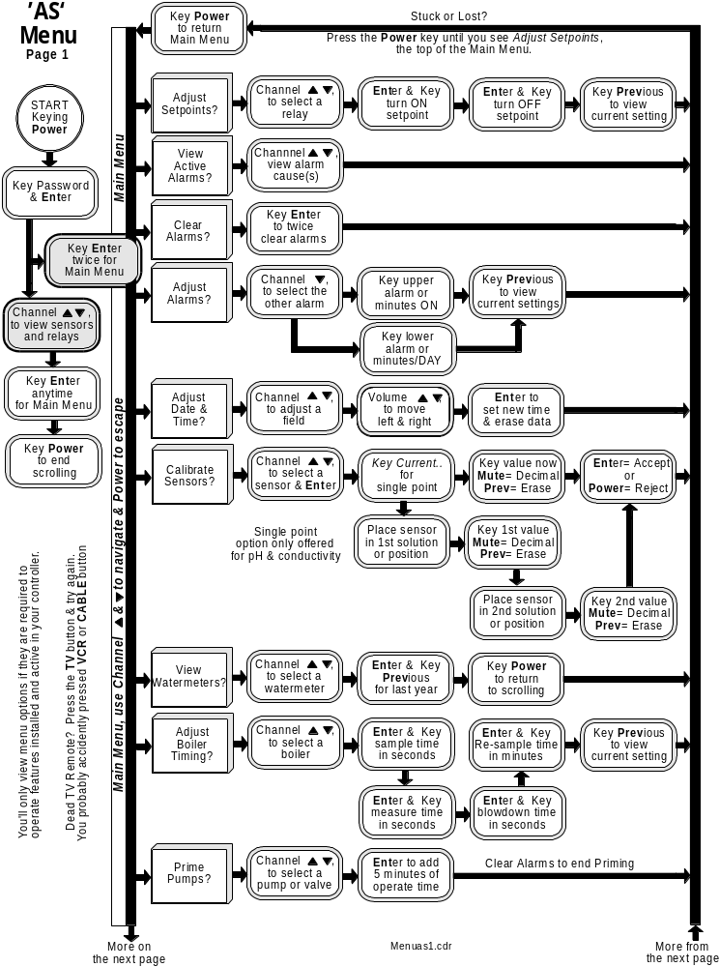
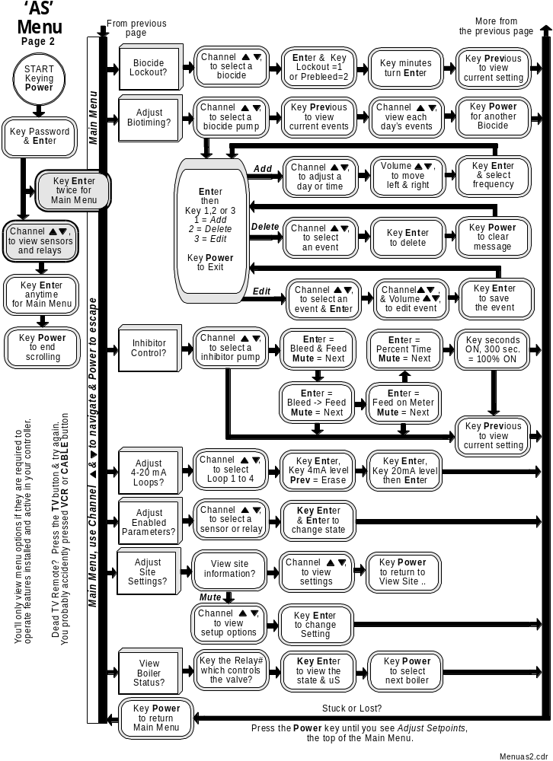

APPENDIX C Options Sub-Panel

C1. SERVICES
The Options Sub-Panel contains:
- The interface cards which allow extra conductivity, and pH to connect to controller analog
inputs ‘G’ through ‘I’

2. The driver and 4-20mA output cards. A single 4-20mA requires one driver and one output card. Two 4-20mA loops requires a driver and two output cards for a total of three cards.

Any combination of extra sensors and 24VAC drivers up to four cards may be mounted on the Option Sub-Panel.
Optional cards are supplied pre-wired to the relay output or controller parameter input.

C2. LOCATION

The 1/8” thick, PVC or Lexan Sub-Panel is mounted to the controller enclosure aluminum backplate.
Controllers with modems will have the backplate mounted above the modem.

C3. EXTRA CONDUCTIVITY SENSORS
Controllers with more than one conductivity sensor will have this part.

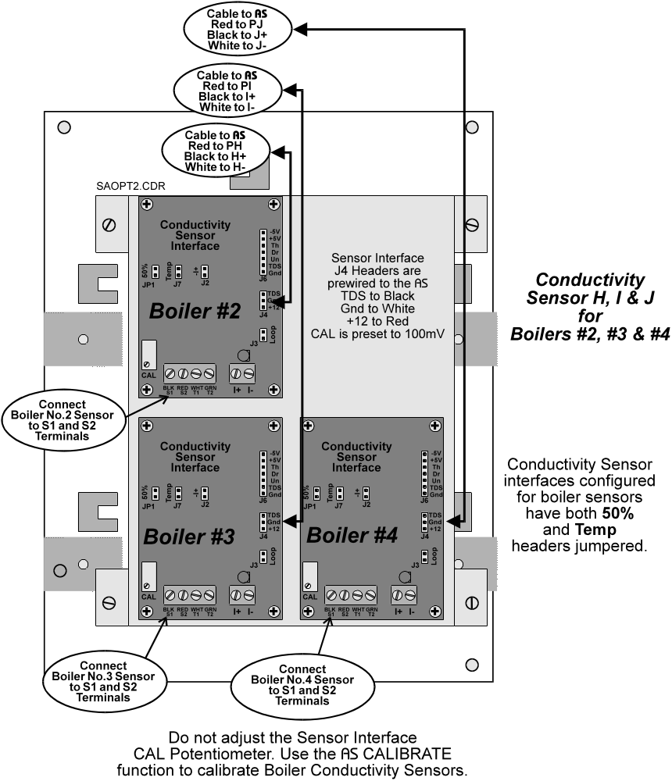

Jumper Configuration
Use | 50% | Temp
Cooling Tower | OUT | OUT
Boiler Blowdown | IN | IN
Condensate | OUT | IN

C4. EXTRA pH SENSORS
Controllers with more than one pH sensor will have this part.
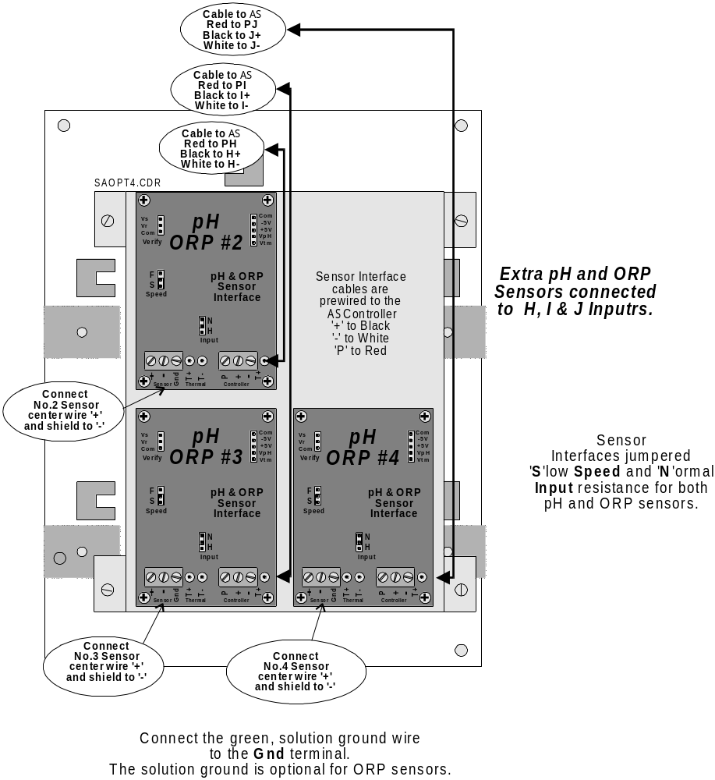

C4. 4-20mA Current Loop Outputs
Controllers with the IC, IO, IP options will have these components
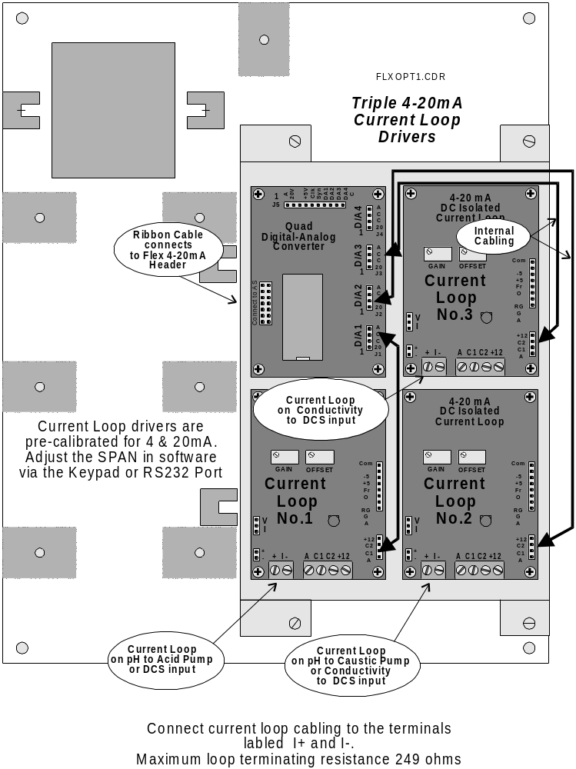

Do not adjust the adjust the Current Loop GAIN & OFFSET potentiometers.
They have been factory calibrated, The ILOOP manual is provided for hardware reference only.

