ProMinent Fluid Controls

ProMtrac

Water Treatment Controller
For Cooling Towers

Measures Conductivity, pH, Temperature,
Make-up Water Meter and Flowswitch

Controls the Bleed Solenoid,
Inhibitor, Acid/Caustic and Biocide Pumps

Includes Conductivity-Temperature-Flowswitch
and pH Sensors

Part No. PR/CO-IN-PH-TB

CONTENTS

Safety

1. INSTALLATION
1.1 Sample Piping
  - Controller Enclosure
  - Backplane Option
1.4 Conductivity-Flowswitch & pH Sensors
1.5 Water Meter
1.6 Pumps and Bleed Solenoid

2. START-UP
2.1 Power-up Display & Keypad
2.2 Bleed Mode: Conductivity Setpoints
  - Inhibitor Feed Mode: Setpoints, Feed Limits
  - Acid-Caustic: Setpoints, Feed Limit
2.5 Verify Conductivity & pH Sensors
2.6 Check Flowswitch & Install Water Meter
2.7 Plug-in Pumps and Bleed Solenoid
2.8 Check Controls

3. OPERATION
3.1 Conductivity Sensor
  - Bleed Controls
  - pH Sensor
  - Acid-Caustic Controls
  - Make-up Meter
  - Inhibitor Controls
3.61 ppm Feed Controls
  - Biocide Events
  - Selecting a Pump Type
  - System – Alarms
  - Password

4. MAINTENANCE
4.1 Guidelines
4.2 Spare Parts
4.3 Technical Support

APPENDICES
- INSTALL
- SPECIFICATIONS
- HARDWIRING
- ‘CL’ 4-20mA OUTPUT Option
- ‘AR’ ALARM RELAY Option
- ‘LB’ LAN - BROWSER Option

Safety
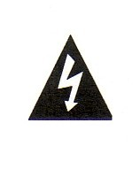
Electrical Shock Hazard
Removing the lower enclosure cover with the controller plugged in,
exposes the user to AC line voltages.

There are no user serviceable parts behind the upper
enclosure cover: do not remove.

USER WARNING : CAUTION

Cooling Tower Water Treatment Controllers operate 120VAC bleed solenoids & pumps and may pump hazardous, corrosive and toxic chemicals.

Opening the controller enclosure exposes user to the risk of electrical shock at power line voltages.

Understand fully the implications of the control setpoints, feed limits and alarms that you select. Harm to personnel and damage to equipment may result from mis-application.

Unplug or turn OFF the AC power to the controller if you have any concerns regarding safety or incorrect controller operation and notify supervisory staff.

YOUR CONTROLLER
Controllers are supplied with default bleed solenoid and inhibitor feed setpoints that will not be applicable to your cooling tower.

Select control modes, adjust setpoints and set biocide pump timing for your site and its water treatment program.

1. INSTALLATION
  - Sample Piping

Controller includes Conductivity-Flowswitch & pH sensors with a ¾’ PVC sensor header.

if you have not previously installed this type controller,
read Appendix A: INSTALL for plumbing and wiring guidelines

CAUTION: Do not exceed 100psi on the sensor & pump tubing.
Always close upstream isolation valves first.

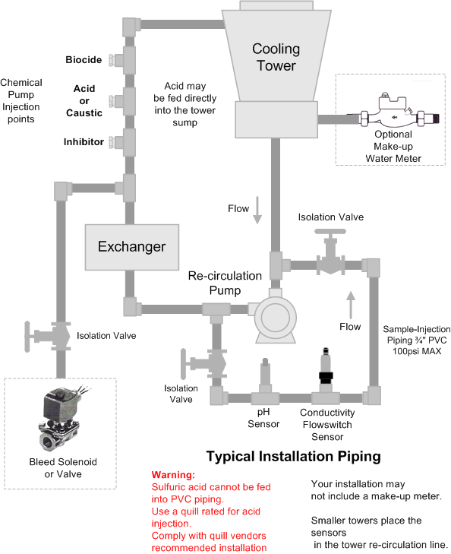

  - Controller Enclosure

Remove the lower, controller enclosure cover.
Hang the controller on a single #8-#10 screw located 60”, 150cm. above the floor
Install the bottom left & right mounting screws through the existing enclosure holes located behind the lower cover.

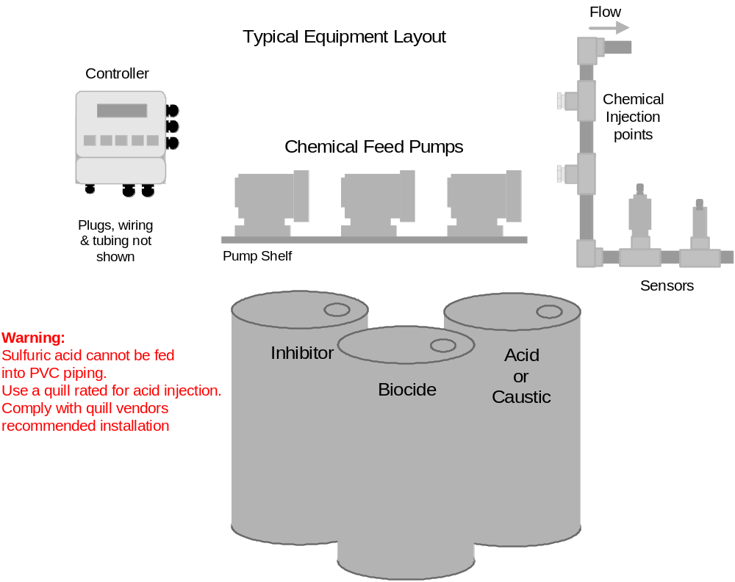

Although sensor cables and pump tubing may be extended, ease of servicing occurs when water treatment components are located in the same area.

Ensure that the lower enclosure cover is installed after terminating sensor
and water meter wiring.

1.3 Backplane Option

ProMtrac controllers may be supplied with pumps, prewired & pre-plumbed on a backplate.

( requested blank page for backplate graphic & part# )

  - Conductivity-Flowswitch & pH Sensors

After installing the conductivity-flowswitch and pH sensors,
open the sample piping downstream isolation valve, then the upstream valve.

Verify that the sensor entries seal, leak and drip free

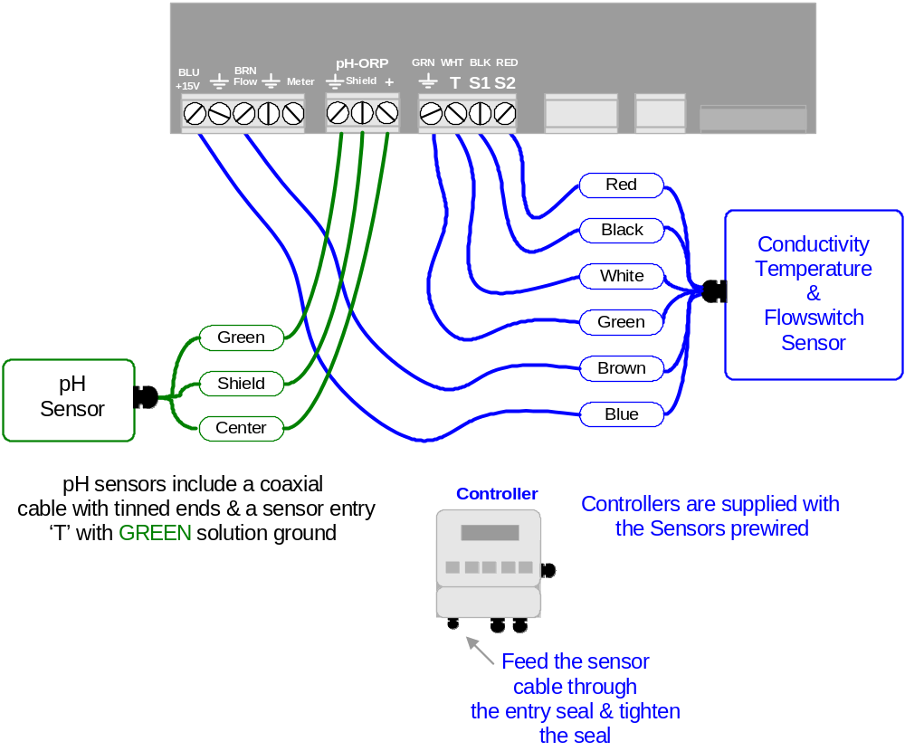

Flowswitch Alternative: A dry contact set, closed when there is flow past the sensors may be used as an operating interlock in place of the flowswitch built into the conductivity sensor.

Disconnect the BROWN Flow wire and connect the alternative flowswitch
to the Flow and adjacent Ground terminals.

  - Water Meter

Refer to manufacturer’s recommendations on meter orientation and upstream and downstream piping. Extend meter cables with AWG22, 2 or 3 conductor.

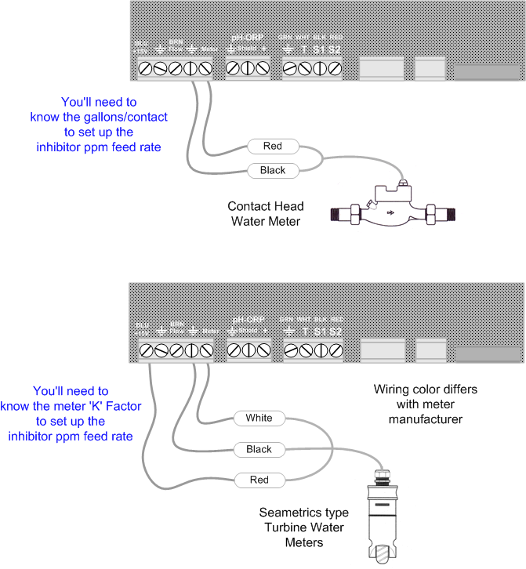

Do not install meter cabling in the same conduit at AC power wiring.
  - Pumps & Bleed Solenoid

The controller supplies the AC power to the bleed solenoid
and frequency control to the pumps.
A controller relay switches power to the solenoid, fused at a maximum of 5 Amps.
High speed, optically isolated switches control each pump’s frequency.

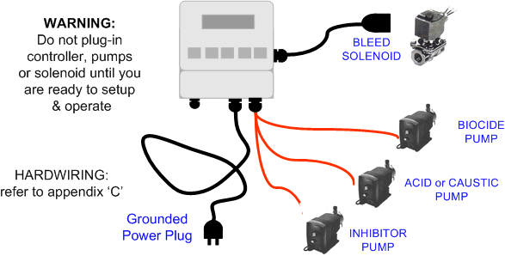

Before plugging in the controller, connect the chemical pumps
orange control cables to the controller

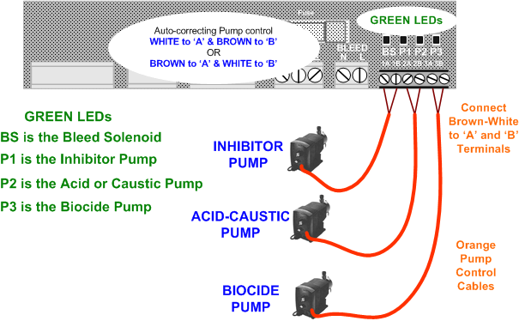

  - Pumps & Bleed Solenoid
continued

START-UP BEFORE you plug-in pumps and bleed solenoid.

A: Plug-in the controller.

B: Set control modes for the bleed, acid-caustic and inhibitor and setpoints.

C: Set the volume feed limits on the inhibitor & acid-caustic pumps.

D: Verify that the sensors are reading correctly and set the alarms.

E: If you are using a water meter; force make-up and verify that meter is measuring the expected volume.

F: Verify that the flowswitch is working by valving OFF flow to the sample piping.

Detail on performing each of the previous START-UP follow in Section 2 of this manual

An overview of system operation is available in the Yearly section of 4.1 Maintenance.

Sidebars: At the bottom of many of the manual pages, provide detail or overview that would clutter the manual.

ACID-CAUSTIC: If the controller displays Acid Pump it’s set to control acid feed. Refer to section 3.9 System for switching from ACID to CAUSTIC control modes.

Built-in HELP:
Current State: The Bleed Solenoid and each of the three pumps has it’s own Current State LCD display which tell you why the control is either ON or OFF.
For example: Why is the Bleed ON when the tower conductivity is less than the TurnOFF setpoint. The Bleed Solenoid Current State would tell you that a biocide Prebleed is occurring and count down the remaining Prebleed time.

Off Site HELP:
The ?123 numbers that occasionally appear at the end of the first line of the display reference on-line help that adds more explanation than could fit on a two line display.
See Section 4.3 of this manual for help site links.

2. START-UP
2.1 Power-up Display & Keypad

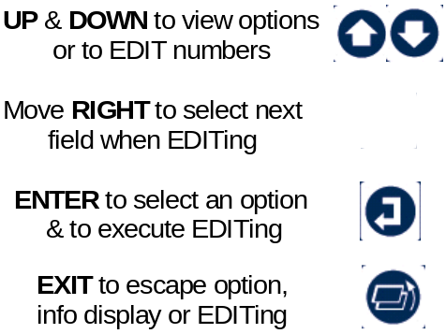  Power ON display: Day of Week & current time  Press ENTER for Controller Diagnostic, Clock,  System configure, US-Metric set.  Press ENTER to clear Alarms  Current Conductivity sensor value  Press ENTER for Conductivity Calibrate & Alarms  Solenoid ON or OFF and ON time today  Press ENTER for Bleed Setpoints, Bleed Mode, Test,  End Prebleed or Lockout and Current State  Current pH sensor value  Press ENTER for pH Calibrate & Alarms  Acid or Caustic Pump ON or OFF  and volume fed from midnight.  Press ENTER for Setpoints, Feed Mode,  Volume Limit, Prime Pump, Pump Type and Current State |  | Keypad  Response  UP or DOWN to the display you wish to view or EDIT  & press ENTER  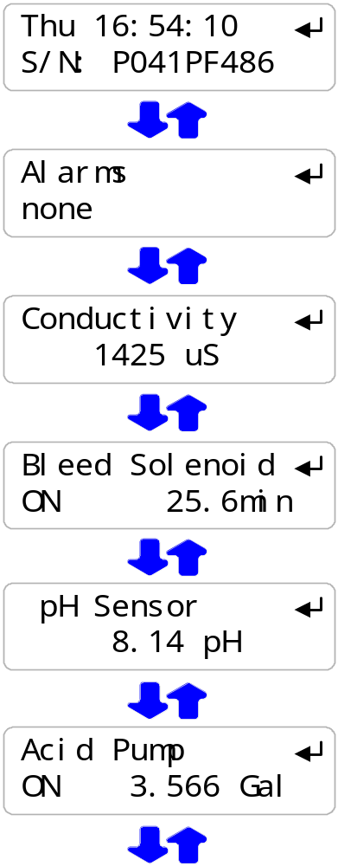

2.1 Power-up Display & Keypad
continued
Water meter measured volume from midnight  Press ENTER to Install, Select meter type,  View year-to-date & days on-line  Inhibitor Pump ON or OFF and volume fed from midnight.  Press ENTER for Inhibitor Setpoints, Feed Mode,  Volume Limit, Prime Pump, Pump Type and Current State.  Flowswitch ON or OFF and ON time today  Biocide Pump ON or OFF, volume fed today & Cycle Day  Press ENTER for Add, Edit & Delete Events, Prebleed, Lockout, Prime Pump, Pump Type,  Cycle Days and Current State  If there is no option card installed  you’ll view the Day-Date power-up display  LAN –Browser, ‘LB’ Option  Displays current IP – see Appendix F, ‘LAN’ for User Manual  4-20mA Output, ‘CL’ Option  Displays loop current – see Appendix D, ‘4-20mA OUTPUT’ for User Manual  Alarm Relay, ‘AR’ Option  Displays relay state – see Appendix E, ‘ALARM RELAY’  for User Manual. |  | 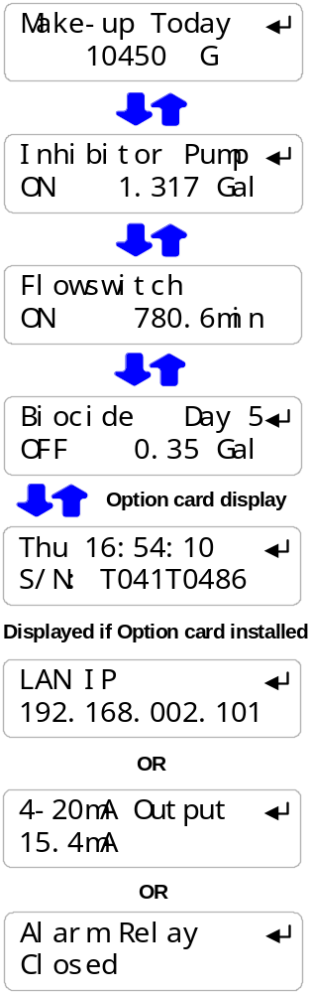

Sidebar: Volumes less than 100mL are displayed in mL so you can verify that a pump is feeding. Volumes greater than 100mL are displayed in Gallons or Liters with 3 decimal points of resolution. Again, so you can ensure the controller is metering chemical.

2.2 Bleed Mode: Conductivity Setpoints

The factory default is ‘Bleed on Conductivity’  Refer to 3.2 Bleed Controls  to select one of three Bleed Modes  Press UP or DOWN until you see  ‘Bleed Solenoid’ & press ENTER  Press ENTER to view or adjust Setpoints  Displays current bleed setpoints,  Varies with Bleed Mode  Press ENTER adjust Turn ON,  or DOWN & ENTER for TurnOFF  Press UP or DOWN to adjust and RIGHT  to move the cursor.  Press EXIT to leave the Setpoints unchanged  Press ENTER, displays current setpoints.  If you make Turn ON less than TurnOFF,  the setpoints will be switched. |  | 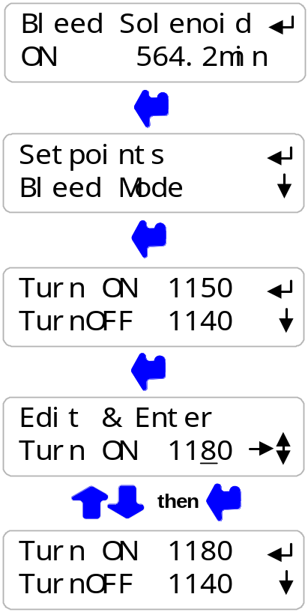

Sidebar: The difference between Turn ON & TurnOFF, the ‘deadband’, is usually set to 10uS.
If you are watching the tower conductivity as the sump float turns the make-up water ON & OFF, you’ll observe the operational deadband exceeds 10uS.

Delays in starting and stopping the make-up due to sump float trip points, increase the operational deadband beyond the controller ON–OFF setpoints.

  - Inhibitor Feed Mode: Setpoints, Feed Limits

The factory default feed mode is ‘Bleed & Feed’  Refer to 3.6 Inhibitor Controls  to select one of four Feed Modes  Press UP or DOWN until you see  ‘Inhibitor Pump’ & press ENTER  Press ENTER to view or adjust Setpoints  Displays current feed mode & setpoint,  Whenever the Bleed Solenoid is ON;  the Inhibitor Pump will be feeding @ 3.25mL/minute.  Press ENTER adjust the feed rate,  Press UP or DOWN to adjust and RIGHT  to move the cursor.  Press EXIT to leave the Setpoint unchanged  Press ENTER, displays current setpoint,  3.05 mL/minute. |  | 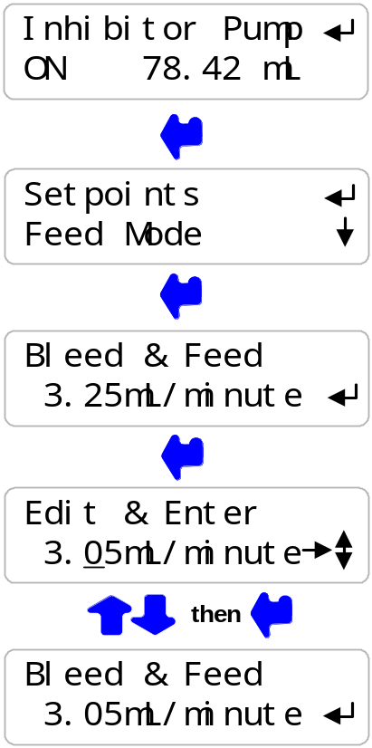

Sidebar: Bleed & Feed is the most common but usually not the best way to feed inhibitor.

If you are not bleed limited, use Bleed then Feed mode to reduce inhibitor use.

If you are using a make-up water meter to control inhibitor feed, the controller will delay feeding when the bleed valve is ON to avoid pumping inhibitor down the drain.

If you request a feed rate greater than the installed pump capacity, the controller sets the rate to the pump maximum & displays an error message.

2.3 Inhibitor Feed Mode: Setpoints, Feed Limits
continued

The Inhibitor feed limit turns OFF the inhibitor pump to prevent overfeeding.  The factory default feed limit 0.5 Gallons/day.  Press UP or DOWN until you see  ‘Inhibitor Pump’ & press ENTER.  Press UP or DOWN until Feed Limit.  Press ENTER to view or adjust daily volume.  Displays the daily feed volume limit,  ?157 indexes more on-line explanation.  Press ENTER to adjust daily feed Limit,  Press UP-DOWN to adjust and RIGHT to move the cursor.  Press EXIT to leave the Feed Limit unchanged  Press ENTER, displays the current daily limit,  2.25 Gallons/day |  | 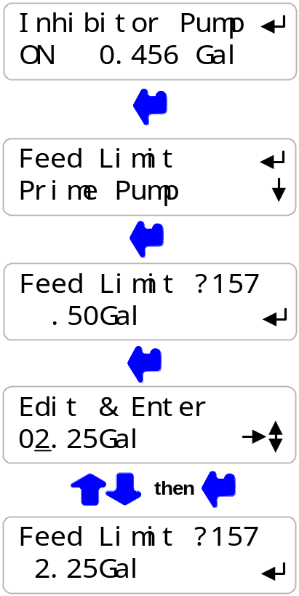

HELP: ?157 and other help numbers display wherever more explanation is available at the HELP link noted in Section 4.3 of this manual..

If you are using this type of water treatment control for the first time, the language and application of some of the controller options and settings requires more detail than a 2 line display can deliver.

2.4 Acid-Caustic: Setpoints, Feed Limit

The factory default ‘Acid Pump’ & ‘pH Control’  Refer to 3.4 Acid-Caustic Controls  to select one of the two Control Modes  If you have selected ‘Caustic’, then  ‘Caustic Pump’ will be displayed.  Refer to section 3.9 System-Alarms.  Press UP or DOWN until you see ‘Acid Pump’.  The pump is OFF & has fed 1.218  Gallons since midnight  Press ENTER.  Press ENTER to view or adjust Setpoints.  Displays current pump operating setpoints.  Pump is 100% ON when the pH is above 8.00 pH and OFF when the pH is below 7.5 pH.  As the pH increases from 7.5 to 8.0, the feed rate  increases from zero strokes/minute to the  pump maximum strokes/minute.  Press ENTER adjust 100% ON,  or DOWN & ENTER for TurnOFF  Press UP or DOWN to adjust and RIGHT to move the cursor.  Press EXIT to leave the Setpoints unchanged  Press ENTER, displays current setpoints.  If you make 100% ON less than TurnOFF,  the setpoints will be switched |  | 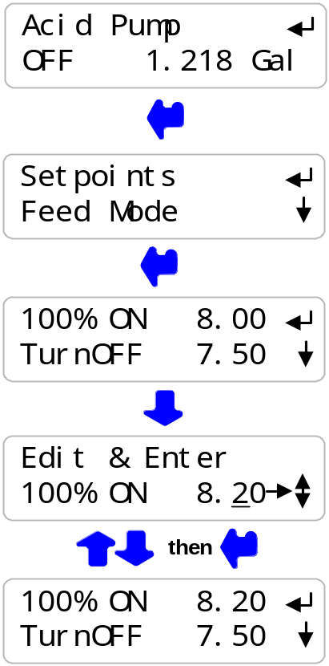

Sidebar: Acid control setpoints are usually set by measuring or estimating the pH at the target cycles of concentration.
The Acid-Caustic pump may never turn OFF if the hydraulics of the site and its water chemistry require a continuous acid or caustic feed .

If make-up water alkalinity changes, the volume of acid required to maintain the setpoint pH will also change.

2.4 Acid-Caustic: Setpoints, Feed Limit
continued

The Feed Limit turns OFF the Acid-Caustic pump  to prevent overfeeding.  The factory default fed limit is 0.5 Gallons.  Press UP or DOWN until you see  ‘Acid Pump’ or ‘Caustic Pump’ & press ENTER.  Press DOWN until Feed Limit.  Press ENTER to view or adjust Feed Limit.  Displays the current feed limit volume,  ?244 indexes more explanation @ www.2eZnet.com  Press ENTER adjust Feed Limit,  Press UP-DOWN to adjust and RIGHT to move the cursor.  Press EXIT to leave the Feed Limit unchanged  Press ENTER, displays the current feed limit,  2.5 Gallons. |  | 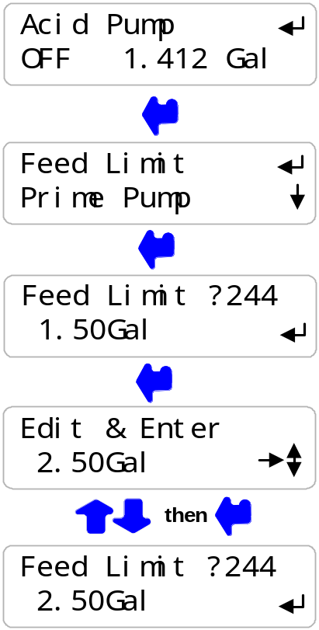

Sidebar: The pH must operate at less than the 100%ON setpoint before the
Feed Limit volume is exceeded.

Feed Limit prevents acid-caustic overfeeding and resulting corrosion if the pH sensor fouls or fails. Acid-Caustic controlled by ‘Meter Control’ will turn OFF if any one feed cycle exceeds the Feed Limit volume.

Pumps operating at less than the rated SPM do not trip the Feed Limit.

The Limit Volume is typically set to 125% to 150% of the longest acid pump run time.
Usually the longest run time at 100%ON occurs under highest cooling load.

Note:
The Acid feed limit restarts every time the pump operate at 100% & does not reset at midnight unless the users sets the Reset @ Midnite option. Refer to Section 3.9

Exceeding the feed limit volume may indicate problems with pH sensor or acid feed.

2.5 Verify Conductivity & pH Sensors
Open the downstream, then the upstream sample line isolation valves, immersing the conductivity sensor  Press UP or DOWN until you see Day & Time.  Press ENTER.  Press ENTER & then press ENTER  to view temperature at the conductivity sensor.  If the BLUE, GREEN & WHITE wires are connected to the controller terminals, you’ll view the current temperature.  ‘Fault’ indicates a wiring or sensor problem.  ‘Fault’ automatically removes conductivity temperature compensation.  Key EXIT twice to return to Day & Time  Press DOWN until you see Conductivity.  Sample the tower water & verify that the displayed conductivity matches the measured conductivity.  Adjust the displayed conductivity by pressing ENTER twice.  Press UP or DOWN to adjust and RIGHT to move the cursor.  Press EXIT to leave Conductivity unchanged.  You’ll see this screen if the sensor is fouled, miswired,  not immersed or you keyed incorrectly.  Press ENTER to ignore or EXIT to return to Factory Default.  ?141 indexes more online explanation.  ENTER displays the current, calibrated conductivity. |  | Verify Temperature  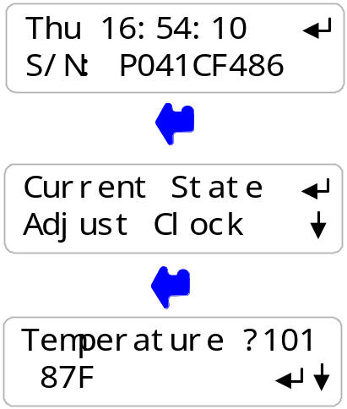  Calibrate Conductivity  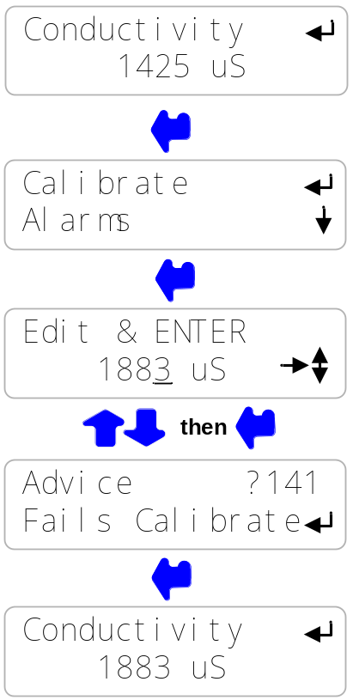

  - Verify Conductivity & pH Sensors
continued

Open the downstream, then the upstream sample line isolation valves, immersing the conductivity & pH sensors  Press UP or DOWN until you see pH Sensor.  Sample the tower water & verify that the displayed pH matches the measured pH.  Adjust the displayed pH by pressing ENTER twice.  Press UP or DOWN to adjust and RIGHT to move the cursor.  Press EXIT to leave pH unchanged.  You’ll see this screen if the sensor is fouled, miswired,  not immersed or you keyed incorrectly.  Press ENTER to ignore or EXIT to return to Factory Default.  ?211 indexes more explanation at the support site.  Displays the current, calibrated pH |  | Calibrate pH  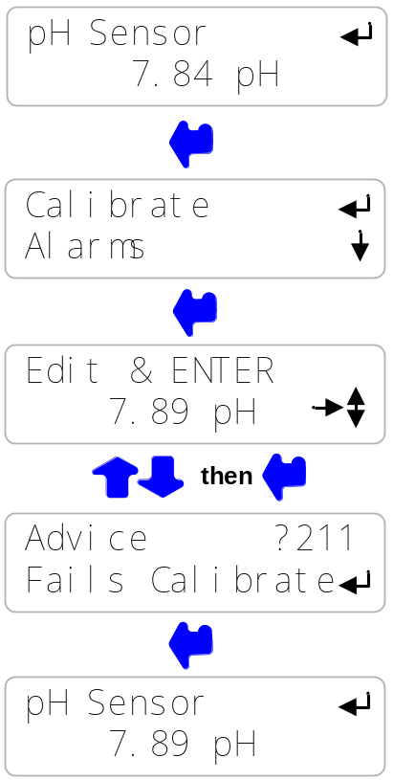

Sidebar: pH’s in cooling towers typically vary from 7.0 to 10.0 with acid feed setpoints typically in the 8.0pH range.

The actual setpoints used in your tower will depend on both the make-up chemistry and the water treatment program.

Acid feed setpoints are provided by your water treatment vendor.

  - Check Flowswitch & Install Water Meter

Open the downstream, then the upstream sample line isolation valves, immersing the conductivity sensor.  Note: The thermal flowswitch requires a maximum of 30 seconds to respond to the change from NO-Flow to Flow  Press UP or DOWN until you see Flowswitch.  Displays ON or OFF and the total minutes ON from midnight.  NOTE: An OFF flowswitch stops all pumps  and the bleed solenoid.  The flowswitch can be bypassed by jumpering the Flow terminal to the adjacent ground terminal.  The factory default water meter is  a 100 Gallons/contact contact head meter  Press UP - DOWN until you see Make-up Today.  Displays make-up volume from midnight.  Press ENTER twice to view or change meter type.  Key ENTER to view or change the gallons/contact.  Metric users will view volumes in ‘L’iters & L/Contact  Press UP-DOWN to adjust and RIGHT to move the cursor.  Press EXIT to leave Gallons/contact unchanged.  ENTER or EXIT displays the current meter type. |  | Flowswitch  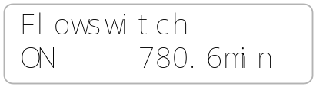  Contact Head  Watermeter  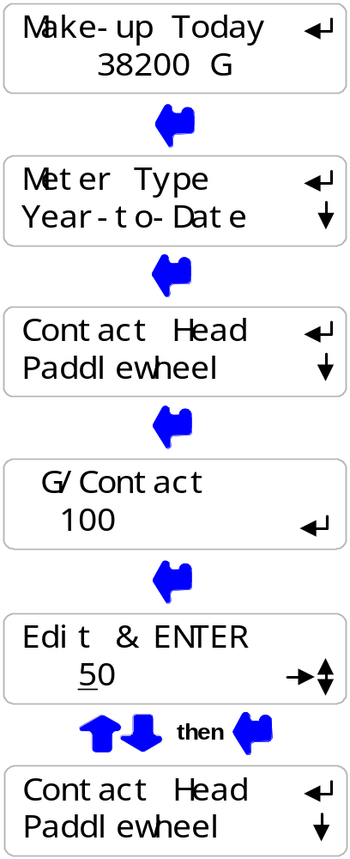

Sidebar: 2 wire meters are usually Contact Head & 3 wire meters are usually, but not always Turbine or Paddlewheel.

  - Check Flowswitch & Install Water Meter
continued

Turbine-Paddlewheel type water meters provide  pulses per Gallon or Liter.  The number of Pulses/Unit Volume is the ‘K’ factor.  Press UP or DOWN until you see Make-up Today.  Displays make-up volume from midnight.  Press ENTER twice to view or change meter type.  Key DOWN to select Paddlewheel type meter  Key ENTER to view or change the pulses per Gallon.  Metric users view pulses per Liter.  Press UP-DOWN to adjust ‘K’ Factor  or EXIT to leave unchanged.  ENTER or EXIT displays the current meter type. |  | Turbine –Paddlewheel  Watermeter  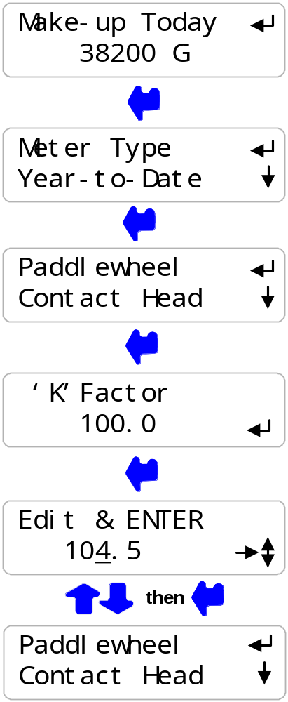

Sidebar: Force make-up by either opening the bleed solenoid bypass or lowering the Bleed Setpoints.

Verify that the make-up meter displays an increasing volume as the float opens the make-up line. Close the bypass or reset Bleed Setpoints after verifying the meter.

WARNING: Verify paddlewheel meters immediately and disconnect if not verified.
Mis-wired paddlewheel meters will fail the water meter Hall Effect sensor.

2.7 Plug-in Pumps and Bleed Solenoid

Sections 2.1 to 2.6 adjust setpoints and verify sensors.  We’re now ready for the bleed solenoid and each chemical pump, verifying each one as it’s plugged in.  Remove the lower access panel on the controller enclosure.  Plug the bleed solenoid into the controller sidewall plug.  Press UP or DOWN to view Bleed Solenoid.  If ON, verify that the green BS light  on the right side of the enclosure is ON.  Verify that the bleed solenoid is open  and that tower water is going to drain.  If OFF, press ENTER & DOWN twice to Test Bleed.  Press ENTER and the Bleed & BS light  will turn ON for 5 minutes  Set the Inhibitor pump frequency control to External  and Stroke control to 100%  Plug in the inhibitor pump.  Press UP or DOWN to view Inhibitor Pump.  If ON, verify that the green P1 light  on the right side of the enclosure is flashing.  Verify that the pump is stroking, primed and feeding inhibitor.  If OFF, press ENTER & DOWN to Prime Pump.  Press ENTER and the Inhibitor Pump & P1 light  will flash for 5 minutes at the current mL/minute setpoint. |  | Bleed Solenoid  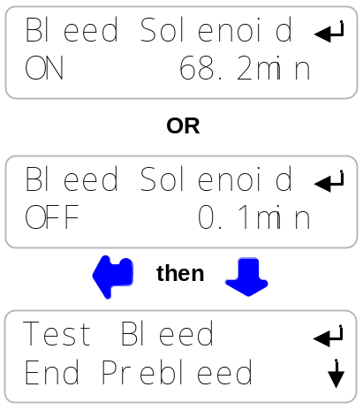  Inhibitor Pump  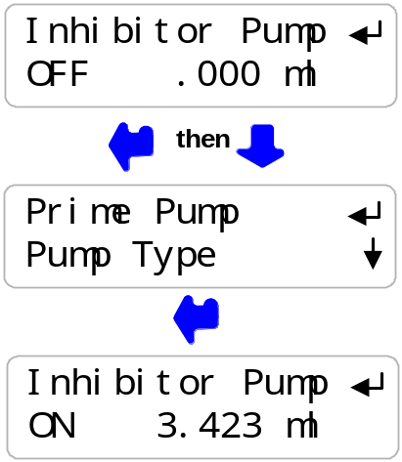

Sidebar: The Bleed Solenoid and Pumps will not turn ON unless the Flowswitch is ON.
The BS,P1,P2 & P3 lights will not turn ON unless the Flowswitch is ON.

Inhibitor pumps set to ‘Bleed then Feed’ or ‘Feed on Volume’ modes will not feed if the Bleed Solenoid is ON. Feed starts as soon as Bleed ends.

  - Plug-in Pumps and Bleed Solenoid
continued
Set the Acid-Caustic pump frequency control to External  and Stroke control to 100%  Plug in the Acid-Caustic pump.  Press UP or DOWN to view ‘Acid Pump’ or ‘Caustic Pump’.  If ON, verify that the green P2 light  on the right side of the enclosure is flashing.  Verify that the pump is stroking, primed and feeding.  If OFF, press ENTER & DOWN to Prime Pump.  Press ENTER and the Acid-Caustic Pump & P2 light  will turn ON for 5 minutes at the maximum stroke rate.  See Section 3.6 Biocide Events, to set biotiming  Set the Biocide pump frequency control to External  and Stroke to 100%  Plug in the Biocide pump.  Press UP or DOWN to view Biocide.  If ON, verify that the green P3 light on the right side on the enclosure is flashing.  Verify that the pump is stroking, primed and feeding biocide.  If OFF, press ENTER & UP 4 times to Prime Pump.  Press ENTER and the Biocide pump & P3 light  will turn ON for 5 minutes at maximum stroke rate.  Reinstall the lower access panel on the controller enclosure |  | Acid or Caustic Pump  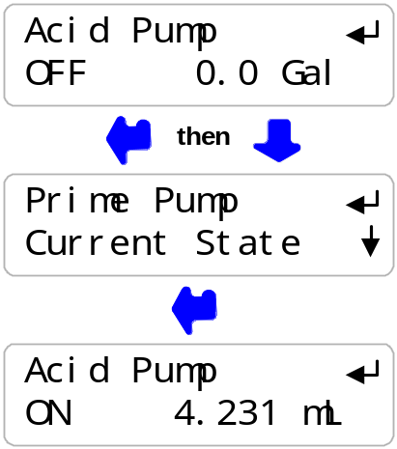  Biocide Pump  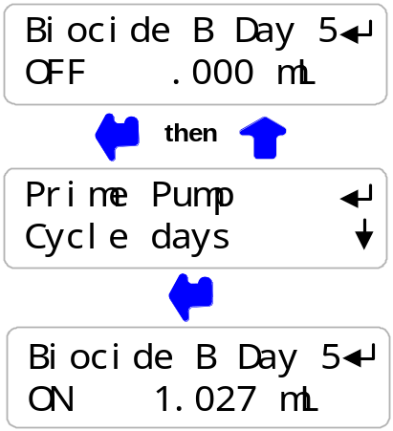

Sidebar: The Bleed Solenoid and Pumps will not turn ON unless the Flowswitch is ON.

Priming the Biocide pump does not cause a bleed solenoid Prebleed or Lockout.

Press ENTER at ‘Alarms’ and ENTER at ‘Clear Alarms’ to end Test Bleed and/or
Prime Pumps.

2.8 Check Controls

Verify that the controls work in the way  that you expect for this site.  Watch the Conductivity increase as the tower operates.  The Bleed Solenoid will turn ON as the conductivity exceeds the Turn ON setpoint.  As the tower makes up, the Conductivity will fall below the TurnOFF setpoint and the Bleed Solenoid will turn OFF.  Verifying a Bleed controlled by a Make-up Meter or Percentage time differs.  If the Inhibitor feed mode is set to ‘Bleed & Feed’, the Inhibitor Pump will turn ON when the Bleed turns ON.  The Inhibitor pump stroke rate will vary with feed mode and setpoint. Inhibitor controlled by the water meter and Bleed-then-Feed mode feed at the maximum stroke rate.  If the Inhibitor feed mode is set ‘Bleed then Feed’ the Inhibitor Pump will always be OFF when the Bleed is ON;  turning ON as soon as the bleed turns OFF.  If the inhibitor pump is set to ‘Feed on Volume’, the inhibitor pump will turn ON after measuring Make-up.  If the Bleed is ON, the Inhibitor Pump will wait until the Bleed turns OFF before turning ON. |  | Conductivity & Bleed  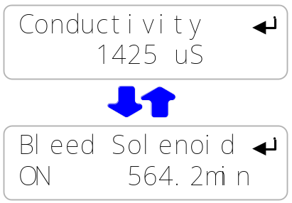  Water Meter or Bleed  & Inhibitor Pump  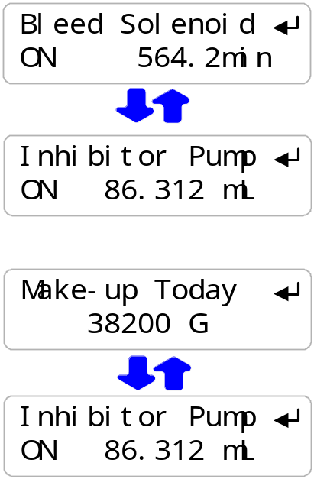

Sidebar: The Bleed Solenoid and Pumps will not turn ON unless the Flowswitch is ON.
The Inhibitor Pump turns OFF if the daily volume limit is exceeded.
Increase the Daily Limit to allow the Inhibitor pump to turn ON.

Bleed Solenoids may turn OFF if Biocide is set to Prebleed and a timed event is scheduled.
Bleed Solenoids may not turn ON if Biocide is set to Lockout and a timed event has started.

2.8 Check Controls
continued

Watch the pH increase as the tower operates,  evaporates cooling water and increases alkalinity.  An Acid Pump will be ON if the pH is greater  than the TurnOFF setpoint.  A Caustic Pump will be ON if the pH is greater  than the TurnOFF setpoint  As the pH changes the Pump feed rate will vary.  Verifying a pH controlled by ‘Feed on Volume’, water meter mode differs, with the Acid or Caustic operating at maximum  SPM after make-up volume is measured. |  | pH & Acid or Caustic  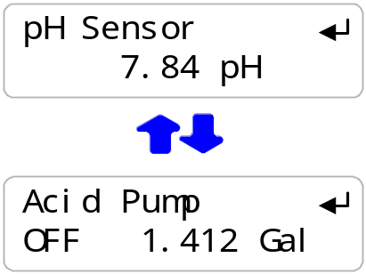

Sidebar: There is a delay between the time the acid pump turns ON and the pH sensor measures the effect as low pH water travels through the piping, basin and back to the re-circulation Pump. A similar delay occurs when the acid pump turns OFF.

These two delays increase the control deadband. Although the Setpoints are 8.00 & 7.5, the actual tower pH may vary from 7.4 to 8.1 due to piping transit delays.

The Acid or Caustic Pump turns OFF if the Feed Limit volume is exceeded.
Press ENTER @ ‘Alarms’ & ‘Clear Alarms’ to reset.
OR ENTER when viewing the Acid/Caustic Pump ‘Current State’ display.

2.8 Check Controls
continued

.  Press UP or DOWN to view the Biocide, the Bleed Solenoid and the value of the Conductivity sensor  If you have not set a Biocide Prebleed or Lockout,  The Biocide pump will turn ON for the preset volume  on the selected Day#  Prebleed time starts at the time set for the event  & ends after the Prebleed time  OR when the conductivity target is met.  Lockout time starts after the biocide volume has  been fed, turning OFF the Bleed  During Prebleed watch the Bleed Solenoid & Conductivity.  During Lockout, watch the Bleed Solenoid ‘Current State’  Press ENTER & DOWN @ Bleed Solenoid  for Prebleed and/or Lockout End options. |  | Biocide Pump  & Bleed Valve - Conductivity  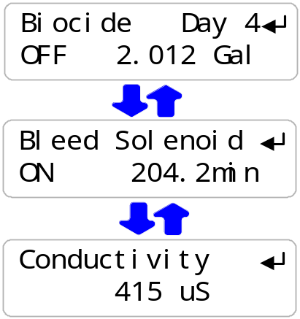

Sidebar: If you set the Prebleed conductivity below the make-up conductivity, then you will always prebleed for all of the prebleed time.

If you require a long Lockout, feed during low tower load to prevent over-cycling the tower.

Do not set Biocide start time before the building automation system turns ON the tower recirculating pump. Feed will be delayed until the controller flowswitch turns ON.

Non-Oxidizing biocides may require a longer ‘kill time’ than an oxidizing biocide and therefore a longer ‘Lockout’

3. OPERATION
3.1 Conductivity Sensor

Sensor calibration and temperature verify is detailed in Section 2.4 Verify Conductivity Sensor  Press UP or DOWN until you see Conductivity.  Press ENTER & then DOWN to Alarms.  Press ENTER to view current alarms or adjust  Press ENTER to adjust the High Alarm  or DOWN & ENTER to adjust the Low Alarm  Press UP-DOWN to adjust and RIGHT to move the cursor.  Press EXIT to leave Alarm unchanged.  ENTER updates the alarms & displays the  current High & Low Alarms.  Conductivity Alarms display on the ‘Alarms’ display  and reset automatically.  ‘Clear Alarms’ does not reset a conductivity alarm above the High or less than the Low Alarm level. |  | Alarms  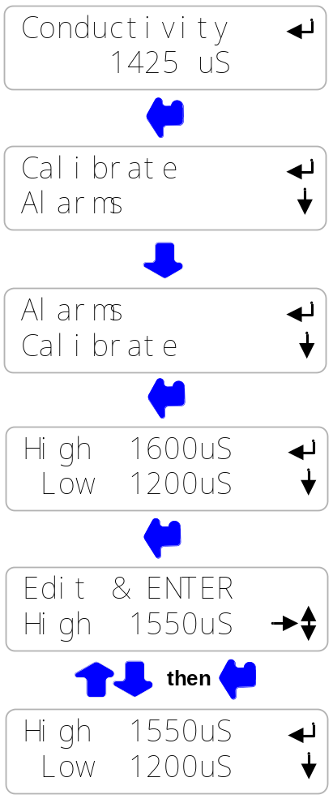

Sidebar: Conductivity alarms may occur when the tower shuts down and drains the sample line or when a Biocide event Prebleed, lowers the conductivity.

When the measured conductivity is between the High & Low alarms, the Conductivity alarm is automatically reset.

3.2 Bleed Controls

For conductivity control setpoints Section 2.2  Bleed Mode: Conductivity Setpoints  Press UP or DOWN until you see Bleed Solenoid.  Displays ON or OFF and ON time from midnight.  Press ENTER to view or adjust Setpoints.  Setpoints vary with selected Bleed Mode.  Press ENTER view current mode or to select from  Conductivity Control, Percentage Time OR Meter Control.  Press ENTER @ Test Bleed to turn ON bleed solenoid  for 5 minutes. ‘Alarms’-‘Clear Alarms’ ends the Test.  Press ENTER @ End Prebleed to a start Biocide Event  on a prebleeding Bleed Solenoid.  Press ENTER @ End Lockout to return  to normal Bleed Solenoid control.  Press ENTER @ Current State to view control status.  Display varies with Bleed Mode |  | 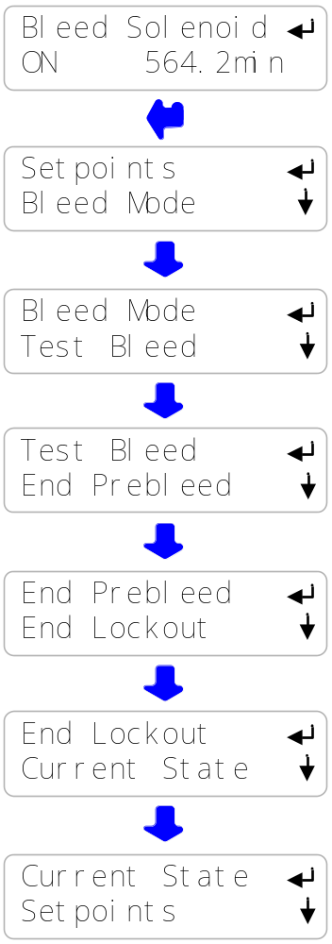

Sidebar: Test Bleed will not turn ON the solenoid if the flowswitch is OFF.

End Prebleed & End Lockout have no effect if the Bleed Solenoid is not
Prebleeding or Locked Out.

3.2 Bleed Controls
continued

Bleed Solenoid Bleed Modes  Press ENTER then DOWN @ Bleed Solenoid  Press ENTER @ Bleed Mode to view current mode and to select a new mode  Most cooling towers operate with Conductivity Control.  Bleed solenoid opens at TurnON conductivity setpoint and closes at TurnOFF setpoint  Percentage Time turns ON the bleed solenoid  for a user set % of 5 minutes.  Meter Control Measures a user set volume on  the Make-up water meter then turns ON  the bleed solenoid for a user set time.  For example:  Measure 100 Gallons of make-up & bleed for 10 seconds.  NOTE: If you change the Bleed Mode, press UP to Setpoints & ENTER to adjust for the new Bleed Mode. |  | 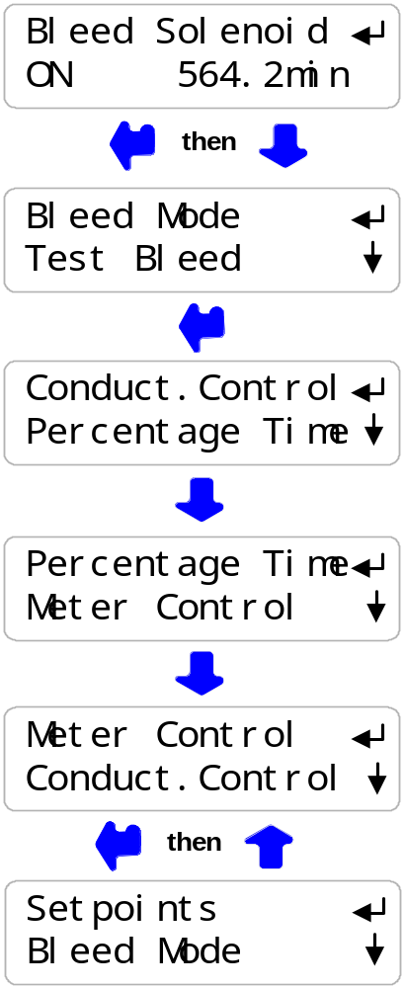

Sidebar: ‘Meter Control’ mode is used where sensor fouling from silica or organics continuously fouls the conductivity sensor.

‘Percentage Time’ mode is used short term to bleed while replacing a sensor or installing a water meter.

3.2 Bleed Controls
continued

Current State of the Bleed Solenoid Control  Press ENTER then UP @ Bleed Solenoid  Press ENTER @ Current State  If bleed ON, displays TurnOFF setpoint, 975 & current conductivity, 993  If bleed OFF, displays TurnOFF setpoint,1000  & current conductivity, 993  If bleed ON, displays Owes 101 sec ?122  & ON ENTER=Stop  If bleed OFF, displays turn-on volume, 10400  & current volume 10,200  If bleed ON, displays Owes 41 sec ?123 & ON ENTER=Stop  Seconds count down to zero & bleed turns OFF.  If bleed OFF, displays seconds to turn ON.  Seconds count down to zero & bleed turns ON. |  | 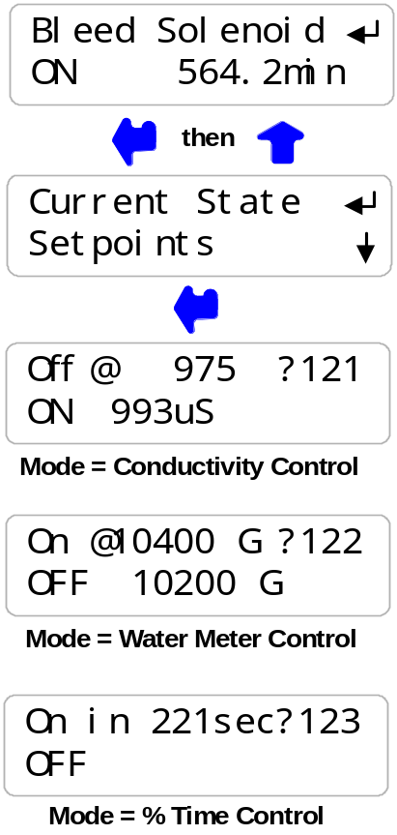

HELP: ?121,122 & ?123 and other help numbers display wherever more explanation is available online.

ON ENTER=Stop ends the current feed cycle or %Time ON period.

3.3 pH Sensor

Sensor calibration is detailed in Section  2.5 Verify Conductivity & pH Sensors  Press UP or DOWN until you see pH Sensor.  Press ENTER & then DOWN to Alarms.  Press ENTER to view current alarms or adjust  Press ENTER to adjust the High Alarm  or DOWN & ENTER to adjust the Low Alarm  Press UP-DOWN to adjust and RIGHT to move the cursor.  Press EXIT to leave Alarm unchanged.  ENTER updates the alarms & displays the  current High & Low Alarms.  pH Alarms display on the ‘Alarms’ display  and resets automatically.  ‘Clear Alarms’ does not reset a pH alarm above the High or less than the Low Alarm level.  High alarms occur on a failure to feed acid or sensor fault.  Low alarms occur on an acid overfeed or sensor fault. |  | Alarms  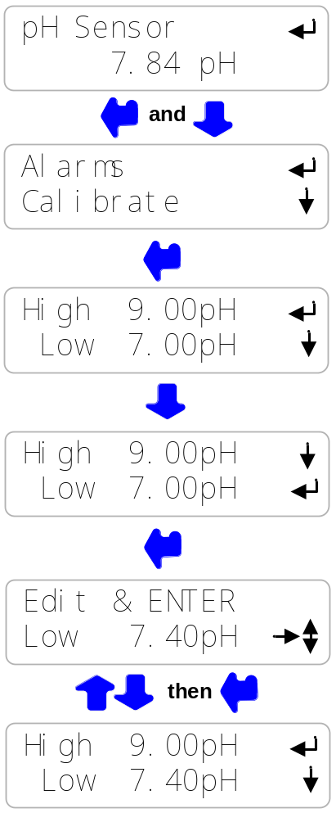

Sidebar: pH alarms may occur when the tower shuts down and drains the sample line or when a pH sensor fouls. Scaled pH sensors can be cleaned with HCl. Immerse until the fizzing stops. Organically fouled sensors may be cleaned with alcohol and soft brush.

Caution: pH sensors will not measure correctly unless the GREEN solution ground wire on the bottom of the sensor entry ‘T’ is connected to a controller ground terminal.

3.4 Acid-Caustic Controls

For pH Control setpoints & Pump Feed Limit see  Section 2.4 Acid: Setpoints, Feed Limit  Acid or Caustic Pump Control Modes  Press ENTER then DOWN @ Acid or Caustic Pump  Press ENTER @ Feed Mode to view current mode and to select a new mode  Most cooling towers operate with pH Control.  An Acid Pump turns ON at TurnOFF pH setpoint,  increasing the feed rate to the pump maximum SPM.  Feed on Volume turns ON the Pump  after measuring a user set make-up volume, feeding the setpoint ppm of Acid or Caustic.  It’s a mode that may be used to bypass a pH sensor  NOTE: If you change the Feed Mode, press UP to Setpoints & ENTER to adjust for the new Feed Mode.  Current State of Acid Pump Control  The Current State changes with the selected Feed Mode  Press ENTER then UP @ Acid Pump or Caustic Pump.  Press ENTER @ Current State  If the pump is OFF, displays Turn ON setpoint, 8.00  & the current pH, 7.48  If the pump is ON, displays the TurnOFF setpoint,  7.50 & the current feed rate 0 to 100%.  If acid pump is ON, displays the owed volume  Owed volume counts down to zero & the pump turns OFF.  ENTER ends current feed.  If OFF, displays volume @ to turn ON, 9800,  & current meter volume, 9700  ?241& ?243 Help numbers display wherever more explanation is available online. |  | 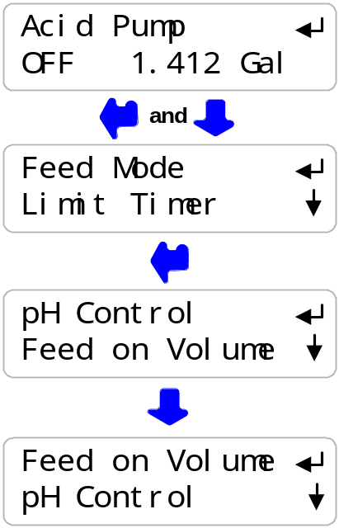  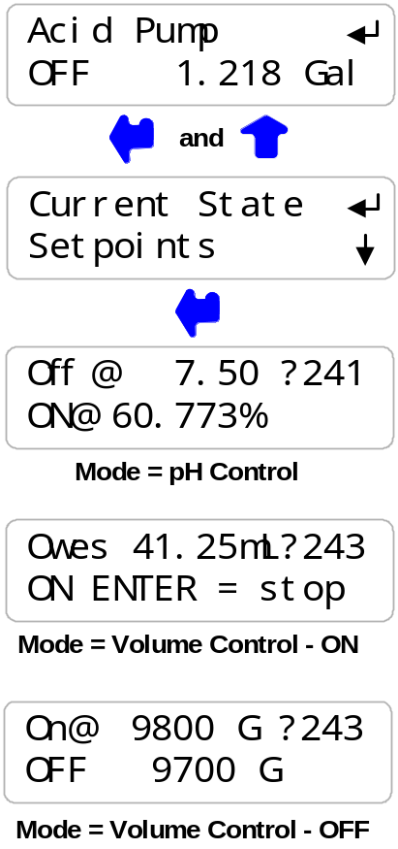

3.5 Make-up Meter

Meter type selection & installation detailed in  Section 2.6 Check Flowswitch & Install Water Meter  Press UP or DOWN until you see ‘Make-up Today’  & press ENTER .  Press ENTER to view current type or to select  Contact Head or Paddlewheel water meter.  Key DOWN & ENTER for volume this year.  Press ENTER for current volume.  Key DOWN & ENTER for days on-line this year  Press ENTER for current days.  Key ENTER to reset Year-to-Date, Days Online  and Make-up Today to zero.  Warning: Cannot Undo  Volume this year to date.  Displays in ‘L’iters if metric selected.  (Press ENTER at Year-to-Date to view)  Days controller installed and operating this year.  Does not count the days that controller power is OFF.  (Press ENTER at Days Online to view)  Press EXIT to return to previous display |  | 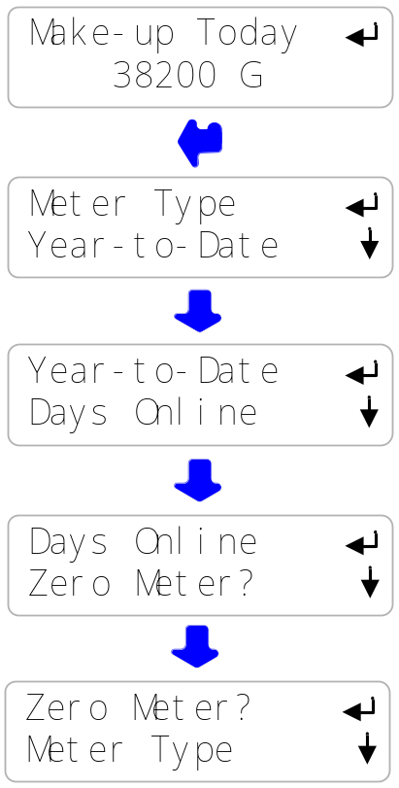  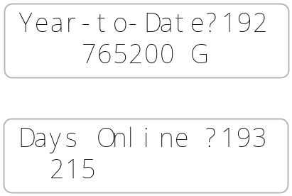

Sidebar: Year-to-Date volume divided by Days Online is average usage,
a figure of merit for a tower tonnage.

HELP: ?192 & ?193 and other help numbers display wherever more explanation is available online.

3.6 Inhibitor Controls

For inhibitor control setpoints & daily feed limit, refer to  Section 2.3 Inhibitor Feed Mode: Setpoints, Feed Limits  Press UP or DOWN until you see Inhibitor Pump.  Displays ON or OFF and volume from midnight.  Press ENTER to view or adjust Setpoints.  Setpoints vary with selected Feed Mode.  Press ENTER view current feed mode or to select from  Bleed & Feed, Bleed then Feed, Base Feed  OR Feed on Volume.  Press ENTER to set maximum volume fed per day  Press ENTER @ Prime Pump to turn ON Inhibitor Pump  for 5 minutes. ‘Alarms’-‘Clear Alarms’ ends Priming.  Press ENTER to view or modify Pump type,  mL/stroke or maximum stroke rate.  Press ENTER @ Current State to view control pump status.  Display varies with Feed Mode |  | 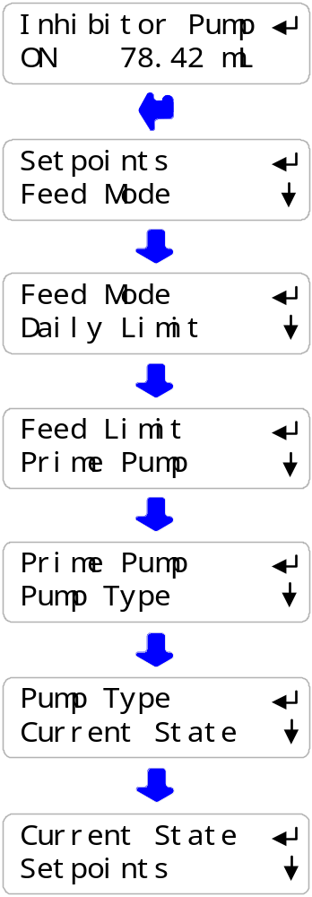

Sidebar: Prime Pump will not turn ON the Pump if the flowswitch is OFF.

Inhibitor pumps set to ‘Bleed then Feed’ or ‘Feed on Volume’ modes will not feed if the Bleed Solenoid is ON. Feed starts as soon as Bleed ends.

Pump Type is seldom changed but mL/stroke may be adjusted to increase feed accuracy.

3.6 Inhibitor Controls
continued

Inhibitor Pump Feed Modes  Press ENTER then DOWN @ Inhibitor Pump  Press ENTER & DOWN @ Feed Mode to view  current mode and to select a new mode  Inhibitor pump turns ON when Bleed solenoid ON.  Pumps inhibitor at the user set mL/minute  Inhibitor pump turns ON after Bleed solenoid turns OFF.  Pumps inhibitor at user set mL/minute of bleed ON time.  Base Feed turns ON the Inhibitor Pump while the  Flowswitch is ON at the user set mL/minute.  Feed on Volume measures a user set volume on  the Make-up water meter then pumps inhibitor  proportional to make-up volume.  For example:  Measure 100 Gallons and then feed 125ppm of inhibitor.  NOTE: If you change the Feed Mode, press UP to Setpoints & ENTER to adjust for the new Feed Mode. |  | 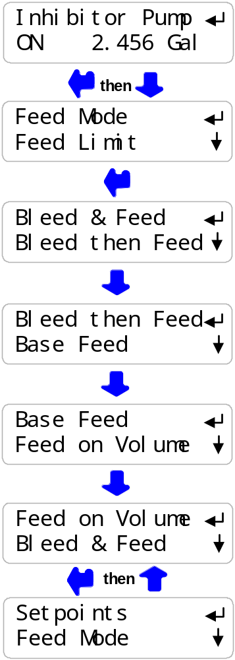

Sidebar: ‘Bleed & Feed’ is used on bleed limited towers where the bleed solenoid is ON for more than 50% of the time.
‘Bleed then’ Feed is used on towers which don’t have a make-up water meter; typically reducing inhibitor usage over ‘Bleed & Feed’ since you are not pumping inhibitor
with the Bleed ON.
‘Base Feed’ is used during start-up or when the tower is not loaded.
‘Feed on Volume’ is usually the most accurate & reliable way to feed for towers which have a make-up meter. It’s also the easiest to setup since the setpoint is in ppm.

3.6 Inhibitor Controls
continued

Current State of the Inhibitor Pump Control  Press ENTER then UP @ Inhibitor Pump  Current state display depends on selected Feed Mode  Press ENTER @ Current State  If the Bleed Solenoid is ON, displays current feed rate ?154  and percentage of pump capacity  If the Bleed Solenoid is OFF: displays Bleed Off ?150  If Pump ON, displays owed volume ?154  Owed volume pumps down to zero and pump turns OFF.  If OFF, displays ‘Bleed Off’  If flowswitch ON, displays current feed rate ?154  and percentage of pump capacity  If Bleed OFF: displays Bleed Off ?150  If Pump ON, displays owed volume ?154  Owed volume pumps down to zero and pump turns OFF.  If Pump OFF, displays turn-on volume, 9800  & current volume 9700 |  | 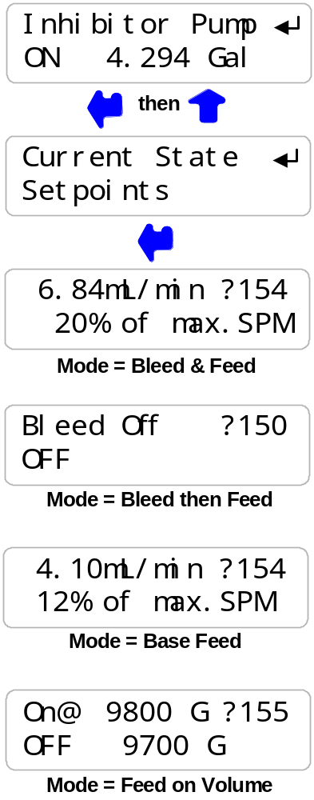

Sidebar: Bleed & Feed feeds at the user set rates while the Bleed Solenoid is ON
Bleed then Feed feeds the user set mL for every minute of Bleed ON time
after the Bleed turns OFF at maximum stroke rate.
Feed on Volume feeds after the Bleed turns OFF at maximum stroke rate.
‘ON ENTER=Stop’ zeroes the owed volume
in Bleed then Feed & Feed on Volume modes.

HELP: ?150,?154,?155 & ?156 and other help numbers display wherever more
explanation is available on-line

3.6.1 Inhibitor Controls
ppm Feed Controls
If a make-up water meter is installed and cabled to the controller, the Inhibitor pump can use a ‘ppm’ setpoint.  Press ENTER @ Inhibitor Pump  Press ENTER @ Setpoints.  If the Feed Mode has been set to ‘Feed on Volume’  ‘Measure’ and ‘Feed’ setpoints will be displayed.  ‘Measure’ refers to the make-up water meter volume.  ‘Feed’ is the ppm setpoint.  In this example, the controller feeds 0.0075 Gallons of inhibitor every 100 Gallons of male-up.  You can adjust both the Measure & ppm setpoints.  In this example, the ppm setpoint is  increased from 75 ppm to 120 ppm  Use the RIGHT key to select the digit you are  adjusting with the UP & DOWN keys. |  | 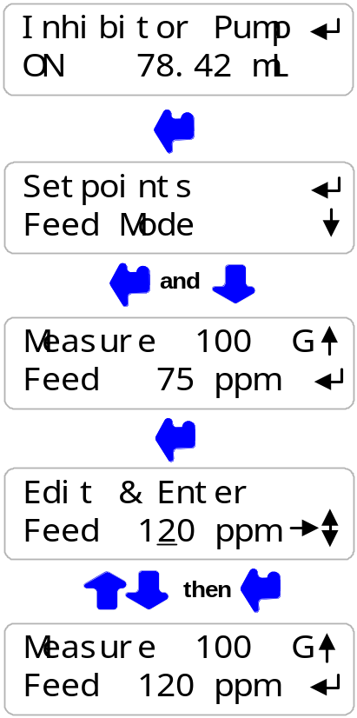

Sidebar: Maintaining the required inhibitor ppm in the cooling tower using Bleed & Feed or Bleed then Feed modes requires more expertise to configure & usually a few adjustments.

Don’t worry about making the Measure setpoint some multiple of the water meter gallons/contact, the controller will do the math.

In this example the water meter could be a 10 Gallons/contact type or a paddlewheel type with a ‘K’ factor of 168. In both cases the controller does the math and correctly meters to maintain the setpoint ppm.

Inhibitors are blended in varying concentrations with effective scale or corrosion control specified at a ppm concentration of inhibitor.

If the tower currently has zero ppm inhibitor, estimate the total amount of water in the tower & piping and pump enough inhibitor to get to the target inhibitor ppm.

3.7 Biocide Events
Biocide Menu Options  Press UP or DOWN until you see ‘Biocide’  Displays ON or OFF and volume fed from midnight.  Day# in selected Cycle 1.28 or 1.7 or 1  Press ENTER to Add a new biocide event.  Press ENTER view or edit current events.  Displays # of active events 1..28  ‘Edit’ not displayed if no events set.  Press ENTER to delete all events.  ‘Delete’ not displayed if no events set.  Press ENTER to view or edit Prebleed Time & Conductivity.  Prebleed runs before each event.  Factory default is 0 minutes Prebleed.  Press ENTER to view or edit Bleed Lockout Time.  Lockout starts when each event starts.  Factory default is 0 minutes Lockout.  Press ENTER to turn ON Biocide pump for 5 minutes.  ‘Alarms’, ‘Clear Alarms’ ends Prime Pump.  Prebleed & Lockout do not run when Prime Pump selected.  Press ENTER to view or edit Cycle Days.  Events repeat every 28 days, 7days or 1 day.  Factory default is 28 Days  Press ENTER to view or modify current pump type, mL/stroke and pump maximum strokes/ minute  Press ENTER @ Current State to view Biocide pump status. |  | 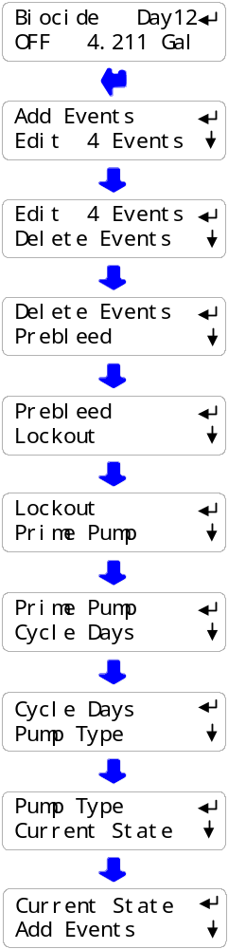

3.7 Biocide Events
continued

Biocide ‘Add Events’  Press UP or DOWN until you see ‘Biocide’.  Press ENTER.  Press ENTER to Add an Event.  Press RIGHT to move the underline to the value you wish to change & then UP – DOWN to adjust.  Days 1,8,15 & 22 are Sundays on 28 Day Cycles.  Time is 24 hour format. 14:00 is 2:00PM.  After you’ve set the day and time you wish to start feeding  and the volume you wish to feed;  Press ENTER to select event frequency.  Key UP – DOWN to select how often  you wish to run the event.  28 Day Cycle offers Once, Weekly or Alternate Weeks.  7 Day Cycle offers Once, Daily or Alternate Days.  1 Day Cycle offers Once, Hourly or Alternate Hours.  Press ENTER to select frequency.  Displays revised total events. We started with 4 events, added a Weekly event & now have 8 events.  You can set up to 28 Biocide events.  This example turns ON the pump for 0.312 Gallons  every Tuesday at 7:15 AM. |  | 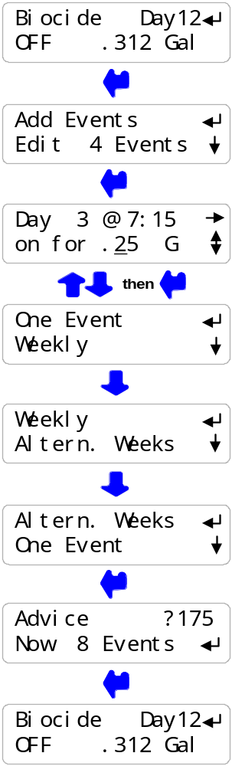

3.7 Biocide Events
continued

Biocide ‘Edit Events’  Press UP or DOWN until you see ‘Biocide’.  Press ENTER & DOWN to Edit Events.  Press ENTER to view and edit current events.  Press UP – DOWN to select an event for editing.  In this example, select 1 of 8 events.  Press ENTER on the selected event.  Press RIGHT to place the underline  where you wish to adjust.  Press UP – DOWN to adjust.  This example changes the event start time  from 6:00AM to 6:45AM.  Press ENTER to end or EXIT to make no changes.  Setting a run time to 0, removes the event. |  | 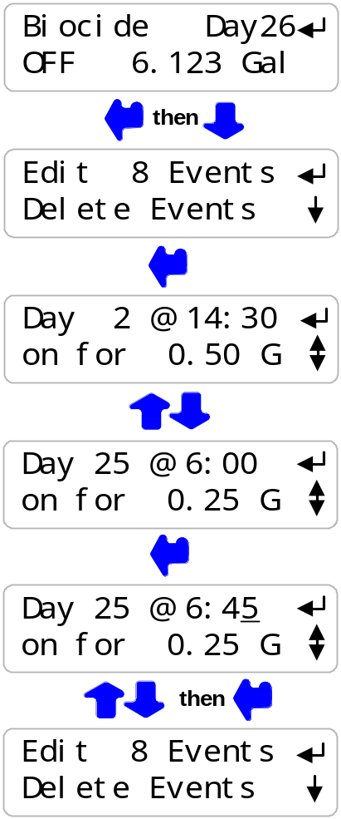

Sidebar: Events are re-sequenced by Day & Time whenever you Edit Events or Add Events.
Keying UP in Edit Events displays the event sequence from Day 1 to Day 28.

Day 1 is always Sunday for 28 and 7 Day Cycles.
The range of Day numbers changes as the Cycle Days changes
from 1..28, 1..7 or 1.

If you change Cycle Days, all events are deleted.

3.7 Biocide Events
continued

Biocide ‘Prebleed’  Press UP or DOWN until you see ‘Biocide’.  Press ENTER and then UP six times to Prebleed.  Press ENTER to view and edit Prebleed.  This example turns ON the bleed for 20 minutes  before each biocide event.  Prebleed ends if the tower conductivity falls below 650uS.  Press ENTER to adjust time  or DOWN & ENTER to adjust conductivity.  In this example, DOWN is pressed to adjust conductivity.  Press RIGHT to place the underline  where you wish to adjust.  Press UP – DOWN to adjust  or EXIT to make no changes.  This example changes the Prebleed  conductivity from 650uS to 600uS. |  | 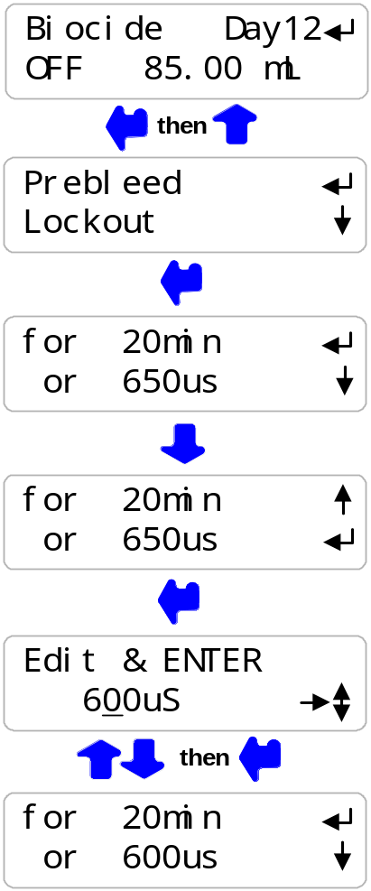

Sidebar: Prebleeding turns on the bleed solenoid before each biocide event to lower the tower conductivity. Prebleeding limits bleed and sewering of the biocide during the ‘kill time’

Biocides are usually fed during tower low thermal load so Prebleeding may not be required.

Prebleeding is also used to prevent overcycling during the Lockout period when the bleed is OFF.

3.7 Biocide Events
continued
Biocide ‘Lockout’  Press UP or DOWN until you see ‘Biocide’.  Press ENTER and then UP five times to Lockout.  Press ENTER to view and edit Lockout time.  Press ENTER to edit or press EXIT.  Factory default Lockout is set to 0 minutes.  Press ENTER to adjust.  Press RIGHT to place the underline  where you wish to adjust.  Press UP – DOWN to adjust  or EXIT to make no changes.  Biocide ‘Cycle Days’  Press UP or DOWN until you see ‘Biocide’.  Press ENTER and then UP three times to Cycle Days.  Press ENTER to view and edit Cycle Days.  Press ENTER to edit or press EXIT.  Key UP – DOWN to select 28,7 or 1 day  & then press ENTER.  Changing Cycle Days deletes existing events.  Biocide events repeat every 28, 7 or 1 day. |  | 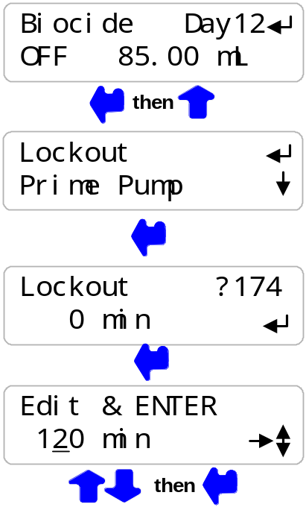  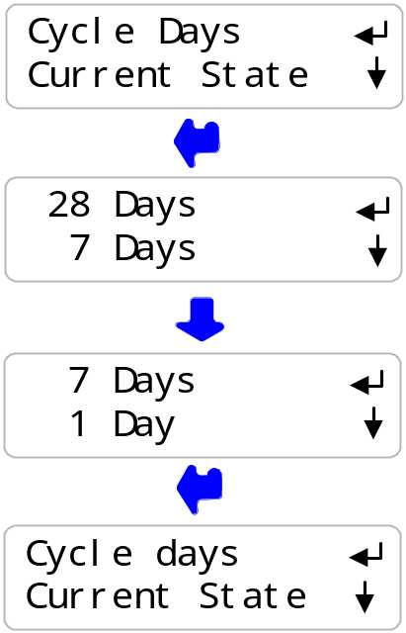

Sidebar: Lockout prevents the bleed solenoid from turning ON during the biocide ‘kill time’ and sewering the biocide.
Lockout is usually used with Prebleed to prevent tower overcycling during the Lockout period.

Non-Oxidizing biocides typically use a 28 or 7 Day cycle.
Oxidizing biocides typically use a 7 or 1 day cycle.

3.7 Biocide Events
continued

Biocide ‘Current State’  Press UP or DOWN until you see ‘Biocide’.  Press ENTER & UP to Current State.  Press ENTER to view Current State.  If there are no Biocide feed events running, displays OFF.  If a Biocide feed event is running,  counts down remaining volume.  Press ENTER to end event  or EXIT to leave this display. |  | 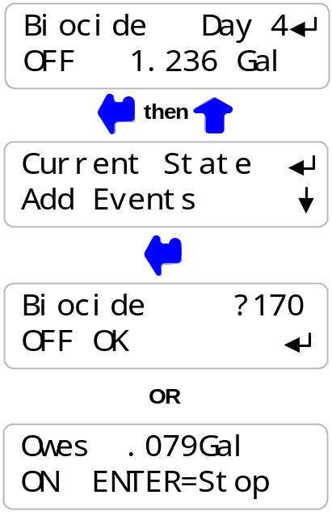

Sidebar: Bleed Solenoid Prebleeding starts when an event is scheduled.

Biocide pump turns ON after Prebleed time ends.

Bleed Solenoid Lockout period starts when the biocide pump turns ON.

HELP: ?170 and other help numbers display wherever more explanation
is available at online.

3.8 Selecting a Pump Type
Viewing the current Pump Type, Stroke Volume and Maximum Strokes/minute  Press ENTER at the Inhibitor Pump, Acid or Caustic Pump or Biocide display and then UP two times  until you view Pump Type.  Press ENTER to view the current Pump Type  In this example it’s a Prominent 1001.  Press ENTER to change the Pump Type.  Press DOWN to the current ml/stroke setting.  Press ENTER to modify the mL/stroke.  Press DOWN to the view the maximum strokes  per minute for the current pump.  If the Pump Type is ‘Other Type’ you can press  ENTER to set the maximum SPM.  Modifying the default mL/stroke  .Press ENTER at ‘Pump Type’ then DOWN  to the current mL/stroke display.  Press ENTER to modify the mL/stroke value.  Press RIGHT to place the underline  where you wish to adjust.  Press UP – DOWN to adjust  or EXIT to make no changes.  This example changes the mL/stroke from 0.19 to 0.162  The controller blocks mL/stroke settings >+25% & <-70% of the factory default to prevent accidental under or over feeds. |  | 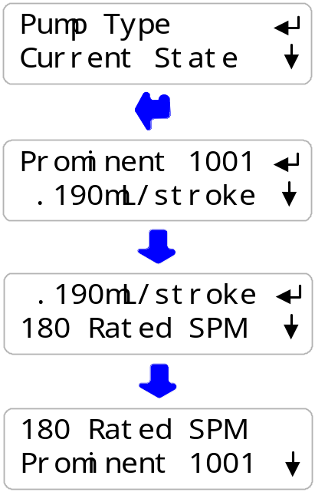  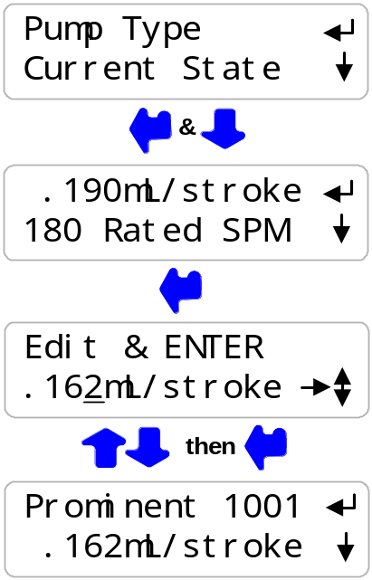

Sidebar: If you require more accuracy then the default mL/stoke setting, ‘Prime’ for one minute from a graduated cylinder and correct the current mL/stroke for the measured volume at the feed stroke rate.

3.8 Selecting a Pump Type
continued
Changing the Pump Type  Press ENTER at the Inhibitor Pump, Acid or Caustic Pump or Biocide display and then UP two times  until you view Pump Type.  Press ENTER to change the Pump Type  .  Selecting one of the six Prominent pumps  Sets the mL/stroke and maximum strokes/minute  for the selected pump.  Setpoints and feed rates are checked to verify that the  new pump can deliver the required volume.  If the selected pump is undersized, the feed rate is set to the maximum that the pump can deliver  and an error message appears.  ‘Other Type’ pumps can be any pump rated from 50 to 400 SPM that can be externally frequency controlled.  You’ll need to set the Maximum SPM and the mL/stroke for the actual pump. |  | 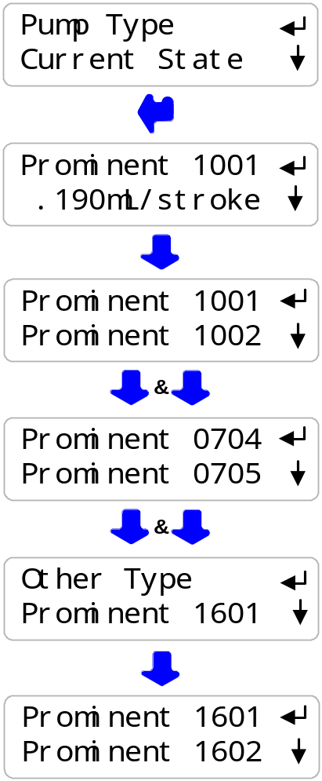

Sidebar: Prominent pumps cannot be over-stroked. If you try to control over the rated SPM, you get the rated SPM.
‘Other Type’ pumps may stall if you set the Maximum SPM greater than the
rated value for the pump.

The frequency control works like a ‘dry contact’ set which switches ON/OFF to frequency control the pump. At 400 SPM, the controller contacts will be closed for 75mS.
At 1SPM the contacts will be closed for 30 seconds.

Whenever the frequency control contacts are closed the green monitoring LED will be ON.
Although the actual contacts are electronic, you can think of them as a contact set, since they work with any polarity of control signal.

3.8 Selecting a Pump Type
continued
Changing Maximum Stroke Rate  Press ENTER at the Inhibitor Pump, Acid or Caustic Pump or Biocide display and then UP two times  until you view Pump Type.  Maximum SPM can only be changed for ‘Other Type’ pumps.  Press DOWN until you view Rated SPM & press ENTER  Press RIGHT to place the underline  where you wish to adjust.  Press UP – DOWN to adjust  or EXIT to make no changes  In this example we have changed the Maximum rated Stroke per minute from 100 SPM to 120 SPM  . |  | 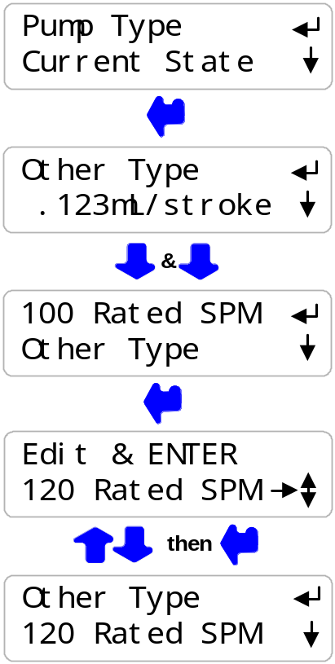

Sidebar: Prominent pumps cannot be over-stroked. If you try to control over the rated SPM, you get the rated SPM.

‘Other Type’ pumps may stall if you set the Maximum SPM greater than the rated
value for the pump.

The controller checks the feed setpoints when you change the mL/stroke or Maximum SPM, modifying setpoints if necessary. If the new mL/stroke or Maximum SPM causes a feed rate to be limited, an error message is displayed.

3.9 System- Alarms

System Menu Options  Press UP or DOWN until you see Day & Time  Press ENTER view System options.  Press ENTER to view Current State  Controller diagnostics  Press ENTER to view and adjust clock.  Press ENTER to stop inhibitor feed  during either a Biocide feed event.  Press ENTER to view or change  US or Metric units.  Press ENTER to view or switch between  ACID and CAUSTIC control  The next menu item will display ‘Caustic Pump’ if you have selected Caustic Control  Press ENTER to view Feed Limit action at midnight  The Feed Limit may be reset at midnight.  Feed Limits that are not reset, require a user reset.  Press ENTER to turn ON the user password.  If PASSWORD on, press ENTER for password tools.  The 4-20mA output may represent either the conductivity or pH sensor. Press ENTER to view or change. |  | 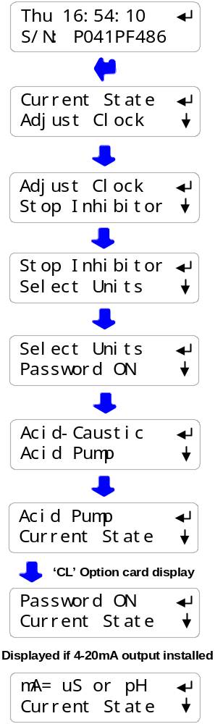

Sidebar: WARNING Midnight Acid-Caustic Feed Limit reset: The default does not reset the feed limit at midnight. If you reset every midnight, you will feed the limit volume every day which may damage site structures. Feed Limit alarms indicate that corrective action is required.

3.9 System- Alarms
continued

Alarms  Press UP - DOWN until you see Alarms  The first alarm to trip will display or ‘none’ if no alarms  Press ENTER to Clear Alarms.  Clearing alarms sets pump owed volumes  & solenoid owed times to zero.  Sensor Alarms, ‘Out-of-Calibration’ and System Alarms  auto-clear when the fault is corrected |  | 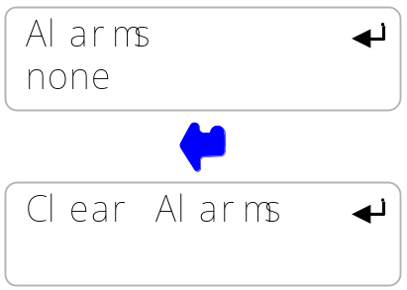

Sidebar
Only the highest priority alarm displays to direct maintenance action to the most critical fault.
When you correct the cause of the highest priority alarm, a lower priority alarm will display.

Alarms are displayed in the following priority:
1. pH sensor
2. Conductivity sensor
3. Acid-Caustic Pump volume feed limit exceeded.
4. Inhibitor pump volume feed limit exceeded.
5. Temperature sensor fault.
6. Turbine meter & 4-20mA power thermally fused.
7. Internal power supply fault
8. Internal clock fault.

3.9 System- Alarms
continued
System: Current State  Press UP or DOWN until you see Day & Time  Press ENTER view System options.  Press ENTER to view the Current State,  Controller diagnostics  Temperature at the conductivity sensor.  Press ENTER to adjust.  Displays ‘Fault’ if not used to compensate conductivity,  Indicates wiring or sensor problem.  Power used for flowswitch, paddlewheel water meters  and to power 4-20mA current loops  Alarms on short circuits, recovers when wiring corrected.  Internal power used or bleed solenoid.  Always 11.7 to 12.3. Alarms on fault.  Conductivity sensor drive, 70-80mV or 950–1050mV  as sensor drive auto-ranges.  Alarms and cannot measure conductivity if out of range.  pH-ORP sensor offset, 2475 to 2525mV  Alarms and cannot measure any sensors if out of range.  Internal diagnostic. Displays Firmware version  Checks that user setpoints being saved  & that the Clocks are operating, |  | 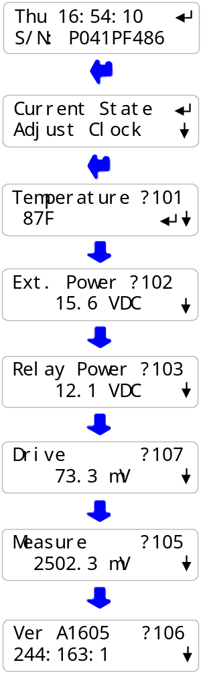

Sidebar: System: Current State verifies the controller operation & alerts you to wiring problems with conductivity temperature, paddlewheel water meters and controller powered 4-20mA current loops.

3.9 System- Alarms
continued
System: Adjust Clock  Press UP - DOWN until you see Day & Time  Press ENTER & DOWN to Adjust Clock.  Press ENTER to view or adjust current Date & Time.  Press EXIT to leave changed  or RIGHT to move the underline.  Press UP – DOWN to EDIT.  After ENTER, press UP-DOWN to select day of the week.  Day of the week is important for Biocide events  which use Sunday as Day 1.  System: Stop Inhibitor  Press UP - DOWN until you see Day & Time  Press ENTER & DOWN to Stop Inhibitor.  Press ENTER to view or adjust current  Inhibitor feed sequence.  ‘No Bioblock’ is the Factory Default.  ‘Biofeed Blocks’ stops the Inhibitor Pump whenever the Biocide pump is ON. |  | 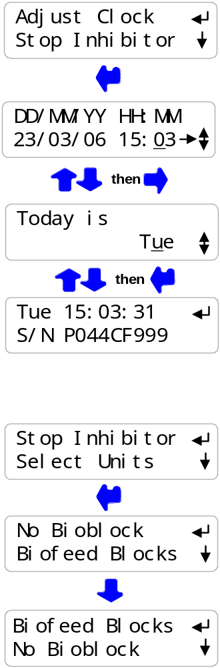

Sidebar: Sites where Biocides are fed into the same sample-feed piping as the Inhibitor may cause jelling or inhibitor degradation.

Blocking the inhibitor pump prevents product mixing in the sample-feed piping during Biocide feed events.

3.9 System- Alarms
continued
System: Select Units  Press UP or DOWN until you see Day & Time  Press ENTER and then DOWN three times to Select Units  Press ENTER to view or adjust current Select Units.  Press EXIT to leave changed  or DOWN to change.  Key ENTER to:  Set to U.S. units, degrees Fahrenheit & Gallons or  Set to Metric, degrees Centigrade & Liters  System: Adjust Temperature  Press UP - DOWN until you see Day & Time  Press ENTER twice to adjust Temperature  Press UP – DOWN to EDIT or RIGHT to move the underline  Press EXIT to leave changed or  ENTER to change the temperature  A Temperature displaying Fault cannot be adjusted.  Temperature cannot be adjusted more than  +/-18F or +-/10C from the factory default.  Press EXIT on this message to return to Temperature factory default setting. |  | 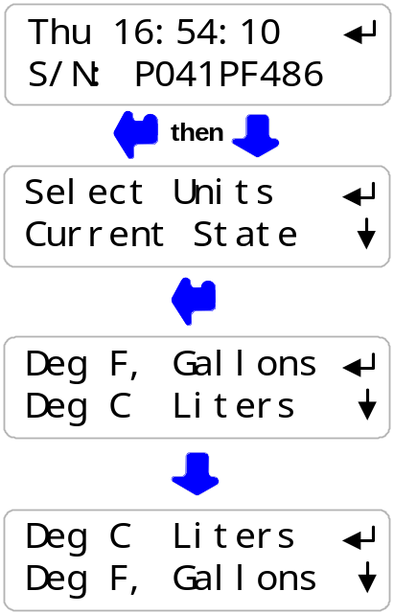  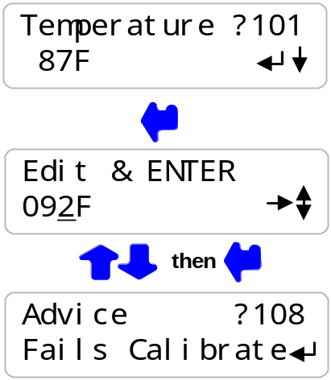

Sidebar: Select Units changes volume fed, make-up meter units, year-to-date units
and volume per contact units.

Temperature compensation of conductivity, switches automatically between C & F as does the System:Current State display of temperature.
NOTE: If you adjust the Temperature, you’ll need to re-calibrate conductivity

3.10 Password
Password is turned OFF in new controllers  Press UP or DOWN until you see Day & Time  Press ENTER & UP to select Password ON  If you press ENTER you’ll be prompted for a password  the next time you press ENTER.  Press UP or DOWN to view the current state of the controller.  Any ENTER key will prompt for the password,  displaying the default password 123.  Use the UP, DOWN & RIGHT keys to enter a password then key ENTER.  A correct password displays, Password OK.  Press any key to start operating the controller. |  | 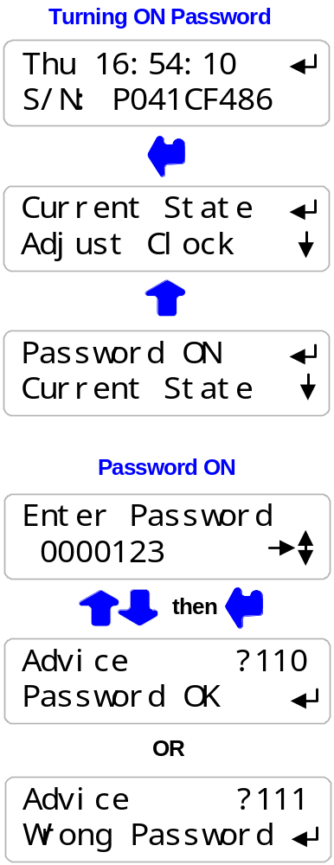

Sidebar: When you first select Password ON, the default password is 123.

Whenever you Enter Password the controller displays the default password.
If you have not changed the default password, press ENTER to log in.

  - Password
continued
Press UP or DOWN until you see Day & Time.  Then press ENTER & UP to view Password tools.  Password tools are available when Password is ON  and you are logged in. Press ENTER to view the tools:  Press ENTER to Log Out.  If you forget to Log Out, the controller logs you out  30 minutes after the last key press.  Press DOWN & then ENTER to view  & change the current password  Press DOWN to Password OFF.  Pressing ENTER turns OFF PASSWORD.  Press RIGHT & UP – DOWN to change  the current password.  ENTER changes the password.  Press EXIT to leave the password unchanged |  | 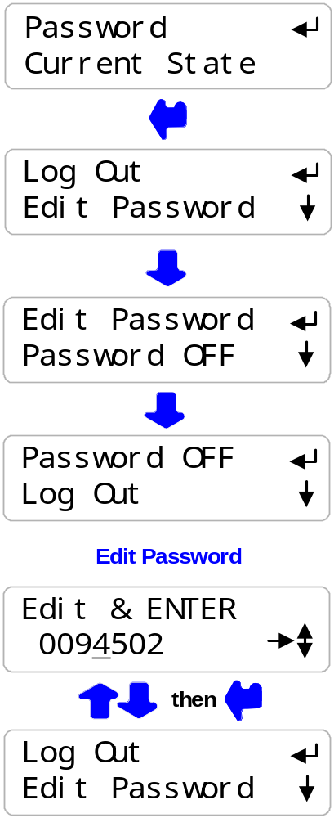

Sidebar: If your controller is password protected. Select Edit Password and change the password from the ‘123’ factory default.

Passwords may be from 1 to 6 numbers. Leading zeros are ignored.

If you forget your password, you’ll require the controller serial number to get a Reset Password. The controller password is ‘123’ after you key in the Reset Password.

4. MAINTENANCE
4.1 Guidelines
Modify the maintenance guidelines to reflect both the site priorities
and the site water treatment program.
Guidelines are for controller function only. Water treatment program maintenance requirements are provided by the site water treatment provider.

Frequency | Activity | Method
Daily | Check for Alarms.  Scan Sensors,  Make-up Meter  & Flowswitch  Note ON time for Solenoids & Volume fed for Pumps | Identify and correct the cause of alarms on sensors and pumps.  Make-up water or Pump rate & stroke may have changed. Higher temperatures may be increasing inhibitor daily volume. Debris may have partially blocked the bleed line.  A high conductivity may indicate a blocked or failed bleed solenoid. A low conductivity may indicate an overflowing tower basin or a scheduled Prebleed before a biocide feed.  A high pH may be due to a loss of prime, no acid or a pump turned OFF on exceeding the feed limit.  A low pH may indicate a siphoning pump or a failed pH sensor.  If there’s a make-up meter, you’d expect daily volume to increase with temperature. High make-up may indicate a stuck make-up float. No make-up may indicate a valved-off or faulted meter & a cause of low run time on the inhibitor pump.  If the tower recirculation pump is ON, verify that the Flowswitch shows ON.  If you check at the same time every day you would expect the bleed solenoid ON time & Inhibitor volume fed to vary only with temperature.  No Bleed solenoid ON time may indicate a fouled conductivity sensor.  Typical cooling towers bleed no more than 40% of the time and feed 5-10% of the time. At noon you’d expect to see 100 to 200 minutes of bleed & 40-50% of the daily inhibitor volume.  If this morning was a biocide feed day, verify that the Biocide daily volume shows the feed event volume.

Frequency | Activity | Method
Weekly | Verify Conductivity  Verify pH  Note Make-up Volume  Verify Flowswitch  ‘Y’ Strainer Filter  System Check | Sample the tower water conductivity.  Verify controller matches the sample +/-25uS  Conductivity sensors should not drift or require cleaning.  Scaling sensors may indicate a restricted bleed, varying make-up hardness, incorrect setpoints or water treatment program.  Fouled sensors may indicate organic, biofilms, oils or silica. Depending on the type of foulant, a change in program or a switch in the bleed control method may be required.  Verify controller pH matches sampled pH +/-0.1pH.  If the conductivity sensor is fouling, usually the pH sensor also fouls.  Weekly water usage indicates both average tower load and maximum daily temperature. High water usage may result from a change in controller setpoints or a leak or overflow in the cooling water system.  Close the upstream sample line isolation valve then the downstream valve wait 30 seconds & verify that the Flowswitch displays OFF.  If the sample line has a ‘Y’ strainer, clean the filter to prevent an unplanned ‘no flow’ outage.  Note that ‘Y’ strainers are not required when using the controller’s non-mechanical flowswitch.  Open the downstream, then the upstream valve and verify that the Flowswitch displays ON.  Visually inspect sample-injection piping for leaking fittings, feed injection points and sensor entries.

Sidebar: Maintenance Guidelines for water treatment are set by the chemical treatment program vendor.

Frequency | Activity | Method
Yearly | pH Sensor  Calibrate Conductivity  Tester  Replace pH test solutions. Verify pH tester  Observe a Bleed Control Cycle  Verify Water Meter | The service life of a pH sensor is reduced by extreme temperature swings and frequent removal for calibration-cleaning. Incorrect sample line isolation valve sequencing stresses the sensor seal & shortens sensor life.  Replace the pH sensor annually.  Verify the conductivity tester annually with a calibration solution using a solution that’s as close as possible to the controller conductivity setpoints.  Replace outdated conductivity calibration solutions.  If you are using pH calibration solutions, replace outdated solutions. If you are using a pH tester, re-calibrate it using a test solution  Observe as the tower cycles up and the conductivity exceeds the Turn ON setpoint. Observe the unobstructed flow from the bleed line, if it’s visible.  Note the conductivity when the float opens the make-up line. Verify that the bleed solenoid shuts off flow when the conductivity falls below the lower setpoint.  Note the conductivity when the float closes the make-up line. Verify that the difference between Make-up ON & OFF conductivities is greater than the difference between Setpoint TurnON & TurnOFF conductivities.  Optimal control occurs when the bleed setpoint deadband (TurnON – TurnOFF) in less than the make-up float ON-OFF conductivity difference.  If a make-up water meter is installed, verify that the controller measures an increase in make-up volume while the make-up float opens the make-up line.  Is the expected volume measured for the size of the line and the float ON time?  If not, the meter Volume/Contact or ‘K’ factor may have been set incorrectly or the water meter may have been cabled in a common conduit with AC power.

Frequency | Activity | Method
Yearly | Observe an Acid  Feed Cycle.  (This may take  some time, but it’s worth doing whenever you make changes to setpoints or when make-up chemistry changes) | Observe the slow rise in pH as the tower evaporates water and increases alkalinity.  Note the time when the Acid pump turns ON.  Initially there may be a delay in pH response as acid feeds depending on feed point, pump setting and the time for acidified water to reach the sensor.  Note the elapsed time when the Acid pump turns OFF.  pH will continue to fall after the Acid pump turns OFF due to pumping and sump transit delay.  If this is a fully loaded tower on a hot day, then the pump elapsed time should be nominally ¾ of the Feed Limit volume setting to prevent nuisance trips.  The piping-sump delay between adding acid and measuring the change in pH widens the  effective setpoint control range.  If you change the tower bleed setpoints, therefore it’s pH; you may need to adjust the Acid or Caustic pump Feed Limit.  Acid feed requires regular maintenance to verify that the pH sensor is reading correctly and the Feed Limit volume is set correctly to prevent an acid overfeed and resulting corrosion.  A Feed Limit volume set too low, will trip and result in no acid feed with possible scaling of heat exchanger tubing.

4.1 Spare Parts

4.1.1 Line Fuse

Protects | Rating / Type | Manufacturer – Vendor
Controller,  and Bleed Solenoid | 5 Amps @ 115VAC  2 Amps @ 230VAC  5mm x 20mm,  Fast Acting | Littlelfuse, Type 217, 250VAC  Digikey Part# F953-ND  Digikey Part# F950-ND  www.digikey.com 1-800-344-4539

4.1.2 Controller Parts

Part# | Description
ProMinent Part# | Replacement pH sensor
SFuse | 120VAC Fuse Kit, 10 x 5A Controller Fuses,
CTF | Conductivity-Temperature-Flowswitch sensor
CTF-Entry | Conductivity entry fitting for PVC ¾” NPT ‘T’ fitting
PR/CO-IN-TB-TB-NS | Spare Controller without sensors & entry fittings
R171230 | Enclosure Power cable entry fitting, PG11
R717231 | Enclosure Sensor cable entry fitting, PG9

On-Line Help

Browse to www.///////////.com/help with the 3 digit HELP#’ from the controller LCD display.

LCD display HELP numbers are preceded by ‘?’

Users Manual
Download PRCP_User from www./////////////////.com

Manual Version | Detail
03/06/29 | Initial release with integrated Conductivity-Temperature-Flowswitch sensor. Revisions on volume feed limits.

Appendix A: INSTALL
A.1 PLUMBING
Typical sample-chemical injection piping operates at 40-60psi and is plumbed in SCH80 PVC.
Sample piping is usually fed from the discharge side of the re-circulation pump, returning to either the suction side of the pump or to the tower basin.
Ensure that the sample piping flow exceeds 1 GPM and that the sample stream represents the tower water.
Avoid sample piping which drains whenever the tower is off-line. Solids will accumulate on the sensors requiring re-calibration and cleaning.
A backcheck may be required at some sites to prevent reverse flow through the injection-sensor piping when the recirculation pump is OFF.
‘Y’ strainers in the sample loop are not recommended. Strainer filters are usually the first location to plug, turning OFF pumps and the bleed solenoid on no flow.

NEW CONSTRUCTION: After pressure testing, valve OFF the sample piping during post-construction re-circulation piping cleaning and passivation.

A.2 SENSORS
Conductivity sensors may be installed in any orientation which allows them to be removed for cleaning. Do not hang conductivity sensors in metallic tower sumps.
pH sensors must be installed vertically, tip down to prevent air blocking of the reference junction.
Water meter and sensor wiring cannot be installed in the same conduit as 120VAC power, pump or solenoid wiring. Even a short section of shared conduit may cause operational problems.
Conductivity, flowswitch and water meter sensor wires may be extended up to 100 feet using multiple pair AWG22 cable. Always splice sensor wires in an electrical fitting to allow both inspection and sensor replacement.
Do not extend pH sensor wiring.
Extend the conductivity sensor using the same colors as the sensor to avoid wiring errors at the controller terminals.
Contact head water meters and mechanical flowswitches are not polarized, simplifying cable extension.
CAUTION: Three wire turbine-paddlewheel meters are polarity sensitive and can be permanently damaged by miswiring. Wait until you are ready to start-up the controller before connecting this type of meter to the controller. Meter wiring errors are easily detected and corrected at start-up.

A.3 CHEMICAL INJECTION
Inject water treatment chemicals downstream of sensors as recommended by the chemical supplier.
Do not inject acid, bleach or other oxidants upstream of a recirculating pump or condenser – heat exchanger.
CAUTION: Acid injection is exothermic, heating water at the injection location. PVC injection piping can heated to failure under low flow or high feed rates. Acid is therefore frequently injected directly into the tower sump or into the recirculation line using a quill. Select a sump location where mixing will occur and acid pooling will not occur,

A.4 BLEED LOCATION
The optimum bleed solenoid location is after the condenser – heat exchanger.
Never install the bleed on the sample line, upstream of the sensors and flowswitch.
If you are installing a bleed solenoid on the tower sump, ensure that the head or pressure at the bleed solenoid is sufficient to operate the solenoid.
Verify that the solenoid is sized for the maximum tower load at the target cycles, on the hottest day of summer. If the bleed is on for more than 50% of the time, inhibitor feed options will be limited.

A.5 MAKE-UP METER
Ensure that the meter manufacturer’s recommendations for orientation and upstream and downstream piping are observed.
Orientation may be limited for contact head meters, while straight upstream and downstream piping is required to prevent errors in turbine-paddlewheel meters.
Contact head meters have a Gallon/Contact or Liter/Contact rating. In some meters this value can be altered by moving magnets or gears. Typical meters are rated 10, 50 & 100 Gallons/contact.
Turbine-Paddlewheel meters have a ‘K’ Factor which is the number of pulses / Gallon or pulses/Liter. Some manufacturers have both nominal values listed by meter size and calibration values on the meter body.
Take the time to get the meter volume/contact or ‘K’ factor correct, since most meters are used to control inhibitor feed and inhibitor ppm errors result when meters are incorrectly configured.

A.6 CONTROLLER ENCLOSURE
The optimum location for sensors, controller, chemical pumps and drums is as close together as access allows. You’ll be able to see where all the wires, plugs and tubing goes, watch pumps turn ON as you prime, grab samples to calibrate sensors…
If you have the space; sample piping on the left, pumps & drums on the right with the controller in the middle.
Wall mount the controller enclosure at eye height for a 5’ to 5’6” person so that an operator does not have to reach over drums or pumps to use the controller key pad.

In areas with daily ambient temperatures over 100F, 40C, locate the controller out of direct sunlight or beneath a sunshade. Internal temperatures over 115F, 45C will degrade the controller display.

Do not punch conduit access holes in the top of the enclosure to avoid condensation damage to the controller electronics.
Plug the controller into an ‘Always ON’ utility outlet.
Maximum controller current @ 120VAC is 5 Amps.

Appendix B: SPECIFICATIONS
Each controller includes an option card slot.
Auto re-configuration occurs on installation of one of LAN, 4-20mA Output
OR Alarm Relay option card.

Analog – Digital I/O | Rating - Detail | Notes
Conductivity  Flowswitch  Sensor | 1 Temperature Compensated conductivity sensor.  Displays 1uS resolution.  Rated 100psi, 35-120F, 2-50C  Flowswitch switches @ 1GPM | Conductivity autoranging from 100uS to 10000uS.  Flowswitch, Max. 30 second ON-OFF & OFF-ON response over rated temperature.
Water Meter | Water Meter, 400 Hz max  0.5mA @ 5VDC measurement current | Contact head meter software debounced.  Turbine-Paddle wheel rating = Seametrics max pulse rate.
Bleed Relay Output | 1 SPST | Relay rated 10A, 120VAC  Controller fused @ 5 Amps
Pump Frequency  Control | 3 Optically isolated analog switches for pumps rated from 50 to 400 Maximum SPM.  Frequency controlled from less than 1 stroke/hour to rated SPM.  Pulse ON time @ 50% of pulse period. Example: 120SPM ON for 0.25 sec. & OFF for 0.25 sec. | Current limited @ 500 ohms in series with each switch.  Monitoring LED period set @ 50% of pulse period.  User selected Prominent pump type auto sets MAX. SPM and nominal mL/stroke @ 40psi.
4-20 ma Output  on conductivity or pH  (‘CL’ optional card) | 1, DC isolated, loop powered.  Nominal 0.1% resolution.  Auto polarity correction field wiring.  Current loop goes to 4mA on no flow for proportional control applications. | Alarms on open loop.  4mA on ‘no flow’  Auto-configure on  card installation and removal.  Software calibration  @ 4 & 20mA
Alarm Relay  (‘AR’ optional card) | Dry contact set.  Rated 500mA @ 24VDC | Closed in the non-alarmed state.  Contact set opens on alarm or loss of controller power.

Communications  User Interface | Rating – Detail | Notes
Keypad - LCD | 5 Key Tactile feedback: UP / DOWN / ENTER / EXIT / RIGHT  2 Line x 16 Character, Backlit | Scan rate 100mS nominal  User adjustable LCD contrast
Browser  (‘LB’ optional card) | 10BaseT Ethernet RJ45 Jack  Full command & control via browser.  XML real time controller data | Static IP.  Fixed MAC

Controls | Rating - Detail | Notes
Bleed Solenoid | Controls: Conductivity, Water Meter & Percentage Time. | Percentage Time bleed stops on no flow.
Inhibitor Pump | Controls: Bleed & Feed, Bleed then Feed, Feed on Volume  & Base Feed  Daily feed volume limit. | User sets feed rate in mL/minute in all modes but Feed on Volume.  User sets ppm when Feed on Volume selected.  User selected block on Biocide feed.  Base Feed stops on no flow.  Feed on Volume blocked during bleed.
Acid Pump  Or  Caustic Pump | Controls: pH & Volume-ppm.  Feed volume limit on each ON-OFF sequence. | User selected reset of feed limit timeout at midnight.  User sets ppm when Feed on Volume selected.
Biocide  (Timed Events) | 28 Events in a cycle.  1 minute resolution  Lockout, Prebleed on both time and conductivity. | User sets volume fed during each event.  User selected 1,7 or 28 day cycle.
Thermal Flowswitch | Bleed Solenoid & Pumps OFF when no flow. | CTF sensor combines Conductivity-Temperature-Flowswitch in one sensor.  Flowswitch trips at 1GPM within 30 seconds.

System | Rating - Detail | Notes
Controller Configuration | User settings and biocide events written on silicon. | Makes current configuration factory default.
Clock | Battery backed, 5 years of normal usage. | CR2032 clock battery available at Radio Shack.

Electrical | Rating - Detail | Notes
AC Input | 115 or 230 VAC, 50/60Hz, | Switch selectable
Fusing | 5 Amps @ 115VAC  2 Amps @ 230VAC | 5x20mm type fuse.
Surge-Spike Suppression | Bleed solenoid relay contacts snubbed 0.1uF, 150R  Varistor on AC power input | Controller electronics transformer isolated from AC line
AC Power Terminals | AC Input & Output :  maximum. Stranded AWG 14, 150mm²
Sensor, Digital Input,  Pump Frequency Control  Terminals | AWG 22, 0.25 – 0.50mm²
Flowswitch Power  Paddlewheel Meter Power  4-20mA output loop power | 14 – 20 VDC, unregulated  Thermally fused @ 50mA | 4-20mA output option can be powered by load or by controller

Mechanical | Rating | Notes
Enclosure | Non-metallic, NEMA4X, IP65  7”W x 6”H x 4”D  180mm W x 150mm H x 100mm D | Nominal dimensions, excluding cable entry fittings.  Allow 12”, on right for bleed cabling plug-n.  Allow 18”, below for cable-conduit access.

Appendix C: HARDWIRING

AC power and bleed solenoid power may be hardwired to the controller terminal
blocks as shown in the following graphic.

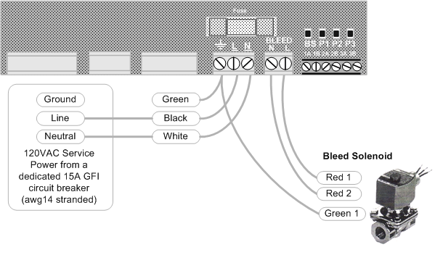
HARDWIRING REQUIREMENTS:

1. Do not exceed AWG14 for AC power wiring.

2. The Bleed Solenoid output is fused at
5 amps at 120VAC .
AC wiring must be minimum AWG18, rated 300V.

3. Use multiple strand, copper AC power wiring.
Do not use solid conductors.

4. RED-RED solenoid wiring typical for ASCO type solenoids.

Appendix D:’CL’ 4-20mA Output Option
The optional 4-20mA output on conductivity or pH is DC isolated from the controller & may be either powered by the load or by the controller DC supply.
The 4-20mA output is auto-polarity correcting & detects an open or unpowered loop.

D1. WIRING

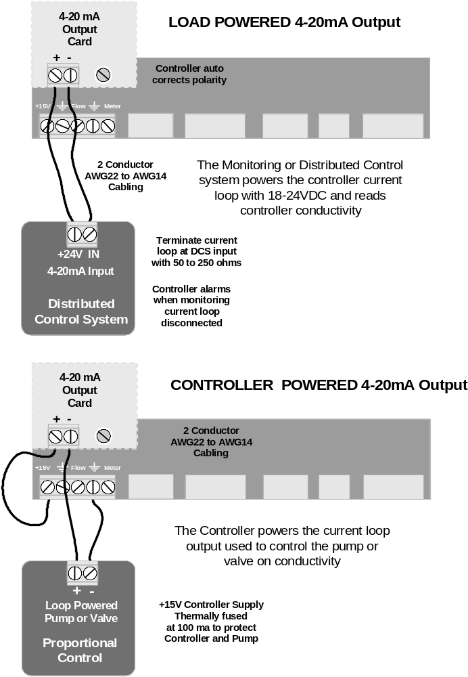

Appendix D: ‘CL’ 4-20mA Output Option
D.2 VIEW & ADJUST SPAN
The displayed value of the 4-20mA loop current  depends on both the conductivity or pH and the Span  Refer to Section 3.9 System-Alarms for uS – pH select  If the current loop output is disconnected you’ll see this display in place of the mA level.  If the flowswitch is OFF, the conductivity & pH are invalid  and you’ll see this display, which is necessary if you are controlling a proportional valve or pump  or alarming on no flow.  Press ENTER @ Select Span to view or adjust the Span  Span sets the conductivity or pH at 4mA & at 20mA  Press ENTER @ Trim Zero to calibrate the 4mA level  Press ENTER @ Trim Span to calibrate the 20mA level  View & Adjust Span  Press ENTER @ 4-20mA Output  & then DOWN to Select Span  Press ENTER.  Displays current Span.  Press ENTER to adjust 4mA level  or DOWN & ENTER to adjust 20mA level.  (Displays pH span if 4-20mA = pH )  Press RIGHT to place the underline  under the digit you wish to adjust.  Press UP – DOWN to adjust.  ENTER updates the Span.  EXIT leaves Span unchanged |  | 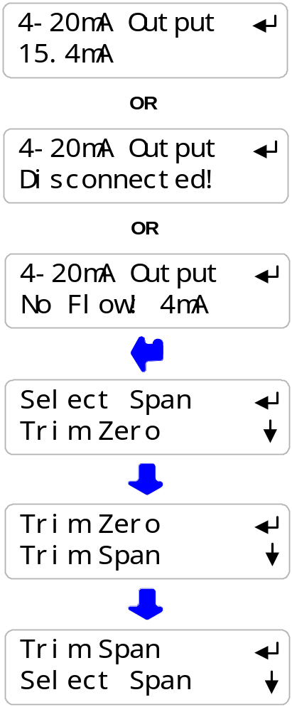  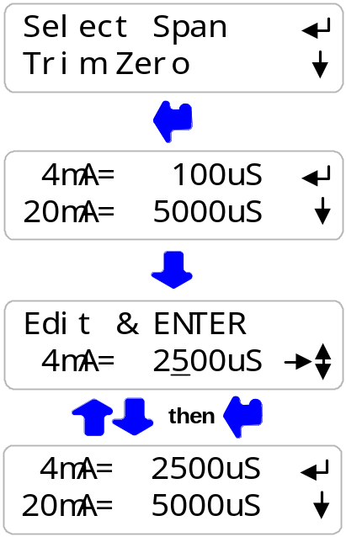

Appendix D: ‘CL’ 4-20mA Output Option
D.3 CALIBRATE
Calibration is seldom necessary & is used to correct to offset errors.
The range of Zero & Span adjustment is limited.
If you are not able to calibrate:
A: Verify your milli-ammeter B: If Load Powered, verify you have at least 15VDC available.

Press ENTER & then DOWN  at 4-20mA Output  Press ENTER at Trim Zero to adjust the 4mA level.  Connect a DC milli-ammeter in series  with either of the current loop wires.  Press UP or DOWN until you read 4mA on the milli-ammeter.  Press ENTER to view the output current and verify that the milli-ammeter reads the same current.  Press ENTER & then DOWN  at 4-20mA Output  Press ENTER at Trim Span to adjust the 20mA level.  Connect a DC milli-ammeter in series  with either of the current loop wires.  Press UP or DOWN until you read 20mA  on the milli-ammeter.  Press ENTER to view the output current and verify that the milli-ammeter reads the same current. |  | 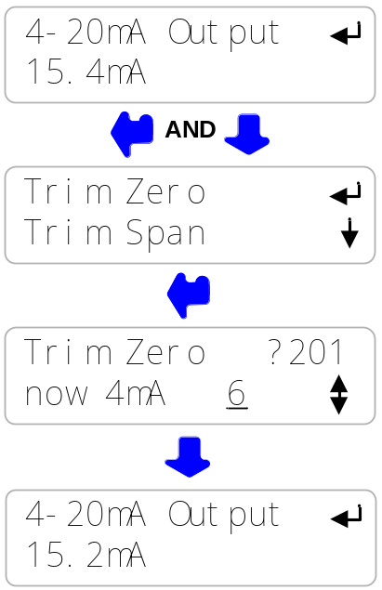  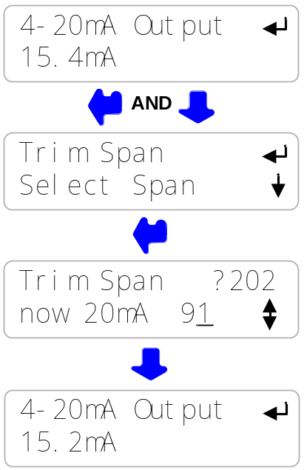

Appendix E: ‘AR’ Alarm Relay Option

E.1 WIRING ALARM CONTACTS
Alarm contacts rated 500mA at 24VDC.
Requires optional Alarm Relay Card

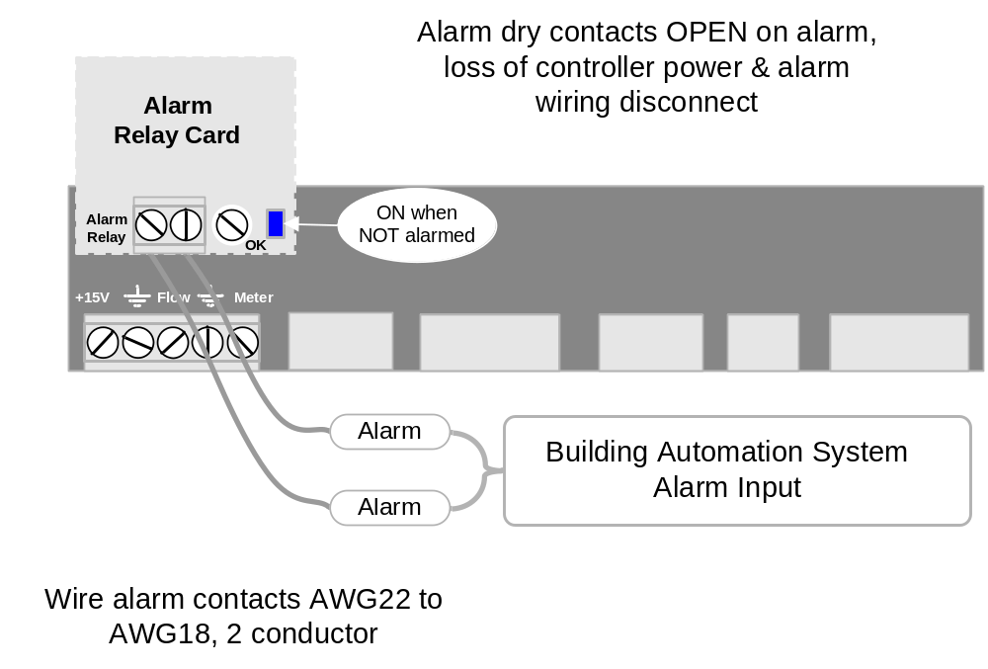

E.2 ALARM DISPLAYS

Press UP - DOWN until you see Alarms  If the Alarm Relay Card is installed you’ll see one of the following displays.  If Alarms & ‘none’ then the alarm contacts will be closed  Alarm contacts open on alarm.  This display verifies the contact set state measured at the Building Automation System input terminals. |  | 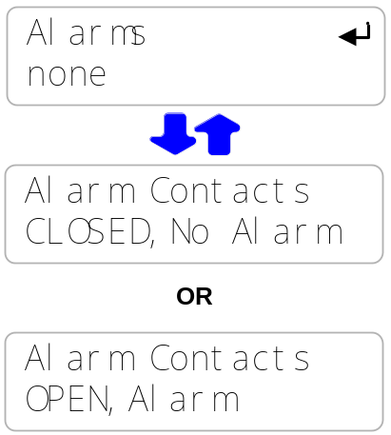

Appendix F: ‘LB’ LAN - Browser Option

Download for ProMtrac_LB.pdf browser manual for the on-line support site

Do not connect the controller to the site LAN without permission and an IP address from the site IT staff.

You can use a crossover cable to connect to your notebook PC to view the controller state.
Information on browsing controllers is available in the ProMtrac_LB manual.



